Sustainable Sydney 2030 The Vision

A response to the community’s ideas for creating a better Sydney

SYDNEY PEOPLE WANT A CITY...

“where people walk”
“ that tells its history”
“ with walkable streets”
“ with well planned public transport ”
“ which lifts the spirits”
“ that is respectful of diversity— cultural, religious, age, gender, sexuality and family structure”
“ that provides public access to the harbour’s edge”
“ with well planned public transport”
“ with self contained communities”
“ which is a place for people from all walks of life”
“ with vibrant culture and entertainment”
“ that offers affordability and social
“ where public spaces invite people to pause and contemplate-where public space invites humanity”
“ which celebrates outdoor life”

INDIGENOUS STATEMENT

The City of Sydney acknowledges Aboriginal people as the first people of Australia.

The Sustainable Sydney 2030 Vision recognises Sydney’s Indigenous heritage and contemporary culture. The City of Sydney is deeply committed to establishing a process of reconciliation in partnership with its Aboriginal and Torres Strait Islander residents. Aboriginal people have lived in the area and around Sydney Harbour for many thousands of years, living near fresh food and clean water. Campsites were usually located close to the shore, especially during summer when fish and shellfish were the main foods. Many of the City’s main roads, such as George Street, Oxford Street and King Street, Newtown are constructed on what were probably Aboriginal walking tracks, which served as trading routes between farmed grasslands or bountiful fishing areas.

The Aboriginal and Torres Strait Islander communities in the City were extensively consulted for Sustainable Sydney 2030. Many issues and ideas raised were consistent with those in the broader community such as improved transport, greater safety, more affordable housing and limiting cars in the City Centre. Ideas raised included supporting Aboriginal and Torres Strait Islander culture and practice and providing economic development, employment and social opportunities for the Aboriginal and Torres Strait Islander community. The City of Sydney will involve the Aboriginal and Torres Strait Islander communities during the implementation of Sustainable Sydney 2030, consistent with the Principles of Cooperation signed between the City of Sydney and the Metropolitan Local Aboriginal Land Council in 2006. The City of Sydney will ensure ideas generated during the consultation process are attributed and will work cooperatively with the community during implementation. This process will be based on respect, trust and a spirit of openness and partnership.

The Vision for Sydney is a Green, Global, Connected City

GREEN
Sydney will be internationally recognised as an environmental leader with outstanding environmental performance and new ‘green’ industries driving economic growth.
The City will reduce its greenhouse gas emissions, with a network of green infrastructure to reduce energy, water and waste demands, led by major renewal sites.
The City will help contain the Sydney Region’s _{t} urban footprint by planning for new housing opportunities integrated with vital transport, facilities, infrastructure and open space.*
The City will protect native flora, fauna and ecologies.

GLOBAL
Sydney will remain Australia’s most significant Global City and international gateway with world-class tourism attractions and sustained investment in cultural infrastructure, icons and amenities.

The City will contain premium spaces for business activities and high quality jobs in the City Centre, and support social, cultural and recreational ' facilities to nurture, attract and retain global talent.
The City will embrace innovation, and new generation technologies to connect it-through new media and the web, stimulating creativity and collaboration.
The City will be a part of global cultural networks and an active participant in global knowledge exchange.

CONNECTED
Sydney will be easy to get around with a local network for walking and cycling, and transit routes connecting the City’s Villages, City Centre and the rest of Inner Sydney.

The City will be easy to get to with an upgraded regional transit network that builds on the existing network, enhancing access to Sydney’s centre from across the region.

The City’s distinctive Villages will continue to be strong focal points for community life and will encourage a sense of belonging. The Villages will be served by Activity Hubs where services are concentrated, interconnected and make a significant contribution to the City’s liveability, which will increasingly underpin its global competitiveness.
The City will be diverse and inclusive. Relative equality will be improved by an increased share of affordable housing and better access to community facilities, programs and services across the City, with a resultant improvement in social equity and wellbeing. Cultural vitality will flow from high rates of participation in artistic expression, performance, events and festivals.

The City will celebrate and support its Indigenous people and their living culture.
The City will commit to partnerships and cooperation between governments, the private sector and the community to lead change. The City is part of a wider national and global community and will pursue relationships with other Australian and international cities for cultural, trade and mutually beneficial exchanges.

Contents

Sustainable Sydney 2030 The Vision 1
SYDNEY PEOPLE WANT A CITY... 1
INDIGENOUS STATEMENT 1
The Vision for Sydney is a Green, Global, Connected City 2
Contents 3
Message from the Lord Mayor 4
Message from the Chief Executive Officer 5
Sustainable Sydney2030 is a call to action. A vision to create a better Sydney 6
THE VISIONARY 7
VIEWPOINT 10
PARTNERSHIPS 12
Vision at a glance 16
10 Targets 18
Specific Targets to make the city for sustainable 18
Five Big Moves 23
Transforming the City 23
Big Move 1 A revitalised City Centre at the heart of global Sydney 24
Big Move 2: An integrated Inner Sydney transport network New sustainable transport connecting Inner Sydney, the City Centre and the City’s Villages, with congestion reduced. 25
Big Move 3 A liveable green network 29
Big Move 4 :Activity Hubs as a focus for the City’s Village communities and transport 33
Big Move 5 Transformative development and sustainable renewal 38
10 Strategic Directions 39
Framework for action: 10 Strategic Directions for a Sustainable Sydney 40
Direction 1: A globally innovative City 40
Direction 2 A leading performer 44
Direction 3 Integrated transport for a connected City. 47
Direction 4: A City for pedestrians and cyclists 50
Direction 5 A lively, engaging City Centre 53
Direction 6: Vibrant local and economies 57
Direction 7: A Cultural and Creative City 60
Direction 8: Housing for a diverse population 64
Direction 9 Sustainable development renewal and design 68
Direction 10: Implementation through effective governance and partnerships 73
10 Project Ideas: How the 2030 Vision could be delivered 77
Idea 1: Western Edge 78
Idea 2: Three City Squares 81
Idea 3 Protecting the Centre 82
Idea 4: Eora journey 84
Idea 5 Cultural Ribbon 86
Idea 6: Harbour to 'the Bay' 88
Idea 7 Connecting Green Square 90
Idea 8: Affordable Housing 93
Idea 9 New moves for Newtown 96
Idea 10: Green Transformers 98
2030 Vision to the Corporate Plan 103
APPENDICES 104
Acknowledgements 116
Glossary of Terms 117

Published 2008 by the City of Sydney, Town Hall House, 456 Kent Street Sydney, NSW 2000, Australia. ISBN 978-0-9751196-6-2

For more information on Sustainable Sydney 2030, including audio and video content: Please visit: www.sydney2030.com.au

Should you require this information in an alternative format please contact: City of
Sydney 9265 9333, TTY: 9265 9276, council@cityofsydney.nsw.gov.au Translation service (TIS) 13 14 50

Message from the Lord Mayor

After more than a year discussing and listening to our diverse community, consensus on the way forward for making Sydney a greener, more global and connected City has emerged.

Adopting an exciting new Vision for Sydney’s City Centre and its Villages for the next 20 years has involved the most comprehensive consultation ever undertaken in the City, with thousands of residents, business people, those involved in the arts, cultural and educational institutions and many community organisations.

Overwhelmingly, people told us they want a City that by 2030 is smarter, more open, more hospitable, more inclusive; cleverer in the ways it does business locally and internationally, and less congested.

Ninety-seven per cent said they wanted us to address global warming. So we’ve made sustainability the overarching theme. Indeed, one of the major objectives of the Vision is to help position Sydney as one of the world’s leading green cities in the race to address climate change.

This presents substantial challenges, but equally, exciting opportunities to rethink the way we live and work as the green revolution takes place over the next few years and decades.

If we don’t actively pursue this goal, we are going to be left behind—the reality is as stark as that. Just as the industrial revolution transformed the world in the 19th century, a new green revolution is set to transform the 21st century. As a progressive and forward-looking City, we need to be ready for the transition to a new green economy with new values and priorities.

With sustainability as a central focus, the 2030 Vision addresses global warming through the three big levers of building emissions, transport and energy (generation).

As the biggest emitters of greenhouse gases, cities are also the source of the biggest savings and the key to achieving post-Kyoto emission reduction targets.

But the Vision also embraces social and cultural sustainability, and seeks to promote a vibrant, creative and diverse community.

Cities are much more than a collection of buildings and an economy. The most successful cities are those which value their culture, their history and their people. These positive sentiments and beliefs shone through in the public response and the submissions received.

With the Vision established, the task now is to engage all the major stakeholders in its implementation—its success will depend on effective partnerships, with all tiers of government, with the private sector and with the community.

Importantly, while Sustainable Sydney 2030 reflects the strategic thinking of the current City of Sydney Council, it is vital that the Vision endures through future administrations regardless of who is in power at the City, State and Federal level. To secure Sydney’s future, its prosperity and liveability we sought and have achieved a broad alliance of support—now we need to keep moving and undertake practical implementation.

Message from the Chief Executive Officer

Sustainable Sydney 2030 is the City of Sydney’s Vision for making this City, among other things, more economically sound, more liveable, more accessible, more inclusive—a more vibrant and captivating place to live and work.
It is a necessary scoping for how the City Centre and its surrounding Villages can enhance and reinforce Sydney’s Global City status by taking on bold initiatives to improve and sustain its natural assets and wellbeing—and build across-the-board prosperity.

Its timing is compelling. Sydney, its people and businesses, as with other major capitals around the world, are facing a host of challenges generated by external forces—from economic globalisation to climate change, from petrol price fluctuations to competition for enterprises and creative talent.

This Vision provides “step change” progressions toward a more sustainable future, while protecting and preserving those aspects of the City that are much loved and which underpin its medium to long-term potential.

The Vision—based on a strong foundation of consultation, research and analysis—mirrors a wealth of ideas from people of all walks of life and generations.
Apart from road-mapping changes to infrastructure, the Vision sets new parameters for the way Council delivers and facilitates services, development and public domain improvements. It also gives direction on renewal and transformational projects aimed at driving enterprise, cultural excellence and social cohesion.

While a range of directions and actions apply to core business areas of the City, other larger and more complex projects and programs will be viewed, assessed and implemented on a progressive, long-term basis.

Integral to the Vision is a commitment by the City of Sydney to enter into partnerships with the community, business and government to realise the program through to 2030—while continuing to take advice and soundings on an ongoing basis.
The Vision sets the agenda for the City’s Corporate Strategic Plans and Capital Works in the years to come.

Sustainable Sydney2030 is a call to action. A vision to create a better Sydney

The 2030 Vision was developed with broad community involvement and support during 2007 and 2008.

As the world grasps the urgent need to respond to climate change and rising fuel prices, the City of Sydney is offering leadership through the 2030 Vision now being implemented to address urgent issues facing Sydney.

THE CHALLENGES
- Climate change
- Global economic competition
- Transport congestion
- Decreasing affordability
- Leisure and cultural experience
- Persistent social disadvantage
- Maintenance of living standards
- Replacing aging infrastructure
- Greater accessibility and inclusiveness

People from all walks of life, across all generations and an extensive range of organisations have given ideas and suggestions to inform the Vision.
The innovative and transformative ideas in the Vision will progressively make necessary and positive changes to city life. As it is implemented, Sydney will be a stronger community and better place to live in the future.

The Vision does not just focus its ideas on the CBD but offers a broader concept of city economy and life as a City Centre supported by a series of thriving interconnected Village economies and communities.

The community's ideas and the work of the 2030 team were supported by the strong voice of international urbanest, Jan Gehl, whose study Public Spaces, Public Life Sydney 2008 provided a policy framework for the 2030 Vision.

"We can either drift into the future or we can take hold of the future with our own hands and shape the future." Kevin Rudd Prime Minister of Australia

THE VISIONARY

,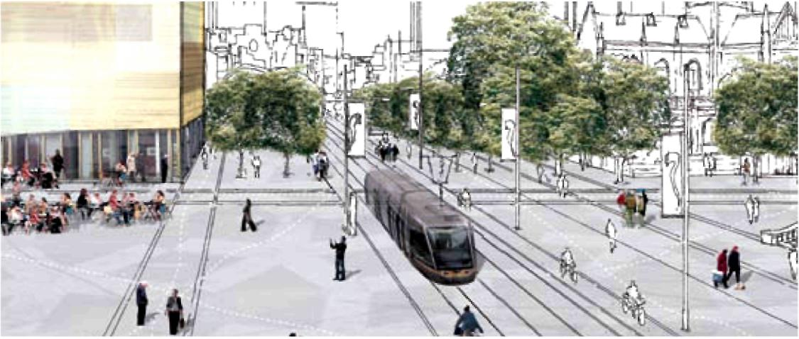

Danish architect and urbanest Jan Gehl has focused on improving the quality of urban life for millions of people worldwide.

"We have produced our ideas and vision of what Sydney could become— now it’s up to the people of Sydney, and the actions of government." Jan Gehl

The City of Sydney has great edges: its magnificent harbour, the green spread of the Domain and Royal Botanic Gardens. But where is its heart?

Its heart is congested, choking on the noise and fumes of the internal combustion engine. That is not healthy, either for the City, or for the citizens. So now that Gehl Architects has finished our Public Spaces, Public Life study, commissioned by the City of Sydney, we have one question for this City: what do you value more—your people, or your cars?

If you say people, then you need to unlock the centre of your City, so that it becomes a place people will want to go, and a place that welcomes everybody —workers, children, old people, students.

To do this, you need a long-term plan. Two great acts would symbolise this change in thinking: to demolish the Cahill Expressway and train station that sever the City from its harbour (the trains then go underground); and bury the Western Distributor whose spaghetti-tangle throttles Darling Harbour and cuts it off from the life-blood of the City.

All great cities have a heart. They attract people to their centres —not just to work and to live, but to shop or meet people, to dine, to visit a library or a gallery, to be part of the life of their City.

Set your thinking for the long-term, and these tasks will not be impossible. Indeed, other harbour cities like Boston and San Francisco have already done it. There, all levels of government worked together to make it happen and here, there could be a similar recognition of the benefits that will flow for greater Sydney. Freed from these constricting bands, the City Centre will breathe again and be open to its harbour. It will be a welcoming place for people from all over greater Sydney.

Meanwhile, there are other steps to take. Sydney needs a coherent, attractive, walkable north-south link. All great cities have such a street—think of the Champs Elysees, or the Ramblas in Barcelona. It could be George Street, the City’s most historic street, linking the two great doorsteps of Circular Quay and Central Railway. But who would dream of walking this great street, clogged as it is with buses and angry traffic?

But close it to vehicles, allowing only buses and bicycles, provide wider footpaths, canopies of trees, and three great public squares at Circular Quay, Town Hall and Central Station, and watch what will happen.

There will be human life along the whole length of it; people in cafes, people sitting on benches under the trees, people walking to their offices and shops.

George Street becomes the great organising spine, with a network of vibrant lanes like Angel Place and small plazas like Regimental Square running off it. It is edged with interesting small shops and bars and places for people to sit and rest.

Parking is confined to the city edges, freeing the city streets for cyclists, pedestrians and a light-rail system.

There is room, too, for great public art, for fountains and play-areas for children (who know how to use space spontaneously), and there are quiet places for people to sit and watch the world go by. No city should be “off-limits” to either the very young or the older people, and all cities should provide delight and surprise.
From Pitt Street Mall—which should be renamed Pitt Street Plaza to signal it is a place for people as well as shops—you can still see the curve of the Harbour Bridge, reminding you that you are in one of the world’s great harbour cities. But there are other reminders of the reasons for Sydney’s founding and the city should celebrate them.

Why not bring the Tank Stream to the surface in parts of the city? Purified, it could become a living symbol of the city of Sydney’s commitment to be a “green” and healthy city. It would extend the harbour’s reach into mid-town, cool the air and bring delight to the city streets.

Green spaces like Hyde Park should better connect to the city and to each other, with distinctive plantings around them and a more generous connection to their surrounding streets.

Sydney has a peculiar difficulty because so many arms of government have a finger in the city pie: the City of Sydney itself, and also the NSW Government through City Rail, State Rail, Sydney Ferries, Roads and Traffic Authority, Sydney Harbour Foreshore Authority (running The Rocks and Darling Harbour and Barangaroo). Then there are the Royal Botanic Gardens and Domain Trust and the Sydney Opera House Trust. All this in just a few square kilometres.

It makes it much harder to organise and co-ordinate the necessary improvements. But when the City commissioned our report, the Lord Mayor asked us to look at what should be done for Sydney’s long-term improvement, not just at what was immediately possible. For no matter what their system of governance, all great cities need a focused, long-term vision, for without it they wither.

We were asked to see our Public Life, Public Spaces study as an integral part of the City’s Sustainable Sydney 2030 project to make Sydney a more liveable, workable and sustainable city over the next generation.

We have produced our ideas, our vision of what Sydney could become. Now it is up to the people of Sydney, and the co-operative actions of government, what becomes of that vision.

Who knows, with a new Prime Minister who is interested in the future of Australia’s cities, you might get some Federal help to make it happen.
In Sydney, it seems to me, you sometimes say “This is too hard, it can’t be done.” In Copenhagen, too, 30 years ago, people of my own car-dominated city said much the same thing.

"Today, it is a city of pedestrians and cyclists, a city where the people, and not the cars, come first. I hope that by 2030, Sydney; too, will be a city for its people. We want a city of people; a city where people feel safe; a city that is interesting and lively". Jan Gehl

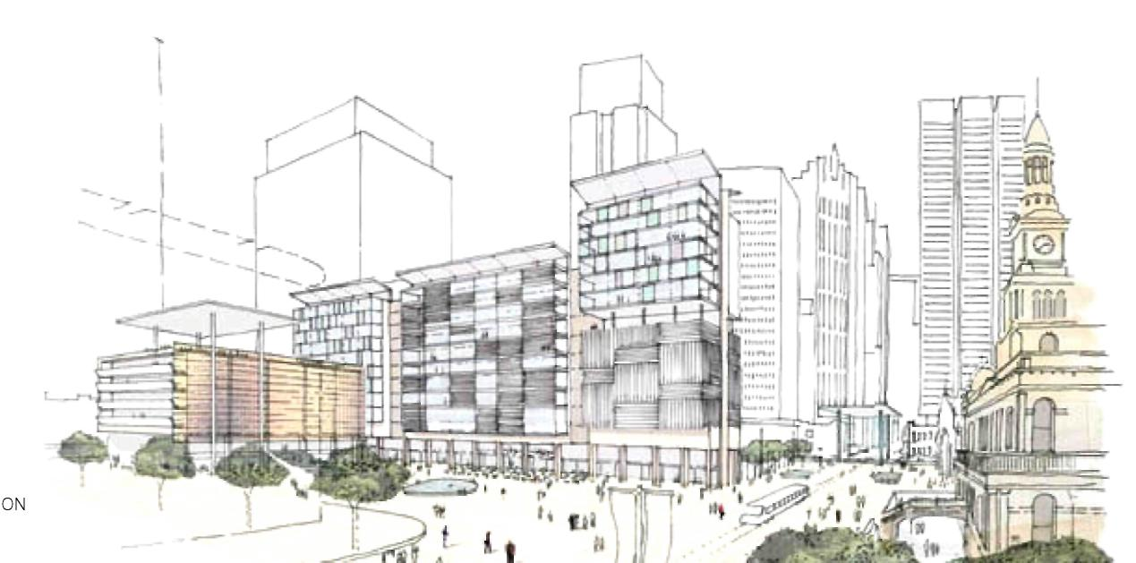

VIEWPOINT

A Global City is more than a CBD
PATRICK FENSHAM

The economies of the world’s great cities are more than a collection of office towers in so-called ‘central business districts’. Think of London’s financial district in the city, new office precinct at Canary Wharf, theatres in the West End, government activities at Westminster and arts venues and museums at South Bank.

Think of New York’s Wall Street, Lower East Side, Greenwich Village and Times Square. Global cities contain diverse precincts and neighbourhoods connected by high quality and dense public transport. Their economies are underpinned by the creativity and constant innovation that occurs where skilled people mix in social, business and cultural activities.

The City of Sydney’s Sustainable Sydney 2030 Vision recognises these prerequisites for a successful city. Importantly, it also anticipates that Sydney’s competitive advantage in the 21st century will derive from its world renowned liveability, and increasingly from the extent to which it is environmentally sustainable.
Sustainable Sydney 2030 has identified Five Big Moves to Transform the City that are underpinned by this understanding.

1. A revitalised City Centre at the heart of global Sydney.
The old ‘CBD’, north of Central Station, is re-cast as the ‘City Centre’, to recognise that a thriving economy needs a diversity of activities alongside pure business uses. Sufficient floor space for business activities will be provided, but ground level cafes and shops to activate street life will be required in new developments. Distinctive retail, civic and entertainment districts will be promoted. Laneways and under-utilised areas will be activated with bars and cultural-activities. The great physical asset of the City Centre is its harbour. Bold proposals to removal the Cahill Expressway and bring the Western Distributor to ground, would allow the City Centre to be reconnected to the waterfront, thereby re-establishing Sydney’s credentials as the Harbour City.

2. A liveable green network for walking and cycling
Around 50 per cent of trips by City residents are by walking and cycling, compared to an average of around 20 per cent across the metropolitan Sydney. The City’s compact urban environment supports these already sustainable travel patterns, and these will be further strengthened by the proposed liveable green network.
Green corridors linking parks and reserves would be integrated with liveable streets, providing a separate, safe and pleasant way for pedestrians and cyclists to move across the city.

3. An integrated Inner Sydney transport network
The centres of other global cities are crisscrossed by fixed rail public transport (typically light rail or metro lines, like the London Underground).

In central areas the same size as the City of Sydney, Berlin has 220 kilometres of track, London 200 kilometres, Barcelona 140 kilometres, Toronto 50 kilometres and Singapore 35 kilometres. Notwithstanding its generally lower density, the Sydney figure of 23.5 kilometres of track appears far from world class in comparison.

Inner Sydney desperately needs a comprehensive and integrated light rail or metro rail network, which Sustainable Sydney 2030 proposes, to connect the City Centre with the surrounding villages, but also to connect the villages with each other.

Key corridors for early action are those connecting George Street through Redfern, to Green Square and Botany, along Regent Street and Botany Road, and between Surry Hills and Rosebery. The other key transport proposals are those which seek to ‘protect the centre’ from the noise, congestion and disruptive impact of vehicular traffic.

Travel by car to and through the City Centre can be minimised by a world class light rail loop, efficient and iconic interchange facilities for moving between rail modes and complementary road and car parking management initiatives.

4. Activity Hubs as a focus for the City’s village communities and transport
In Sydney, the city’s economic, creative, entertainment and cultural activities are spread throughout its Villages. Education and health facilities are at the core of employment concentrations in Darlinghurst (around St Vincent's Hospital) and Camperdown (around the Royal Prince Alfred Hospital and University of Sydney).
Surry Hills and Chippendale are buzzing with small, creative businesses in converted warehouses, galleries, and shops, amidst great residential diversity.
Kings Cross, Oxford Street, Newtown and Glebe have their own distinctive, small business cultures.

The 10 Activity Hubs proposed in Sustainable Sydney 2030 are about fostering these local economies, as well as providing a focus for the residential oriented community and cultural facilities and local retailing.

Each of the identified Hubs will be strengthened through local planning and business development initiatives.

5. Transformative development and sustainable renewal
Significant change and development has occurred in the last 20 years or so with, for example, Darling Harbour, Walsh Bay, Woolloomooloo, Pyrmont, and the old showgrounds at Moore Park all transformed in this period.

Sustainable Sydney 2030 lifts the sustainability bar for the next 20 years of renewal and redevelopment. Frasers Broadway, on the old CUB site, is proposing ambitious sustainability initiatives. Development at Green Square will make a significant contribution to affordable housing, and provide a shopping, business and cultural focus for communities south of Redfern.

Barangaroo, adjacent to the City Centre, is expected to be a world class district of economic activity, with a variety of large and small businesses, combined with cultural and leisure activities. The NSW Government has responsibility for this area.

Sustainable Sydney 2030 proposes that all these and other new developments should host ‘green transformers’. These are gas-fired, low emissions electricity plants, initially gas-fired, which could also provide local area heating, cooling, water recycling and waste-to-energy capacity.

Ultimately, a network of green transformers would service most of the City’s buildings. This is intended to not only significantly reduce greenhouse gas emissions, but also make the City energy self-sufficient by 2030. The City’s density should make this a viable proposition.

A key imperative is to integrate these renewal areas into the fabric of the city, so they contribute to overall liveability and sustainability. New streets with pedestrian and cycle ways should connect to existing streets, high quality public spaces should be a focus for activity, and a mix of premises should provide for a range of business types.
In the future, Sydney’s globally oriented economy will be sustained by a strong City Centre and diverse precincts elsewhere hosting high quality, innovative businesses.
Liveability and sustainability will be fundamental to the City’s competitive advantage.

Patrick Fensham, Director SGS Planning and Economics, led the consortium that worked with the City of Sydney’s Strategy and Design team and across the organisation to create the 2030 Vision. He gives a snapshot of Sydney in 2008 and the changes proposed in a Green, Global and Connected City by 2030.

We have adopted an exciting new Vision for Sydney's City Centre and its Villages for the next 20 years and beyond. It will be delivered in partnership with the Sydney community.

PARTNERSHIPS

The City of Sydney cannot achieve the Vision on its own.

A share of the proposed actions need to be led by others. The City of Sydney is committed to working with the State and Federal Governments, local Councils, community and business groups to implement the Vision over the long-term.

The Success Ingredient.
MARIA ATKINSON

“Living in a sustainable city is a success ingredient. To be globally competitive we, business in particular, need diverse talented and inspired and informed people that are internationally connected and aware.

Image, image, image—facilities, social, affordability, lifestyle, diversity, clean and green city. So green innovation—we’ve got to adapt to the changes and the impacts of climate change. We need to reduce water usage. We need to maximise our water collection—no doubt, it rains a lot in Sydney. We need to have treatment and reuse of that water—we need to avoid waste. Transport congestion—we provide choices. The city is an ecosystem. We need to extend the boundaries, we need to manage it as a total catchment. We need to significantly improve the environmental performance of existing buildings and we need things to make it easier. Let’s all of us focus and go for best and let’s collaborate.

The Sustainable Sydney 2030 plan is one of the most exciting leadership activities I know.”

Maria Atkinson is Global Head of Sustainability, Lend Lease, and spoke at a Sydney 2030 Forum in 2007

Healing Sydney’s scars
KEN MAHER

“Great cities don’t just happen. They are the result of a sometimes serendipitous combination of design and culture. By design I refer to beautiful parks, fine streets and elegant architecture, and by culture I refer to the life of the city— street life, cafes, theatres, markets, events and interesting places to work and live.

Cities also need to be regularly nurtured, adjusted, and strategically guided towards the future. Most great cities are very public and vital places.

The new challenge facing all cities at this time is responding to the demands of climate change. If we are to manage our carbon emissions responsibly we will need to radically modify the way we live, the way we move around (by public and not private transport) and also change the way we think about the design of our cities.

The Sustainable Sydney 2030 Vision is a timely and significant initiative. It takes the sustainability challenge head on, especially in the areas of energy and transport. It provides a framework for turning the balance away from cars in favour of pedestrians, away from a private in favour of a genuinely public city, and away from consumption towards responsibility in the use of limited resources. Through this Vision, Sydney can become an international exemplar, but it will only work if the leadership shown by the City Council is supported by all levels of government and the business community.

Sustainable Sydney 2030 proposes to reclaim Railway Square from the dominance of the car, giving over more space to pedestrians. George Street, which under Jan Gehl’s ideas would be a major pedestrian boulevard, can be continued past Railway Square to re-connect south of Cleveland Street and beyond to Green Square, while cross city traffic can be diverted below the square. A new green gateway from the south can be established by a necklace of parks and squares surrounding the station precinct.

The really exciting opportunity at Central is healing the scar of the railway lines to the south of the station. By building over the rail lines, we can establish a new neighbourhood, where streets and parks can provide a public network that will provide much needed connections between Surry Hills, Chippendale and Redfern.

A mixed-use precinct with twice the capacity for housing and offices and shops at Barangaroo has the potential to create a more diversified community, evolving over time.

There is also the potential for a major venue immediately south of the station in this precinct—perhaps a site for an entertainment centre to liberate the current site in Haymarket for parkland or a new theatre.

A major public square on Cleveland Street at the George Street intersection can be a threshold to the central city from the south. Running along the west side of Prince Alfred Park, between Belmore Park and Elizabeth Street, and on to Hyde Park, a grand promenade for pedestrians and cyclists would provide a new alternative journey into the city.

If our city is to be more liveable, more amenable, and more engaging for its citizens, then we need to reclaim the public spaces, provide better connections between the parts, and “heal” the built fabric.”

Ken Maher is Chairman of Hassell, and Professor in Architecture at the University of New South Wales.

This article was published in the Sydney Morning Herald in 2008.

Looking after the cultural feeding grounds
NEIL ARMFIELD

“By 1970 I was 15, and venturing into town by myself. I found the delicious satisfactions of Rowe Street, down the hill from Richards and the old Theatre Royal, and I saved up my money from my Saturday morning job in the Burwood Paint and Paper store, and had my hair cut at Lloyd Lomas. I bought records at Rowe Street Records, cards at the little art shop next door. I bought my gear at Merivale and Mr John and the even more groovy In Shop around the corner. The details of that little street were everything, built up layer after layer across I guess, a century or so of use—and then it went. Along with the Theatre Royal, the Australia Hotel— concreted over by the banality of Seidler’s MLC Centre.

Australian writer Tim Winton asks us what are we afraid of, what are we hiding, covering up, in this very Australian desire to pull down, to rebuild, to obliterate our past. This obliteration goes way back of course, the harbour city, as the architect Peter Myers has pointed out, is the second city, built over that first harbour city of the Gadigal people. And of course, there’s money to be made. It has been the engine of growth in this town since 1788. But how do we factor into the equation the cultural and spiritual value of place?

As a kind of enlightenment dawned in the 80s and the 90s and beyond, some bold and generous advances were made. A string of remarkable performance and cultural venues has spread across the city, the Sydney Theatre, the MCA, Angel Place, the Museum of Sydney, the Conservatorium, Belvoir Street Theatre, the Carriage works. We’re rather good at destinations, at monuments. But who’s looking after the breeding grounds, the grasses at the end of the creek, where you find the little fish feeding, the place from which a culture can grow with safety and with strength. This is what needs our attention now.

The Sydney Opera House was conceived around 1950 out of a conversation between Sir Eugène Goossens and Premier Joe Cahill. Between then and the opening in 1973 lay some 23 years. Between now and 2030 lie some 23 years. Clover Moore imagines Sydney in 2030 alive with artistic ferment. The work to be done in securing that place, in making these feeding grounds is, compared with the monumental grandeur of the Opera House, more subtle and detailed and complex. But when it’s done, it will be no less heroic.”

Neil Armfield is one of Australia’s leading Theatre Directors and Artistic Director of Belvoir Street Theatre and spoke at a 2030 City Talk in 2007.

Creative learning
ELIZABETH ANN MACGREGOR

“As cities all over the world are recognising the importance of the role of culture, what should Sydney do to secure a distinctive place as one of the world’s great cities in 2030?

The creative aspect of the city will be fundamental to the prosperity of Sydney in 2030—not because of the need to attract tourists but because of the need to retain residents.

There is increasing recognition that creativity in business will be important in generating economic wealth in the future. At a time when an idea can spawn a billion dollar company, innovation and creativity is a bankable commodity. There is a strong correlation between arts training and creative thinking and innovation. As businesses look for ways to develop creativity in their workforce, the role of artists and arts organisations as a source of inspiration will be increasingly recognised.

Arts education plays a valuable role in developing the skills required by successful individuals in an increasingly sophisticated knowledge economy.

For Sydney to be a world class creative city in 2030, we need to invest strongly now in the institutions that can provide creative learning opportunities. Arts organisations can provide the stimulating atmosphere that helps to foster ideas that go on to become the innovations of the future. Sydney could become a global leader in creative learning for people of all ages.

By 2030 Sydney will need a thriving cultural sector, generating economic activity day and night along its harbour frontage. Recent developments along the waterfront have created more spaces for cultural activity as well as bringing economic activity to previously dormant parts of the city. Much more could be done to create the kind of ‘porous’ spaces that allow people to easily access a range of cultural experiences. By porous I mean spaces that open up more to the outside, that incorporate social activities, that merge into public spaces where more informal kinds of activities can take place, breaking down the boundaries between the formal and informal. We have incredible artistic talent this country—we should use it. By 2030 I would love to see our artists getting the kind of public recognition we give to our sports stars and celebrities. Let’s get more artists to help visualise our public places and institutions—public and private.

Artists could make contributions to all kinds of things in the life of the city—if we treated them as critical contributors, I believe we would have a richer, more distinctive city. We need to provide our artists with places to live and work. We need to support them at all levels of their careers, not just when they are young. We can all point to examples of vibrant arts quarters in other cities, where the artists are key. Why should artists be forced out into the outlying suburbs to work as the price of real estate increases? Why can’t we invest in studio space as the British Lottery has just done in London? We need artists in the city itself, not just spearheading urban regeneration in outer suburbs.

To be a sustainable city, Sydney needs to be a city of ideas as well as a city of pleasure. To be sustainable, Sydney will need to attract the kind of educated and creative workforce that will drive the economy. We don’t want to live in a city of commuters—we need to create a city with and for artists and creative people of all kinds. Sydney should be a world leader in a new kind of cultural investment—one that has long term objectives, not short terms fixes. A city that fosters creative learning and involves artists at the core of its activities is a city that looks to the future. And who knows, by 2030, we may just have the edge over London.”

Elizabeth Ann McGregor is Director of the Museum of Contemporary Art and spoke at a 2030 City Talk in 2007.

Vision at a glance

A snapshot of the 2030 Vision

TEN TARGETS

- TARGET 1: Reduce 1990 green-house gas emissions by 50 per cent
- TARGET 2: Capacity to meet local electricity and water demand
- TARGET 3: 48,000 Additional dwellings
- TARGET 4: 7.5 per cent of all housing social housing—7.5 per cent affordable housing
- TARGET 5: 97,000 additional jobs in the City
- TARGET 6: 80 per cent of City workers commuting on public transport—80 per cent of work trips by City residents in non-private vehicles
- TARGET 7: 10 per cent of trips made in the City by cycling—50 per cent of trips made by walking
- TARGET 8: Every resident within a 10 minute (800m) walk to a main street
- TARGET 9: Every resident within a 3 minute (260m) walk of continuous green link
- TARGET 10: 45 per cent of people believing most people can be trusted
Full outline on page 28

BIG FIVE MOVES

- A Revitalised City Centre at the Heart of Global Sydney
- An Integrated Inner Sydney Transport Network
- A Liveable Green Network
- Activity Hubs as a Focus for the City’s Village Communities and Transport
- Transformative Development and Sustainable Renewal
Full outline on page 34

TEN STRATEGIC DIRECTIONS

- 1 A Globally Competitive and Innovative City
- 2 A Leading Environmental Performer
- 3 Integrated Transport for a Connected City
- 4 A City for Pedestrians and Cyclists
- A Lively, Engaging City Centre
- Vibrant Local Communities and Economies
- Cultural and Creative City
- Housing for a Diverse Population
- Sustainable Development, Renewal and Design
- Implementation through Effective Partnerships
Full outline on page 64

Project Ideas
- 1 Western Edge
- 2. Three City Squares
- 3 Protecting the Centre
- 4. Eora Journey
- 5. Cultural Ribbon
- 6. Harbour to the Bay
- 7. Connecting Green Square
- 8. Glebe Affordable Housing
- 9. New Moves for Newtown 0) Green Transformers
Full outline on page 128

10 Targets

Specific Targets to make the city for sustainable

10 TARGETS FOR 2030
- TARGET 1: By 2030, the City will reduce greenhouse gas emissions by 50 per cent compared to 1990 levels, and by 70 per cent compared to 1990 levels by 2050.
- • TARGET 2: By 2030, the City will have capacity to meet up to 100 per I cent of electricity demand by local electricity generation and 10 per cent of water supply by local water capture.
- TARGET 3: By 2030, there will be at least 138,000 dwellings, 48,000 additional dwellings in the City for increased diversity of household types, including a greater share of families.
- TARGET 4: By 2030, 7.5 per cent of all City housing will be social housing, and 7.5 per cent will be affordable housing, delivered by not-for-profit or other providers.
- TARGET 5: By 2030, the City will contain at least 465,000 jobs including 97,000 additional jobs with an increased share in finance, advanced business services, education, creative industries and tourism sectors.
- TARGET 6: By 2030, the use of public transport for travel to work by City Centre workers will increase to 80 per cent and the use of non-private vehicles by City residents for work trips will increase to 80 per cent.
- TARGET 7: By 2030, at least 10 per cent of City trips will be made by bicycle and 50 per cent by pedestrian movement.
- TARGET 8: By 2030, every resident will be within a 10 minute (800m) walk to fresh food markets, childcare, health services and leisure, social, learning and cultural infrastructure.
- TARGET 9: By 2030, every resident in the City of Sydney will be within a three minute walk (250m) of continuous green links that connect to the Harbour Foreshore, Harbour Parklands, Moore or Centennial or Sydney Parks.
- TARGET 10: By 2030, the level of community cohesion and social interaction will have increased based on at least 45 per cent of people believing most people can be trusted.

Global warming represents a massive challenge which Sydney must face in its future planning

The Target set by the Vision aims for a 70 per cent reduction of greenhouse gas emissions against the City’s current performance by 2030.

The Target is the same as a 50 per cent reduction in green-house gas emissions compared to the level in 1990. This base year is sometimes used to be consistent with the language of the Kyoto Protocol, the international framework to reduce greenhouse gases.

The data used to estimate greenhouse gas emissions for the City for the year 1990 is not as reliable as information currently available, and underestimates emissions. The Vision used accurate data from 2006. This figure was then used to determine a more realistic 1990 baseline.

The target for emissions in 2030 is 1.6 mega tonnes of carbon dioxide compared to 5.4 mega tonnes in 2006 and 3.2 mega tonnes in 1990.

1 Green Transformer
The 2030 Sustainable Sydney Consortium teams and the City of Sydney, developed the Green Transformer concept and analytical framework used to assess its effectiveness as part of the 2030 Vision

The 2030 Vision calls for the City to re-imagine the way society and industry produce and use our energy. It proposes to build a network of ‘Green Transformers’ that would cut the carbon content of electricity, provide low greenhouse hot water, heating, and cooling for both new and existing buildings.

Green Transformers will also be configured to use the waste heat to transform sewage into recycled water. Within the next two decades it is also possible that half of the City’s waste could be digested and returned as electricity into the local distribution network.

Green Transformers will be integrated into urban renewal projects, installed into existing buildings, or possibly stand alone as their own sustainability showpiece. The benefits of low carbon electricity and low greenhouse heating and cooling provided by the Green Transformers will be distributed throughout large parts of the City through a new underground green reticulation network facilitated by the City of Sydney.
Importantly, existing development will get the opportunity to connect to a low-cost, low-carbon solution.

The main technological component of Green Transformers is cogeneration, the simultaneous generation of electricity and harvesting of waste heat. Natural gas, a much cleaner fuel than coal, is used to generate electricity, emitting less carbon dioxide for the same amount of electricity. Also, rather than wasting two thirds of the energy by blowing it into the atmosphere through large cooling towers at coal-fired power stations, Green Transformers will use that waste heat to provide low greenhouse heating and cooling homes and workplaces.

This will lead to an overall energy efficiency of approximately 85 per cent—at least twice as efficient as the best coal fired power station.

Combined with other supply and demand side policies in renewables, energy efficiency, and transport, Green Transformers will bring about 50 per cent less greenhouse gas emissions.

At the same time a Green Transformer network will work towards securing 100% of the City’s electricity supply by 2030 compared to current levels. A major achievement of 2030 is that the individual greenhouse footprint of City residents will shrink from over 35 tonnes to under 12 tonnes of carbon dioxide per year—a 66 per cent reduction. n.
While Green Transformers are based on robust and well tested and established technology, the innovative approach adopted by Sustainable Sydney 2030 is a radical departure from the current approach to energy provision within New South Wales and will not come without its challenges.

Under an optimistic growth scenario, the use of Green Transformers means the City would not be reliant on any coal fired electricity. If all major urban centres followed suit, NSW would not need any new base-load power stations and could plan for the decommissioning of existing coal-fired power stations.

2. Electricity
Renewable electricity will also be essential to any meaningful emissions reduction plan, and is expected to comprise 25 per cent of the City’s electricity supply in 2030.

A fully renewable future is a desirable goal— however, this cannot happen overnight. The Vision offers a transition technology and fuel that will significantly reduce emissions and that is available for large-scale use at an acceptable cost. Cogeneration and gas is such a combination.

3. Transport
50 per cent of trips in the City are made by walking and cycling and the use of public transport is high. However, more needs to be done.

Over 70 per cent of City Centre workers travel to work by public transport, the highest proportion of any Australian City. The City has a high share of residents (59 per cent) who live and work in the City, travel shorter distances and are less likely to drive.
However, in the last five years the City’s energy demand increased by almost 20 per cent.

4. Water
Although water consumption has been reduced in the last five years through restrictions, the general trends have been increasing consumption.
Based on current trends, the City’s water use will increase by 22 per cent by 2030, green-house gas emissions increase by 41 per cent and waste by 50 per cent.
Preventing this means setting new targets. It means innovation and investment in new ways of approaching the infrastructure of City planning and the infrastructure encompassing transport, water, energy and waste management.

5. Waste
The relatively clean and separated waste stream of the City is ideal for re-use. The Vision recommends a Green Infrastructure Plan. The City and adjoining Councils could work together to identify a potential waste transfer station and conversion site with a view to creating energy from waste.

The City could also seek partnerships with waste services companies and research institutions to assist in the development of waste-to-energy technology.

This could result in the collection and conversion by 2030 of 50 per cent of the waste stream to electricity or green gas through the Green Transformer Network.
The Green Infrastructure Plan has a central focus on developing sustainable technologies, infrastructure and transport.

6. Lighting
A 10 per cent overall reduction in emissions is possible by phasing out incandescent light bulbs with progressively more efficient lighting technologies. This can be achieved through a reduction across all building types (six to nine per cent in dwellings and 12 per cent for non-residential buildings).

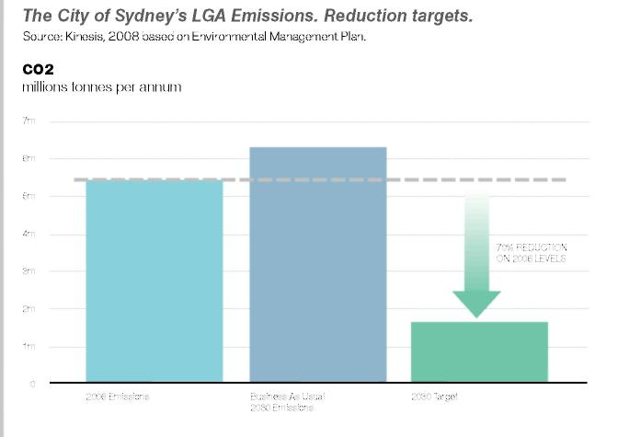

7. Appliances
A drop of 10 per cent in electricity consumption is projected through a meaningful commitment to lowering the power use of major and minor appliances in the home and office, including standby electricity consumption. The introduction of a policy of minimum energy performance standards would eventually affect all buildings.

8. Car parking strategies
Though current City planning controls do not require any parking to be provided, in new developments, on current trends, all new multi-unit residential buildings will have 1.1 car park spaces per dwelling. Under the 2030 Vision, effective alternative transport options will enable a 40 per cent reduction on this allocation would lower energy consumption for lighting and ventilation in car parks.

9. Housing strategies
Savings will flow from an increased inner-city population. Based on transport patterns remaining the same, for each person living in the City instead of the wider Sydney metropolitan area produces savings of 1.5 tonnes of carbon dioxide from lower transport emissions, especially private car use.

THE KYOTO PROTOCOL
The Protocol, established in 1997, is a legally binding international plan to:
- Reduce greenhouse gas emissions
- Set targets for industrialised countries to reduce their pollution, and
- Establish an international emissions trading system

The Protocol includes a major program, the Clean Development Mechanism, to allow developed countries to invest in clean energy and emissions reduction projects in the developing world, and use the emissions reductions to help meet their domestic targets.

The first commitment period for emissions cuts runs from 2008 to 2012, and targets for post 2012 are currently being negotiated.

The graph below shows how the proposed strategic actions will individually and collectively achieve emission reductions by 2030.
Source: Kinesis, 2008 based on Environmental Management Plan.

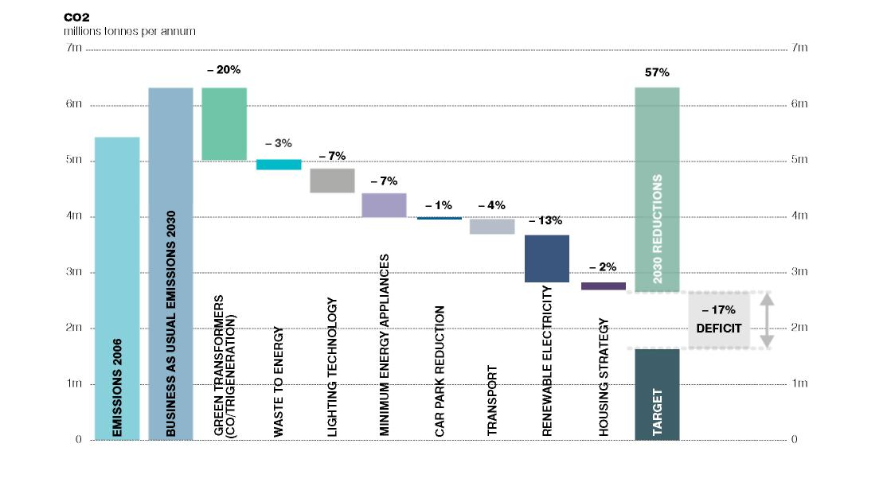

Five Big Moves

Transforming the City

Embodying the aspirations set by the community in the 2030 consultation, the big moves of the 2030 Vision are intended to “remake the City” into one that is green, global and connected.

The Big Moves will secure Sydney’s future growth prospects while improving its attractiveness and liveability. They will ensure the sustainability of the City environmentally, socially and economically.

BIG MOVE 1
A REVITALISED CITY CENTRE AT THE HEART OF GLOBAL SYDNEY
Lively, people-friendly and premium business centre reconnected to the harbour.

BIG MOVE 2
AN INTEGRATED INNER SYDNEY TRANSPORT NETWORK
New sustainable transport connecting Inner Sydney the City Centre and the City’s Villages, with congestion removed from the City Centre and Villages.

BIG MOVE 3
A LIVEABLE GREEN NETWORK
Continuous green corridors integrated with liveable streets, providing dedicated pedestrian and cycle ways and new ways to explore the City and its Villages.

BIG MOVE 4
ACTIVITY HUBS AS A FOCUS FOR THE CITY’S VILLAGE COMMUNITIES AND TRANSPORT
Sustainable places for communities in the City’s distinctive Villages to meet, create, learn, work and shop.

BIG MOVE 5
TRANSFORMATIVE DEVELOPMENT AND SUSTAINABLE RENEWAL
Initiatives to re-make the City, including energy and water efficient infrastructure, affordable housing, high quality public space and design and access to essential transport choices.

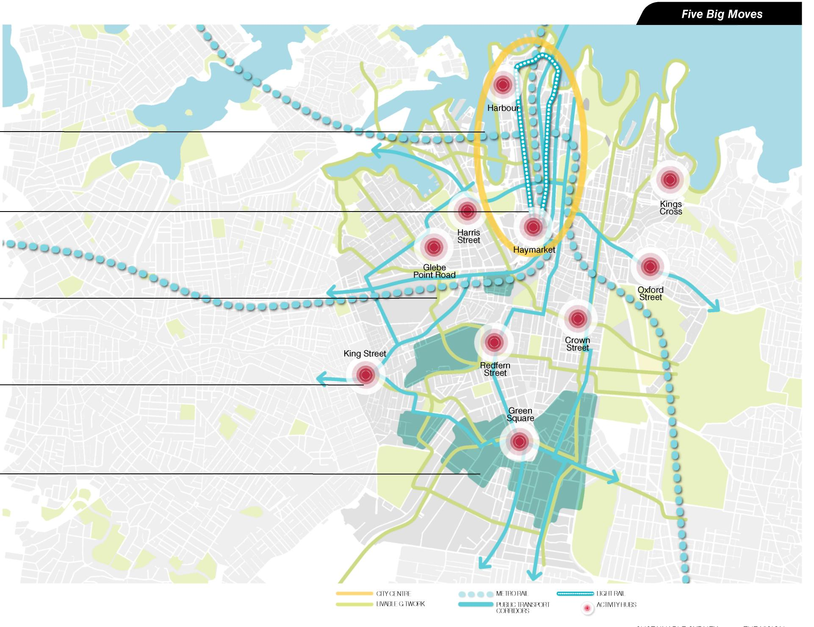

Big Move 1 A revitalised City Centre at the heart of global Sydney

A lively, people-friendly global business centre, reconnected to the waterfront.

The City Centre is a hub of cultural, tourism, business and retail intensity.

1. Revitalised City Centre

The Opera House, the Bridge, the Harbour and night skyline have iconic status. Reinforcing Sydney’s prestigious role in the life of the nation means providing a continuing sense of delight and surprise as people live, work, visit and walk through the City.

Successful contemporary cities are alive and inviting by day and by night. They offer art, design, culture and entertainment, attractive public spaces and workplaces, great shopping experiences and easy access. A series of initiatives under the 2030 Vision will work together to revitalise Sydney’s City Centre focusing on building on the existing tourism, cultural, retail, residential and public domain experiences offered in the City Centre.

The Public Spaces, Public Life Sydney recommendations by renowned Danish Architect Jan Gehl, as adopted by the City as part of the 2030 Vision, offer strategies to improve the design of the public domain, make the City more inviting and easier to move around. The liveability of the City Centre is of critical importance to achieving the future economic growth targets of the Metropolitan Plan for Sydney and the Sustainable Sydney 2030 Vision.

The redevelopment at Barangaroo provides the opportunity to accommodate commercial growth and to create a sustainable new City precinct at the harbour’s edge.

The creativity needed to support a dynamic economy is dependent on the interaction and connection of creative people, on a stimulating environment, on affordable accommodation and access to invigorating work, production and event performance spaces.

The City Centre will be walkable, not dominated by cars, attractive around the clock and unique for making easy connections to one of the world’s great harbours.

- New waterfront and more space for global Sydney
- Stronger City Centre economy and tourism through precinct and cluster development
- Distributed green infrastructure
- A central spine and three major squares to provide a focus for public life in the City Centre
- High quality light rail loop to easily get around the City Centre
- Revitalise and reclaim the western edge of the City Centre to create new public spaces and residential, visitor and business uses
- ‘Fine grain’ retail, hospitality and mixed-use precinct west of George Street
- A cultural ribbon from Darling Harbour to Bennelong Point and Macquarie Street
- Sydney’s Indigenous story and culture acknowledged and celebrated
- Green zones and pedestrian-friendly streets

Big Move 2: An integrated Inner Sydney transport network New sustainable transport connecting Inner Sydney, the City Centre and the City’s Villages, with congestion reduced.

2. Integrated inner city transport network

Sydney 2030 provides an opportunity for integrated transport renewal on a major scale. Inner Sydney needs better transport connections into the City and between Activity Hubs and Villages.

The City wants to work in partnership with government and others to develop and implement new sustainable transport initiatives.

Major public transport routes are at capacity and it can be difficult to move efficiently around the City. Congestion inhibits economic development and private vehicle use is a major source of green-house emissions. Buses and taxis are impacted by congestion and make pedestrian movement and cycling unpleasant and sometimes dangerous.

A sustainable and integrated transport network requires planning for the right mode of transport in the right place with easy transfer and suitable, accessible pricing.

- An integrated Inner Sydney transport strategy
- Public transport corridors
- A cycle network
- The City Centre light rail loop
- Town Hall transport plaza
- Northern and southern interchanges
- Community transport
- Parking strategy
- Managing parking and cars in the City of Sydney

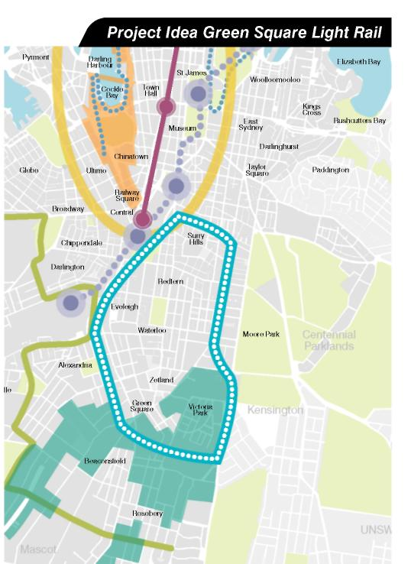

"Rethinking transportation is essential, we need to dramatically change the way people move about, the 50 years of cheap gasoline is over." Jan Gehl. Gehl Architects

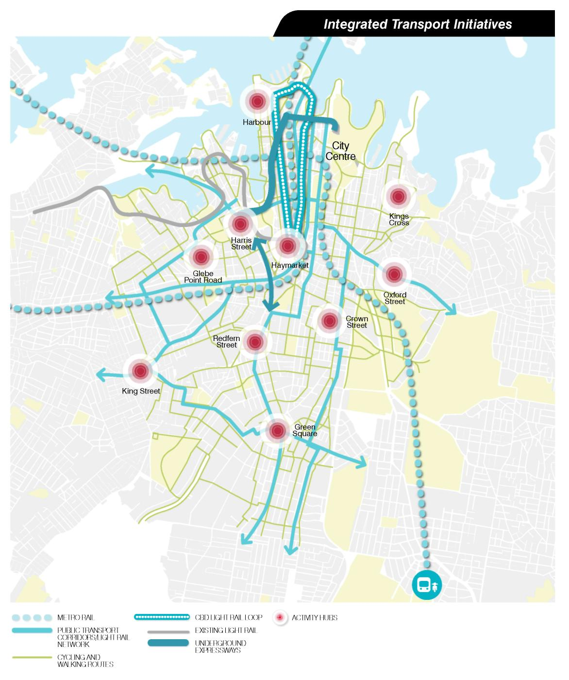

Sustainable Sydney 2030 Vision for Transport Initiatives

1. Integrated Inner Sydney Transport Strategy
- Establish the right transport modes for the specific needs of existing and future travel in Inner Sydney.
- Co-ordinate the plan across Inner Sydney Councils and with State and Federal Governments, including advocacy for essential infrastructure funding.
2. Public transport corridors
- Identify nine corridors connecting the City Centre with the villages and other Inner Sydney areas. These corridors should contain more sustainable, higher volume a frequent public transport services, including surface light rail or underground metro line
- Ensure all corridors link to the City Centre light rail loop and regional public transport connections.
- Ensure a cross- regional corridor connecting Green Square to the East and Inner West.
- Ensure corridors from the City Centre to:
  - Green Square and Rosebery
  - Oxford Street and Bondi Junction
  - Victoria Road
  - Glebe and Parramatta Road
  - Pyrmont and Glebe
  - King Street Newtown
  - Redfern and Botany Road
  - Inner North
3. Implement the cycle network
- Develop the current strategy to create a comprehensive, high quality cycle network that is safe enough for children to use.
- Give priority to separated, dedicated cycle lanes.
- Work with Inner Sydney Councils to introduce a public bicycle transport system for every day, easy cycling.
- Integrate bike hire nodes with transport interchanges and Activity Hubs, as well as shopping, entertainment, work and cultural opportunities.
4. Advocacy for regional transport connections
- Ensure that the capacity of the transport network to support travel to the City Centre from across the Sydney region is increased. Support the planning and early implementation of metro rail lines.
- Support the existing and proposed upgrades to the heavy rail network.
- Integrate new stations with commercial and retail development and develop as transport interchanges.
5. Support and plan for a City Centre light rail loop
- Improve access in the City Centre with a high frequency north - south light rail loop connecting with Barangaroo, Circular Quay and Central Station.
- Integrate the City Centre light rail loop with key radial public transport corridors through efficient public transport interchanges.
- A new light rail loop could provide the opportunity to remove the monorail which adversely impacts on the quality of the pedestrian experience.
- Plan for attractive walking links and quality signage between the new loop and wider transport routes across the City and metropolitan Sydney.
- Plan for interchanges at Central, Town Hall and Circular Quay to enable people to move easily in a north and south direction.

Green Square Light Rail
A key focus of the Vision is the need for an integrated high volume public transport mass transit system. There is a need to connect the City Centre area to Green Square, as this area has a growing population. The City of Sydney proposes a Green Square light rail connection for funding by State and Federal Government as part of infrastructure improvements for Inner Sydney.
6. Investigate and plan for Town Hall transport plaza
- Create a mid-city transport plaza along Park and George Streets, catering for links to east-west and north - south public transport routes, minimising the need for bus and vehicle access across the City Centre.
- Give priority to light rail, cycling and pedestrian activity, while ensuring the interchange plaza is integrated with commercial, retail, entertainment and cultural activities to create a lively City precinct.
- Provide for an upgraded Town Hall Station and possible new train station at Park and Pitt Streets to accommodate new underground metro rail or heavy rail.
7. Northern and southern interchanges
- Develop high quality transport interchanges in the north and south of the City Centre, linked with the metro rail stations and the City Centre light rail loop, to minimise the need for buses to enter the City Centre.
- Integrate the two transport interchanges to create connections to pedestrian and cycle connections to pedestrian and cycle networks, and opportunities for bicycle hire and care share pods.
- Integrate the interchanges with commercial, retail, entertainment and cultural activities to create lively City precincts.
8. New Links
- Realign Regent Street to Harris Street with an underground connection off Darling Drive, making an easy link to the Cleveland Street intersection, south of Central Station.
- Investigate the potential for a small park and link to Frasers Broadway.
- Reduce traffic on Abercrombie Street; transform Wattle Street to a park road and Harris Street to a liveable, main street.
- Reduce traffic on Botany Road to promote liveable, main street use and encourage traffic to use O’Riordan Street and Wyndham Street.
9. Provide community transport
- Provide services for people experiencing transport disadvantage across the City, including older people and people with a disability.
- Build on existing shuttle bus routes provided by the City to address gaps in the existing transport links between Villages and Activity Hubs.
10. Parking strategy
- Reduce existing parking as new public transport infrastructure and services are provided.
- Establish planning policies that enable some existing public and private parking structures to be designed in a way they can be converted to alternative uses over time.
- Establish policies and pricing mechanisms for car parking that support and fund green transport.
- Develop options for encouraging energy efficient vehicles, car-pooling, trading schemes for car parking in new development spaces for car share, and parking rates linked to accessibility to public transport and services.
11. Plan to underground the Western Distributor
- Reduce the need for cars to travel unnecessarily on surface roads through the City Centre by establishing better connections between existing roads.
- Remove the Western Distributor foyers and replace with a connection to the Cross City Tunnel and Darling Drive.
- Explore connecting Darling Drive to Broadway and / or Cleveland Street through a tunnel and connecting Darling Drive to the Anzac Bridge approaches on the western side of Pyrmont.
12. Cahill Expressway
- Improve public amenity at Circular Quay and reduce vehicles travelling through the City Centre.

Big Move 3 A liveable green network

Continuous green corridors linked with liveable streets, dedicated pedestrian and cycle •ways and new ways ■ to explore the City and its Villages.

3. Liveable Green Network

The liveable green network is made up of streets and lanes with pedestrian priority. Ten green corridors are proposed across the City linking the villages and hubs to provide safe and attractive paths.

The “Connected City” is an aspiration of large City economies dependent on the mobility of people, products and ideas.

Jan Gehl’s Public Spaces, Public Life Sydney Study of the City Centre made a series of recommendations to transform the City Centre into a hub for pedestrians and cyclists.

To be a truly “Connected City” people must be able to get around easily and meet face to face as well as have access to the vital road, air and rail transport systems that link them with other major centres and global cities.
Separate cycle paths, shaded footpaths, streets lined with trees, reduced vehicle flows are all hallmarks of the green corridors that will invite people to walk and cycle.

2030 provides the framework for turning the balance away from a private to a genuinely public city. Ken Maher Chairman Hassell

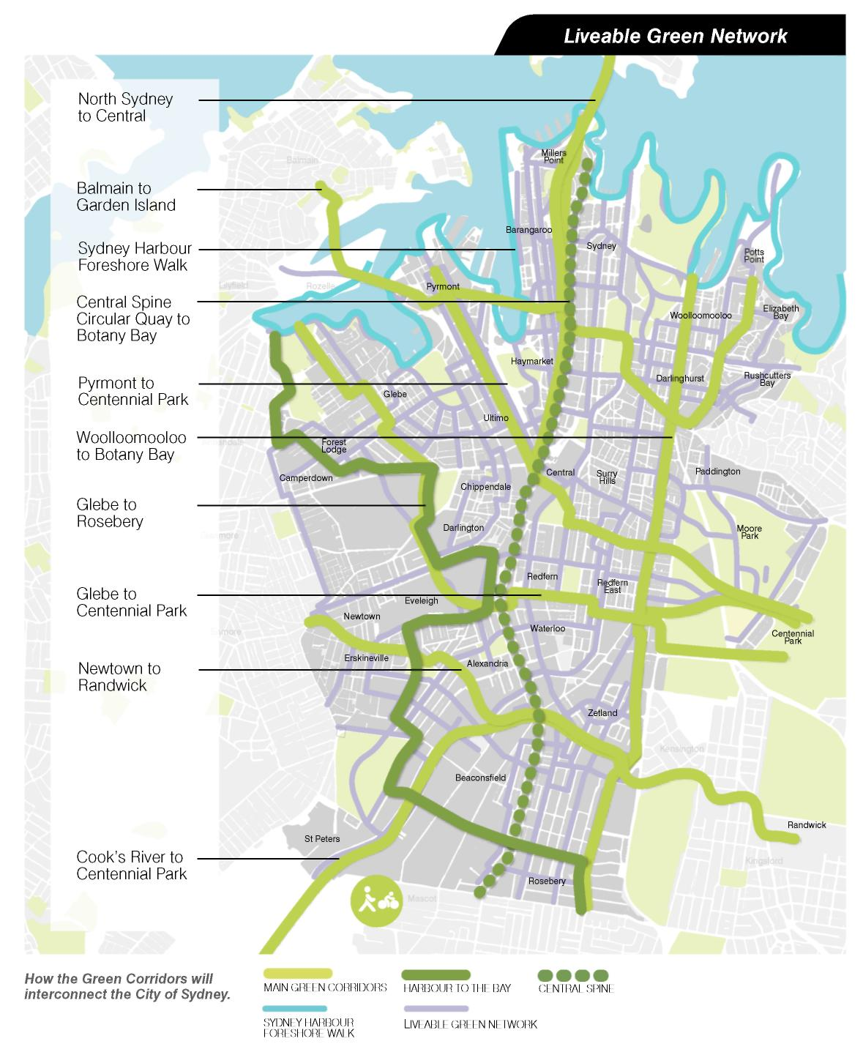

Sydney Harbour Foreshore
- Provide Sydneysiders and visitors with a continuous 15 kilometre foreshore walk from Glebe to Rushcutters Bay connecting many of the City’s cultural attractions and destinations such as the Fish Markets and the Circular Quay weekend markets.
- The walk will link with the City Centre, the Cultural Ribbon and Eora Journey Indigenous cultural interpretation walk of City landmarks, from Mrs Macquaries Chair to Redfern.

Circular Quay to Botany Bay
- Provide a north-south spine connecting the harbour to the bay and the City Centre to Botany, along George Street and Botany Road.
- This spine will have a pedestrian focus with dedicated cycle and public transport facilities and may over the long-term have sections with no private vehicular traffic.
- All green corridors will cross or meet this ‘central spine’ providing a network of alternative paths to move around and enjoy the City.

North Sydney to Central
- Provide a cycle and pedestrian link to join the two halves of Global Sydney, North Sydney and the City Centre.
- This route is already heavily used by walkers and cyclists and could be further improved.

Woolloomooloo Bay to Botany Bay
- Provide a corridor to connect the north and south of the City via Bourke Street.
- This will also link through to Green Square and other areas in the south.

Balmain to Garden Island
- Provide a corridor to connect Balmain and Woolloomooloo to the City Centre and the other corridors across the City.
- Balmain has the potential to be within walking distance of the City Centre. The Glebe Island closure provides the opportunity to investigate a lightweight bridge across the eastern end of White Bay direct to the main centre of Balmain, resulting in a direct connection across to Pyrmont.

Pyrmont to Centennial Park
- Link the Harbour at White Bay to Centennial Park from Central Station to reinforce the station’s role as a City Centre transport hub.
- This will provide connections to Harris Street, a liveable main street, Ultimo Activity Hub, Powerhouse Museum, ABC studios, Sydney Institute of Technology, University of Technology Sydney, Central Station, the ridge of Surry Hills to Centennial Parklands and Fox Studios and beyond to the eastern beaches.

Glebe to Centennial Park
- Provide a link from the Harbour at Jubilee Park, along Glebe’s main street to the Glebe Activity Hub, University of Sydney, Carriage works, Redfern’s liveable main street and Activity Hub.
- Connecting the Eastern Suburbs and Centennial Parklands sports and recreation facilities to Redfern and the Inner West.

Glebe to Rosebery
- Provide a connection from the Harbour to Rosebery following Orphan School Creek.
- It will link up with activities at Jubilee Park, Camperdown Hospital site, Royal Prince Alfred Hospital, Sydney University, Carriage works, Australian Technology Park, Erskineville Park, Ashmore Precinct, Sydney Park. Also to provide access to future long-term renewal investigation areas around the Alexandra Canal through to Rosebery, connecting to the Central Spine and Centennial Park corridors at Redfern Activity Hub.

Newtown to Randwick
- Provide a southern city connection from the Inner West to the Eastern Suburbs and beaches.
- It will connect Newtown, through Erskineville, to Green Square along the Green Square Boulevard and water channel beneath Southern Cross Drive to Kensington and the University of New South Wales.

Cooks River to Centennial Park
- Connect Cooks River and Botany Road to Green Square, Centennial Park and beyond to the Eastern Beaches.
- It will create a green corridor along the tributary channels of the Alexandra Canal that over the long-term could be investigated for mixed-use residential and business activities.

"Quiet streets, shops, art galleries, links to institutions, workplaces and homes could all be on the walking and cycling journey of the green network." Rod Simpson Simpson+Wilson Architecture+Urban projects

"The future of Sydney is a pedestrian-oriented future." Rachel Neesom Neesom Murcutt Architects

Big Move 4 :Activity Hubs as a focus for the City’s Village communities and transport

Places for people to meet, be part of their community, to shop, work, learn and be creative.

4. Activity Hubs as a focus for the City's Village

Future sustainability means essential local services need to be in walking distance, with convenient public transport to the City Centre and other Villages.

Ten Activity Hubs would provide a focus for doing business, healthcare, taking transport, shopping, meeting people and having cultural and learning experiences.
The 2030 Vision builds on the work of creating eight Village Hubs as part of the Local Action Plans developed in 2007 in partnership with local communities.
It also proposes two new Activity Hubs—Harbour (Hickson Road) and Green Square—to join:
- Crown Street
- Kings Cross
- Oxford Street
- Redfern Street
- Harris Street
- Glebe Point Road
- King Street
- Haymarket

The Activity Hubs are places with distinctive and diverse character around key community main streets.

ACTIVITY HUBS

Core
Transport interchange/hub
Business hub
Primary school
Library
Community space
Learning centre
Wi-Fi hotspot
Childcare
Health/medical
City of Sydney service centre/ shop-front
Fresh food (market)
Bike parking, showers and lockers
Public spaces

Support
Recycling centre

Community garden
Business hub
One-stop governance shop (including other government services)
Car share pod
Cultural live sites
Workshops/studios
Secondary school
Places of worship

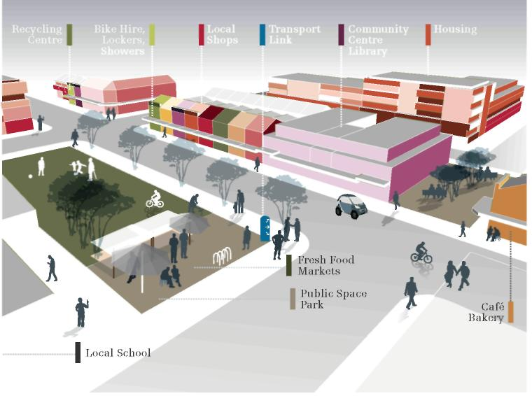
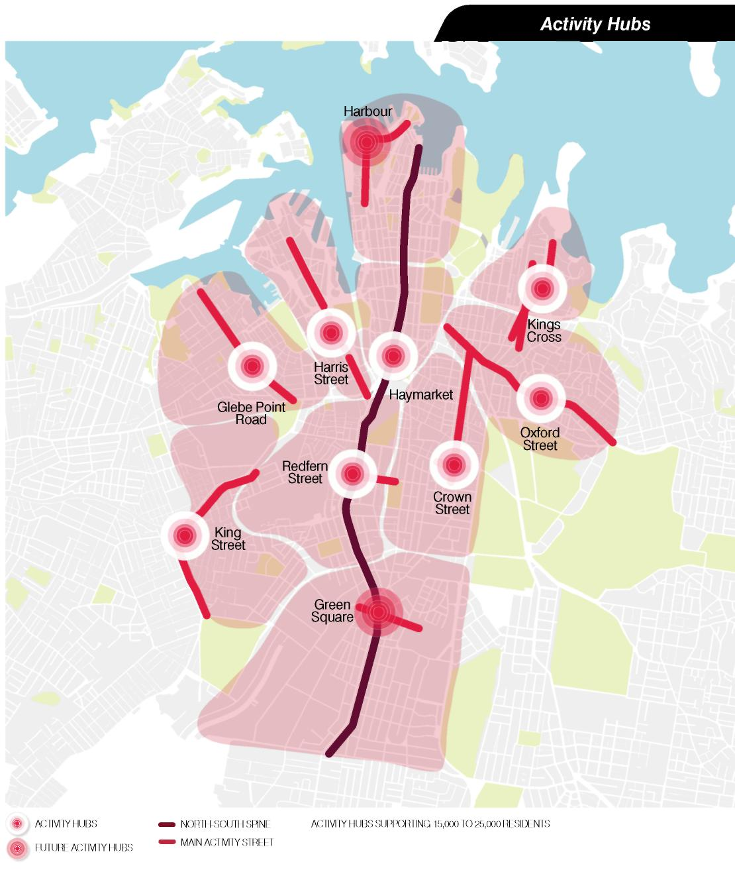

Activity Hubs will better recognise the economic role of the key job centres outside the City Centre and nurture the conditions for further development. Core elements of an Activity Hub include transport interchange, primary school, business centres, library, community space, childcare, Wi-Fi hotspot, fresh food market, bike parking, health and medical, City of Sydney service centre and a range of optional activity centres, dependent on local character and need.

Crown Street
- Develop the Crown Street civic hub around Shannon Reserve and the new library and community centre.
- Identify fresh food market opportunities.
- Investigate opportunities for mixed-use renewal of Redfern Mall/Surry Hills Shopping Village at the corner of Cleveland and Crown Streets.
- As part of Council’s economic development program, support creative industries and start-ups in nearby ‘SOGO’ (south of Goulburn Street) by encouraging adaptive re-use of existing warehouse buildings and ground level activation in SOGO.

Kings Cross
- Support Kings Cross as a key entertainment and tourist destination, including planning for a range of accommodation, while recognising and protecting its important residential character.
- Renew the public square around Fitzroy Gardens and El Alamein Fountain.

Oxford Street
- Retain and support the precinct as the historic centre of Sydney’s gay lesbian, bisexual and transgender communities as part of precinct and economic development planning.
- Promote a mix of retailing along Oxford Street and side streets, ranging from start-ups to boutique tenants through the City’s Economic Development Strategy.
- Transform Oxford Street into a liveable main street.
- Identify fresh food market opportunities.
- Develop as a cultural, creative and safe precinct through precinct management strategies.
- Partner with Woollahra Council on the Hub concept.

Redfern Street
- Support Aboriginal and Torres Strait Islander business, training and cultural initiatives, including an Australian Indigenous Cultural Centre, as called for in Indigenous consultation.
- Continue the revitalisation of Redfern and Regent Streets.
- Investigate business opportunities for creative and new cultural activities such as markets, studios and performances at nearby Carriage Works, as a focus of economic and cultural development strategies.
- Pursue fresh food market opportunities at Carriage Works.
- Encourage Redfern Park for sports and recreation focus.
- Encourage low cost and affordable housing for the Aboriginal and Torres Strait Islander community near Redfern.
- Improve walking links and business opportunities for the Redfern community at Australian Technology Park and Eveleigh Railway Workshop precinct.

Harris Street
- Support the expansion of enterprise clusters of culture, media and education.
- Transform Harris Street into a liveable main street and promote mixed-uses around Fig Street.
- Consolidate civic, social and community facilities around Ian Thorpe Aquatic Centre and Community Centre, with Hub focus on the Powerhouse forecourt area.
- Develop student housing for University of Sydney, Sydney Institute of Technology and University of Technology Sydney.

Glebe Point road
- Pursue further ‘dual use’ opportunities for Glebe Public School to enable broad community to access the school’s open space and facilities.
- Create connections to affordable housing site, Blackwattle Bay and the new foreshore park.
- Identify fresh food market opportunities.
- Create walking links and stronger community connection with the University of Sydney.

King Street
- Support local arts, creative and live music through the City’s economic and cultural development strategies and grants programs.
- Partner with Marrickville Council to investigate options for improving the public spaces and links to Newtown Station, Australia Street and Newtown Square.
- Provide access to Newtown Station from Erskineville Road and integrate Erskineville Road with the King Street Activity Hub.
- Work with local residents, businesses, artists and community and cultural groups to develop a community and creative hub, retail or fresh food market in the station precinct.
- Support affordable housing for artists and students.
- Work collaboratively with Marrickville council to support Newtown as a cultural and creative hub.
- Integrate adaptive re-use and redevelopment of Newtown Tram Sheds into the Activity Hub.

Haymarket
- Build on Haymarket’s proximity to Central Station and Belmore Park in planning for the redevelopment of Central Station precinct.
- Continue to celebrate Sydney’s Chinese communities through extension of support initiatives like Chinese New Year.
- Improve pedestrian connections to George Street and World Square and improve access to the open space around Darling Harbour.

Green Square
- Promote Green Square as an exemplar of sustainable development.
- Develop as a residential and employment area. Introduce an economic development strategy to support development controls to attract and support emerging environmental, creative and knowledge oriented industries. Replicate the small business and residential mix of Surry Hills.
- Ensure substantial social community and cultural infrastructure is delivered upfront and acts as a catalyst for further development.
- Encourage investors, designers, owners and occupiers to add diverse character similar to that found in the City’s existing Villages.
- Provide a variety of employment spaces and residential building types.
- Provide substantial contribution to the 2030 target of increasing access to affordable housing.
- Improve access from Rosebery to the Green Square Activity Hub and maintain long term options for an additional Hub on Botany Road to support growth and change in this corridor.

Harbour
- Ensure sufficient residential development to support a new Activity Hub at Barangaroo, north of the main commercial office precinct.
- Include affordable housing.
- Develop the Activity Hub to service new residential development, and the established Millers Point, Rocks and ‘north’ City centre communities.
- Encourage a focus for cultural activities around Walsh Bay, and a foreshore connection between Circular Quay and Darling Harbour, and investigate opportunities for the regional cultural infrastructure project as a Hub catalyst.

Big Move 5 Transformative development and sustainable renewal

Initiatives to re-make the City, including energy and water efficient infrastructure.

Sydney has significant areas for future renewal that are outside the City of Sydney’s direct planning control. The 2030 Vision proposes strategic directions to guide and influence the shape of these major redevelopment sites within the City.

The current redevelopment of the former Carlton and United Brewing site on Broadway by Frasers will exemplify 2030 sustainability objectives.
It will introduce a world leading approach to carbon neutral energy supply and sustainable water use and waste management; reuse of historic buildings and design by leading Australian and world architects.

The City’s response to the sustainability challenge means redevelopment of Barangaroo at East Darling Harbour, Green Square and sites around Redfern and Waterloo, including Australian Technology Park, can now be guided by the broad sustainability principles and strategic directions of Sustainable Sydney 2030.

These and other key renewal sites provide immediate opportunities to plan for collective and innovative approaches to energy generation, waste treatment and affordable housing.

They also provide people-oriented development—new public domains, housing and work places that are accessible to and inclusive of everyone.

An $800 million concept plan proposes to transform the former Carlton and United Breweries (CUB) brewery site into a vibrant new precinct with office space, apartments and a 5,400 square metre community park. This replaces a 5.8-hectare disused industrial site on the western edge of the Sydney CBD, close to Central Station.
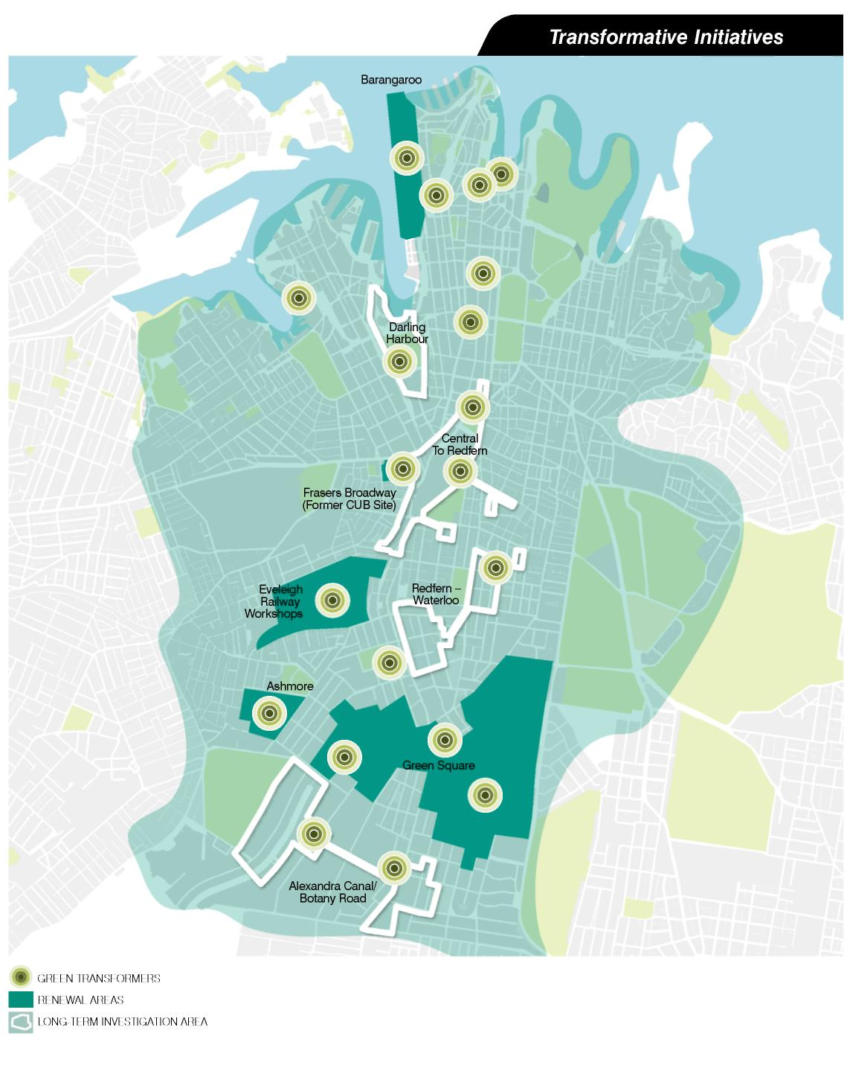

10 Strategic Directions

The City had a “conversation” with thousands of workers, residents and students— this combined with extensive research by Sydney's leading planners, architects, thinkers and designers led to the 10 Strategic Directions.

- A globally competitive and innovative city
- A leading environmental performer
- Integrated transport for a connected city
- A city for pedestrians and cyclists
- A lively engaging city centre
- Vibrant local communities and economies
- A cultural and creative city
- Housing for a diverse population
- Sustainable development, renewal and design
- Implementation through effective partnerships

Framework for action: 10 Strategic Directions for a Sustainable Sydney

Each Strategic Direction reflects aspirations and qualities that the City must build on. The City of Sydney cannot achieve the Vision on its own. A share of the proposed actions need to be supported and led by other agencies and stakeholders.

Direction 1: A globally innovative City

Keeping Sydney globally competitive is central to Sydney’s and Australia’s future. The City must focus on the global economy and sustained innovation to ensure continuing prosperity.

City Context

- The City is an acknowledged global city with natural assets, a strong economy and globally competitive businesses
- The City Centre is at the heart of Global Sydney as identified in the Metropolitan Strategy
- A globally competitive City is critical to Australia’s economic prosperity
- A globally competitive City expands opportunities for residents, business, workers and the broader society
- Reversing slow and ineffective adjustments to a sustainable economy
- Responding to the next wave of globalisation
- Boosting innovation © developing effective partnerships © dealing with looming macro-economic imbalances
- Increasing interstate and global city competition
- Intensifying global competition in service industries

Why Action is needed

- Reversing a lack of investment in strategic economic infrastructure and amenities
- Responding to inequality, affordability and social stress
- Accelerating investment in green economy and technology

ACTION/PROJECT IDEA:WESTERN EDGE

A revitalised western edge of the City Centre

Sydney’s global and national economic focus will be reinforced by extending the commercial core to connect the City Centre with Barangaroo, positioning Sydney—and Australia—for the next wave of global economic development. This development must be supported by improved transit, pedestrian movements and cycling connections.

The “fine grain” parts of the city will increasingly become desirable destinations for shopping, leisure and urban living, supporting the global economic focus
The concept explores a more sustainable future for Darling Harbour—transformed to parklands supporting an expanded residential community—once the current buildings reach the end of their useful life and need upgrading.
See page 132.

The consultations undertaken for Sustainable Sydney 2030 recognised that an outward looking, globally oriented city is important.

What the community said: people want a city...

“ that is globally connected”
“ that attracts investment and workforce”
“ of diversity, a world recognised innovation hub, with housing and employment opportunities for a wide variety of people”
“ that is an international gateway city to Asia”
“ that is a globally renowned culture hub for arts, music, food, architecture”
“ which is an international destination for tourists”
“ that has global impact”

OBJECTIVE 1.1
Plan for growth and change in the City Centre.

CITY NOW
- Constraints on future capacity to accommodate new jobs in the City Centre.
- Insufficient recognition of the characteristics and activity clusters in city precincts.

CITY IN 2030
- The City Centre is reinforced as the heart of Global Sydney.
- Sufficient capacity is available to accommodate growth of globally oriented economic activities.

ACTION 1.1.1 Ensure the City Plan provides capacity for employment growth in the City.
ACTION 1.1.2 Ensure the City of Sydney’s economic development strategies strengthen the economic roles of the City Centre precincts.
ACTION 1.1.3 Plan for long-term increased development opportunities and improved connections to the Western waterfront.
ACTION 1.1.4 Advocate for a new foreshore precinct at Barangaroo with a lively waterfront parks, boardwalks, cafes, culture and entertainment.
ACTION 1.1.5 Establish a Precinct Management Team to work with landowners, businesses and other stakeholders to strengthen precincts.
ACTION 1.1.6 Establish development strategies in the precinct west of George Street to activate the street level with cafes and retail and upper floor apartments and small workplaces, in the European tradition.

OBJECTIVE 1.2
Strengthen globally competitive clusters and networks and develop innovative capacity.

CITY NOW
- Insufficient knowledge about Sydney’s competitive attributes and industry clusters.
- Lack of a formal networks and cluster development strategy.

CITY IN 2030
- Strategies and actions for cluster development based on a strategic vision.
- Industry and activity clusters developed through stakeholder partnerships.

ACTION 1.2.1 Investigate the establishment of the ‘Sydney Partnership’ with the private sector, research and educational institutions.
ACTION 1.2.2 Develop the City’s strategic economic development and research capabilities.
ACTION 1.2.3 Foster economic collaboration and knowledge exchange with other national and global cities.
ACTION 1.2.4 Foster industry networks in a selected group of high growth globally competitive industries.

OBJECTIVE 1.3
Plan for global city support functions.

CITY NOW
- Lack of coherent direction for critical City support area in City’s south.
- Uncoordinated planning for airport and port activities.

CITY IN 2030
- Sufficient development potential for Global City support activities is available.
- Areas in transition to residential and other uses are well planned and support public transport.
- A robust planning and governance framework for the areas around the Airport is established.

ACTION 1.3.1 Undertake precinct and structure planning in the southern mixed use employment area.
ACTION 1.3.2 Work with partners to prepare a planning and development framework for managing the impact of airport growth.

OBJECTIVE 1.4
Develop innovative capacity and global competitiveness.

CITY NOW
- Underutilised location links between education providers.
- Underdeveloped relationships between education institutions and creative and innovative capacity.

CITY IN 2030
- A physically and technically linked City. A City with a strong ‘innovative milieu’.

ACTION 1.4.1 Support local community economic development and continuous learning
ACTION 1.4.2 Identify, develop and support the creation of innovation precincts across the City, for example at Ultimo-Pyrmont Education and Cultural precinct.
ACTION 1.4.3 Support the growth of the Australian Technology Park (ATP) and precincts.

OBJECTIVE 1.5
Strengthen business competitiveness.

CITY NOW
- Many businesses are mobile.
- Insufficient opportunities for active business leadership.

CITY IN 2030
- Costs kept competitive with other cities.
- More opportunities for business leadership in the City Centre.

ACTION 1.5.1 Undertake continuous improvements to approvals and licensing processes.
ACTION 1.5.2 Develop mechanisms to strengthen business leadership in the City Centre.

OBJECTIVE 1.6
Enhance tourism infrastructure, assets and branding of the City.

CITY NOW
- Unfulfilled tourism promise.
- Fragmented marketing and branding of Sydney.

CITY IN 2030
- Effective partnerships for delivering world-class tourism and cultural infrastructure and amenities are established.
- Consistent branding for Sydney backed by the State Government and the City of Sydney.

ACTION 1.6.1 Work in partnership with the Tourism Industry and State Government to develop visitor facilities and attractions, including new hotels and accommodation opportunities.
ACTION 1.6.2 Work towards a single marketing organisation— Global Sydney—as a partnership between industry and other governments.
ACTION 1.6.3 Develop strategies to assist visitor orientation and movement around the City.

Direction 2 A leading performer

The City of Sydney has adopted ambitious greenhouse gas emission reduction targets and will work towards a sustainable future for the City’s use of water, energy and waste.

City Context

- The City of Sydney has adopted ambitious greenhouse emissions reduction targets in response to mounting evidence of a warmer, more unstable climate
- Global warming is the most important urban management issue for the City in the 21st century effective action is required across a number of fronts
- All levels of government, the private sector and the community have a vital role

Why action is needed

- Stabilising emissions to maintain an acceptable global climate ensuring the City can cope with the impacts of rising sea levels and increased flooding
- Reducing the unsustainable growth in energy, water and waste resource demands ensuring the City has greater energy security

ACTION PROJECT IDEA: GREEN TRANSFORMERS CONVERTING ENVIRONMENTAL TARGETS TO REAL CHANGE
The City of Sydney aims to reduce its dependence on coal-fired electricity, and shift to low carbon energy and sustainable water supplies to and beyond 2030.
The City of Sydney will facilitate the development of Green Transformers— infrastructure hubs which will reinvent the supply of energy and water in the City.
These systems could be installed in a number of configurations in urban renewal areas and existing residential and commercial areas. Green Transformers will lower greenhouse gas emissions, reduce potable water consumption, and guarantee a level of self-sufficiency for the City.
See page 186.

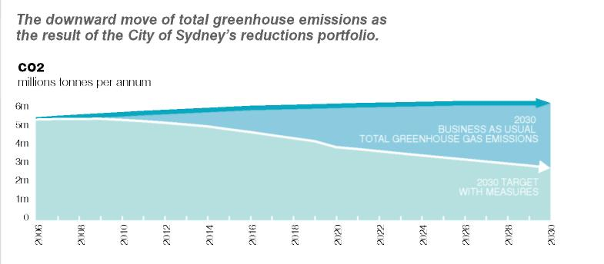

The consultation undertaken for Sustainable Sydney 2030 consistently highlighted that the community’s environmental concerns focus heavily on climate and water issues. By and large most stakeholders are aware of their own responsibilities, but are unsure about which tier of government is responsible for addressing these issues.

What the community said: people want a city...

“ with car free areas”
“ where activities are close to transport”
“ with public transport I to easily get around Inner Sydney”
“ with user friendly and seamless transport”
“ with less traffic congestion”
“ with easy access in and around the City”
“ with one ticket to travel on all modes”

OBJECTIVE 2.1
Increase the capacity for local energy generation and water supply within city boundaries.

CITY NOW
- Reliance on centrally provided infrastructure outside of the City.

CITY IN 2030
- A network of Green Transformers in the City. Continuous improvement in resource efficiency.

ACTION 2.1.1 Prepare a Green Infrastructure Plan for the City.
ACTION 2.1.2 Investigate the development of Green Transformers.
ACTION 2.1.3 Increase the use of recycled water.
ACTION 2.1.4 Integrate Green Transformers throughout the City by using the City’s streets for reticulation.
ACTION 2.1.5 Improve environmental reporting and disclosure against published targets.

OBJECTIVE 2.2
Reduce waste generation and stormwater pollutant loads to the catchment.

CITY NOW
- Invisible drains that quickly remove water which is treated like waste.
- City generated waste is generally beyond City of Sydney control.

CITY IN 2030
- Water is celebrated and retained for re-use.
- A City that sees waste as a valuable resource.

ACTION 2.2.1 Renew stormwater infrastructure by installing water sensitive urban design in the catchment.
ACTION 2.2.2 Develop an integrated waste management strategy with other Inner Sydney Councils and identify sites for associated processing infrastructure.

OBJECTIVE 2.3
Improve the environmental performance of existing buildings.

CITY NOW
- An urban management strategy that focuses on what is easier—new development.

CITY IN 2030
- An urban management strategy that focuses on sustainable new development and retrofitting existing development.

ACTION 2.3.1 Investigate ways to accelerate retrofitting of existing buildings for better environmental performance.
ACTION 2.3.2 Investigate ways to accelerate the uptake of the Green Power purchase within the City.
ACTION 2.3.3 Extend the work of existing programs that make a positive contribution to improved resource efficiency across the City.

OBJECTIVE 2.4
Demonstrate leadership in environmental performance through the City of Sydney’s operations and activities.

CITY NOW
- A commitment to strategic environmental initiatives.

CITY IN 2030
- International recognition for environmental leadership across all areas of the City of Sydney activities.

ACTION 2.4.1 Investigate the application of carbon minimisation criteria to procurements and contracts.
ACTION 2.4.2 Investigate best practice initiatives to prepare the City for the social and other impacts of global warming, such as peak fuel impacts, storms and flooding.
ACTION 2.4.3 Work with other sectors to promote sustainable environmental industries and develop economic and educational benefits.
ACTION 2.4.4 Continue to develop and implement education and support initiatives to assist residents, businesses, workers and visitors to reduce their environmental impacts.

Direction 3 Integrated transport for a connected City.

Quality transport will be a major driver to sustainability—the City must offer a variety of effective and affordable transport options.

City Context

- Quality transport will strengthen the sustainability and liveability of the city. Sydney must be connected, accessible, easy to get to and easy to get around
- The City of Sydney has a role in advocating, sharing and presenting a sustainable vision
- Heavy rail, metro rail, light rail, bus ways, buses, ferries, private cars, motorbikes, scooters, taxis, bicycles and pedestrians all have a role in the City
- Transport to and within the City must be considered at the Sydney regional scale, the Inner Sydney scale, the city scale and the City Centre scale

Why action is needed

- Minimising greenhouse gas emissions and managing the impacts of global warming
- Maintaining economic competitiveness
- Reducing the negative impacts of congestion
- Improving health and wellbeing
- Managing the growth in freight traffic
- Matching transport to user needs
- Integrating the elements of Sydney’s transport system ensuring reliable transport supports an ageing population and people with a disability

ACTION/PROJECT IDEA: PROTECTING THE CENTRE TRANSPORT MEASURES TO SUPPORT PUBLIC LIFE IN THE CITY CENTRE

‘Protecting the Centre’ proposes innovative and ambitious measures to reduce the impact of traffic on public space and improve amenity in the City Centre.
Staged measures include a reliable, frequent and affordable light rail loop to easily get around the City Centre linked to upgraded rail stations, new metro rail lines and public transport corridors that connect Central Sydney with Inner Sydney.
This transit initiative will be supported by transport management actions to reduce the number of private vehicles in the City Centre.
See page 144.

The consultation undertaken for Sustainable Sydney 2030 highlighted the desire for a City that is connected, accessible, easy to get to and easy to get around.

What the community said: people want a city...

"with car free areas"
"where activities are close to transport"
"with less traffic congestion"
"with user friendly and seamless transport"
"with public transport to easily get around inner Sydney"
"with easy access in and around the city"
"with one ticket to travel on all modes"

OBJECTIVE 3.1
Support and plan for enhanced access by public transport from the Sydney Region to the City of Sydney.

CITY NOW
- The radial rail and bus networks perform a major role moving commuters to work in the City Centre, but the system has failed to keep pace with growth.
- The road network is congested, particularly during the weekday peaks.
- Ferries serve a niche market and have an iconic role.

CITY IN 2030
- Public transport is the mode of choice for all trips to the City from other parts of the Sydney Region.

ACTION 3.1.1 Support upgrades to the existing regional rail system and new metro rail lines.
ACTION 3.1.2 Investigate development opportunities at and around existing and new stations in proposed Activity Hubs.
ACTION 3.1.3 Improve the operation of existing City Centre stations, including their interchange role.

OBJECTIVE 3.2
Develop an integrated inner Sydney public transport network.

CITY NOW
- City residents travelling within Inner Sydney rely on a range of transport modes, and planning for this requires more sophisticated transport policy responses.
- Lack of integration between transport modes and inefficient information and ticketing systems.

CITY IN 2030
- Enhanced opportunities for Inner Sydney residents to take public transport for travel to the City Centre.
- Increased tourist and event accessibility between the City Centre, Activity Hubs and Villages.
- An accessible network for older people and people with a disability.

ACTION 3.2.1 Develop an Inner Sydney Transport Strategy.
ACTION 3.2.2 Improve integration of cross-regional public transport services, including light rail and metro rail, and the quality of transport hubs.
ACTION 3.2.3 Develop modal interchanges.
ACTION 3.2.4 Identify a network of local bus services.
ACTION 3.2.5 Develop an integrated accessible community transport network.

OBJECTIVE 3.3
Reduce the impact of transport on public space in the City Centre and Activity hubs.

CITY NOW
- Pedestrian experience in the City is poor.
- Lack of clear connections for pedestrians in the City.
- Public transport operation is constrained.

CITY IN 2030
- Active management of travel demand.
- An integrated approach to traffic management, public transport and public domain.

ACTION 3.3.1 Improve public transport circulation in the City Centre.
ACTION 3.3.2 Increase the amount of street space dedicated to sustainable transport modes and urban space.
ACTION 3.3.3 Manage car travel demand.
ACTION 3.3.4 Develop sustainable travel initiatives.
ACTION 3.3.5 Investigate transport pricing mechanisms to encourage sustainable travel.

OBJECTIVE 3.4
Manage regional roads to support increased public transport use and reduced car traffic in City streets.

CITY NOW
- The regional road network is a major part of the City’s transport system, but the amenity of some key City streets in the network is severely compromised.
- Freight is placing new demands on the City’s road network.
- Traffic congestion impedes Sydney’s economic development.

CITY IN 2030
- Innovative demand management could reduce congestion on regional road network.
- Freight demands managed to protect residential amenity.

ACTION 3.4.1 Develop a road hierarchy and management plan for major corridors.
ACTION 3.4.2 Ensure opportunities to improve amenity are provided as part of future regional road management.

Direction 4: A City for pedestrians and cyclists

A safe and attractive walking and cycling network linking the City’s streets, parks and open spaces.

City Context

- Residents of the City walk or cycle for nearly half of their average weekday trips
- People who live in the City are less likely to own a car, less likely to have a driving licence, and less likely to use a car for short trips
- Many services are local in the City, which makes walking and cycling a real option
- The relatively high residential density surrounding the City Centre suggests that within a 10 kilometre area there is a significant potential pool of people who could cycle for work and other activities

Why action is needed

- Minimising greenhouse gas emissions and managing the impacts of climate change
- Reducing reliance on traditional transport energy sources
- Maintaining economic competitiveness
- Reducing City congestion
- Improving health and wellbeing

ACTION/PROJECT IDEA: LIVEABLE GREEN NETWORK HARBOUR TO THE BAY

The Liveable Green Network is a safe and attractive walking and cycling network linking the City’s streets, parks and open spaces.

The Liveable Green Network links the Activity Hubs, mains streets, major activity precincts and the City Centre.

Streets (active main streets as well as quieter streets) and lanes in the network will have pedestrian and cyclist priority and good amenity with traffc calming and densely planted street trees.

Some streets and lanes will have the capacity to incorporate storm water treatment and accommodate the reticulation system for sustainable energy, water, district hot water and district cooling.

A potential corridor connecting the Harbour to the Bay, from Glebe to Rosebery and beyond, is shown as a Project Idea connecting the waterfront, major parks and urban activities.
See page 162.

What the community said: People want a city...

“ which is a place where people walk.”
“ with walkable streets.”
“ with ribbons of green.”
“ with public access to the harbour’s edge.”
“ with transport that spans the City in a human scale.”
“ with connections between the villages and parks.”
“ which celebrates I outdoor life.”
“ which is not clogged by cars.”
“with public access to the harbour’s edge.”

Consultation undertaken for Sustainable Sydney 2030 consistently highlighted people’s desire for a City where walking and cycling were a genuine, enjoyable and safe alternative to the car.

OBJECTIVE 4.1
Develop a network of safe, linked pedestrian and cycle paths integrated with green spaces throughout both the City and inner Sydney.

CITY NOW
- Discontinuous cycling routes which share the road space with cars.
- Disconnected green spaces with potential for greater use as cycling and pedestrian routes.
- Much loved ‘main streets’ choked with cars.
- Inner Sydney bicycle and network planning hampered by multiple agencies with responsibility.

CITY IN 2030
- A connected City.
- A City that is attractive for pedestrian movement and cycling.
- Taking action through effective partnerships.

ACTION 4.1.1 Deliver the Cycle Strategy and Action Plan and plan for an expanded network beyond 2017.
ACTION 4.1.2 Prepare design plans for a continuous foreshore path between Glebe and Rushcutters Bay and from the harbour at Glebe, to Botany Bay, Rosebery and beyond.
ACTION 4.1.3 Work with partners to develop and implement the ‘liveable network’ in the City and extend it to Inner Sydney.
ACTION 4.1.4 Continue to ensure walking and cycling facilities and networks are designed so that they are safe and meet the needs of everyone.

OBJECTIVE 4.2
Give greater priority to cycle and pedestrian movements and amenity in the City Centre.

CITY NOW
- Unrealised potential as a walkable City Centre.
- Few effective transport alternatives for short trips in the City Centre.
- Lack of information and knowledge about City Centre connections.

CITY IN 2030
- The City will be a great walkable City.
- Pedestrian movement and cycling are integrated into transport planning.

ACTION 4.2.1 Manage the road space to encourage walking, cycling and the use of public transport.
ACTION 4.2.2 Re-time traffic signals and phasing to give priority to pedestrians.
ACTION 4.2.3 Reduce the speed limit in the City Centre to 40kph to improve safety and amenity.
ACTION 4.2.4 Implement part-time or full-time road lanes and street closures where outdoor activities can be encouraged.
ACTION 4.2.5 Improve directional signs and education about pedestrian networks in the City Centre.
ACTION 4.2.6 Implement a public bicycle scheme.

OBJECTIVE 4.3
Promote green travel for major workplaces and venues in the City.

CITY NOW
- Insufficient end-of-trip facilities for cyclists and pedestrians.
- Tax and other salary incentives favour cars over public transport, pedestrian movement and cycling.

CITY IN 2030
- City of Sydney facilities provide ‘end of trip’ facilities for walkers and cyclists.
- Employers offer a range of incentives to encourage walking and cycling.
- The tax system actively encourages walking and cycling.

ACTION 4.3.1 Establish or improve end of trip facilities to encourage walking and cycling.
ACTION 4.3.2 Require Green Travel Plans for major development.
ACTION 4.3.3 Provide bike parking, showers and change facilities for walkers and cyclists at approved City of Sydney buildings.
ACTION 4.3.4 Establish and encourage incentive programs for employees who take sustainable transport to work.

Direction 5 A lively, engaging City Centre

The City Centre's (international iconic status will be maintained and ' enriched with an inviting streetscape and vibrant public spaces.

City Context

- The City Centre has a unique natural setting
- It has special significance for Indigenous Australians
- The City Centre contains a positive legacy of open spaces, a street network, heritage and landmarks
- The City Centre’s iconic status needs to be preserved

Why action is needed

- Protecting the City Centre’s role as Australia’s iconic location
- Opening and re-connecting the City Centre to the water
- Reclaiming the City Centre from traffic
- Creating more and better spaces for people to enjoy the City
- Preserving and extending the City’s ‘fine grain’ — the small scale and diverse spaces providing for small retail and service tenancies, set in vibrant and attractive streets
- Increasing life on the street
- Creating a more diverse and mature night time culture

ACTION/ PROJECT IDEA: THREE CITY SQUARES LINKED CITY SQUARES FOR PUBLIC LIFE

A new north-south ‘central spine’ with priority for public transport, cyclists and pedestrians is proposed. This would transform George Street as the City’s premier street, linking City Squares at Circular Quay, Town Hall and Central Station.
The City Squares will be activity, service and civic hubs for the City Centre communities of residents, workers and visitors.
The linked City Squares will be active public spaces for large public gatherings and celebrations with improved transport connections and interchange.
See page 138.

The consultation undertaken for Sustainable Sydney 2030 revealed how attached the people of the City are to the City Centre. They acknowledge that it is the focus for business, cultural and recreational activity. They want to see its status preserved.

What the community said: people want a city...

“ which lifts the spirits”
“ which celebrates outdoor Sydney”
“ that provides new public access to the harbour’s edge”
“ which has a human scale”
“ with well planned public transport”
“ which has a distinctively urban identity”
“ where public spaces invite people to pause ' and contemplate, where public space invites humanity”
“ not clogged by cars”
“ that is beautiful”
“ that tells its history”
“ where people walk”

OBJECTIVE 5.1
Strengthen the City’s public domain identity and create more places for meeting, rest and leisure.

CITY NOW
- Lack of distinctive streets. Lack of open space network. Dominated by noisy and polluting traffic.

CITY IN 2030
- A strong City identity—a central north-south spine linking major public squares.
- An inviting streetscape—a strong hierarchy of significant public spaces.

ACTION 5.1.1 Plan for a north-south central spine in the City Centre connecting three new squares at Circular Quay, Town Hall and Central; with priority for public transport, cycling and pedestrians.
ACTION 5.1.2 Develop a public space improvement strategy to enhance streets and squares in the City Centre.

OBJECTIVE 5.2
Provide an activity focus for the City Centre worker and visitor communities.

CITY NOW
- Lack of a focus for the City’s worker, student and visitor communities.

CITY IN 2030
- The three new squares on the north-south spine are service and activity hubs for the City Centre’s communities.

ACTION 5.2.1 Prepare a City Centre Community Facilities and Programs Strategy and review the City Plan to deliver the three squares as a focus for City Centre community life with services such as childcare, libraries and information services.

Objective 5.3
Manage and strengthen precincts in the City Centre.

CITY NOW
- Insufficient variation in height and built form controls leading to overshadowed streets and insufficient protection for fine grain areas.
- Underdeveloped cultural and leisure precincts.
- Under-recognised underground life and activity for low rent spaces.

CITY IN 2030
- Fine grain protected in key precincts, for example, in the Retail Core west of George Street south of Erskine Street to Chinatown and City South.
- Cultural and hospitality precincts develop in the vicinity of cultural venues.
- Sydney’s laneways and underground spaces are part of the attraction of the City Centre and complement street life.

ACTION 5.3.1 Ensure the City Plan continues to preserve mixed uses and ‘fine grain’ development, in particular west of George Street, south of Erskine Street to Chinatown and in the City South.
ACTION 5.3.2 Undertake cultural mapping to identify opportunities for cultural, entertainment and hospitality precincts around existing venues, and facilitate by appropriate development controls, street level lighting, signage and paving.
ACTION 5.3.3 Investigate use of underground spaces for cultural venues, public art and exhibition spaces, entertainment and hospitality.
ACTION 5.3.4 Promote laneway precincts such as Angel Place.

OBJECTIVE 5.4
Increase the supply of small scale spaces for retail and small businesses on streets and lanes.

CITY NOW
- Diminishing supply of independent and specialist retailing.

CITY IN 2030
- Australia’s premier retail destination with a great variety of offerings.

ACTION 5.4.1 Prepare a retail strategy focused on expanding small scale capacity across the City Centre and reinforcing high-end shopping in the retail core.
ACTION 5.4.2 Investigate planning controls requiring new and redeveloped buildings to be built to the street edge with active, externally focused frontages for small retailing.
ACTION 5.4.3 Develop ways to encourage existing building owners to build to street edges. Fill in empty colonnades and activate blank building edges with retail activity on streets and laneways.
ACTION 5.4.4 Investigate conversion to ‘grand retail’ or ‘grand hotels’ for landmark city buildings.

OBJECTIVE 5.5
Assist appropriate small businesses to locate and thrive in the City Centre.

CITY NOW
- Diminishing opportunities for start-up or young entrepreneurs to establish in the City Centre.

CITY IN 2030
- Precinct identities and economic specialisations are developed and underpinned by a wide cross-section of businesses including start-ups and niche operators.

ACTION 5.5.1 Develop ‘City Centre Business Diversity’ criteria to attract and encourage businesses in the City Centre.
ACTION 5.5.2 Investigate the merits of a Small Business Development Fund to provide grants to businesses that meet the ‘City Centre Business Diversity’ criteria.
ACTION 5.5.3 Investigate creating City of Sydney assisted or funded business incubators.

OBJECTIVE 5.6
Support the development of diverse, new bars and restaurants in the City Centre.

CITY NOW
- An unsophisticated late night bar and hospitality culture.

CITY IN 2030
- A thriving and quirky array of ‘out of the way’ choices for late night dining, drinking and continued conversations.

ACTION 5.6.1 Establish a liquor licensing working group to monitor and assist in the implementation of new liquor licensing laws and promote the further reforms needed.

Direction 6: Vibrant local and economies

Building the sense of community and local economy by attracting and clustering innovative enterprises in the City's Villages

City Context
- The City is made up of diverse communities, with diverse lifestyles, interests and needs
- The City is made up of a ‘City of Villages’ of different character
- The Villages have an important economic and employment role in the City
- The City’s local communities and economies can be even stronger

Why action is needed
- Reducing the disparity between rich and poor—enhancing social wellbeing and relative equality
- Meeting the needs of a diverse population ensuring equitable distribution and access to social infrastructure © enhancing the distinctive character of Villages
- Providing spaces for small and local businesses ensuring all communities have

ACTION/PROJECT IDEA: New moves for Newtown Building on the Creative hub
King Street is Newtown’s great public asset and its strongest urban element— a fine-grained and sinuous retail strip that traces the ridge-line. It is a socially diverse, public promenade, serviced by two train lines (Newtown and Erskineville Stations) and multiple bus routes.

The consistent narrow frontages with relatively few large retail tenancies create a collage of interesting retail, fashion, restaurant and entertainment venues reflecting the local cosmopolitan community and its role as a regional attraction.

The future of these streets should give priority to pedestrians, enhance public space and improve the links between the railway station and Australia Street. Ideas to encourage spaces for small businesses, fresh food markets and creative activities should be explored.
See page 180.

The consultation undertaken for Sustainable Sydney 2030 consistently highlighted the community’s desire for a vibrant, inclusive, and accessible City where people feel a sense of belonging.

What the community said: people want a city...

“ with markets and cultural festivals and sports events”
“ which offers affordability and social diversity”
“ where there was a connection to the local Village”
“ with a sense of belonging”
" with diverse communities sharing together”
“for children”
“ with vibrant culture and entertainment”
“ where different Villages offer different specialties”
“ which is inclusive, fair, and affordable” 1
“ which is a place for people from all walks of life”
“ which is friendly”
“ with self-contained communities”
“ with places to eat, drink and socialise”
“ with improved small businesses in Villages”

OBJECTIVE 6.1
Maintain and enhance the role and character of the Villages.

CITY NOW
- The City of Villages concept has successfully highlighted the distinct character of the City’s local residential and commercial precincts, but needs refinement given the new context of Sustainable Sydney 2030.

CITY IN 2030
- The Villages sustain a mix of local jobs and services and each has a distinct character.

ACTION 6.1.1 Ensure that City of Sydney planning policies and programs support a Sustainable City of Villages.

OBJECTIVE 6.2
Create a network of Activity hubs as places for meeting, shopping, creating, learning and working for local communities.

CITY NOW
- Lack of identified locations for a more intense mix of activities to provide a focus for new strategic investment in established areas and support local level sustainability.
- Narrow view of the role of the City Centre as Global Sydney.

CITY IN 2030
- A recognised layer of Activity Hubs for meeting, shopping, creative activities, learning and working.
- City Centre, Villages and Activity Hubs for an integrated Global Sydney.

ACTION 6.2.1 Develop plans for each Activity Hub to support community needs, the role and future character of community life at Crown Street, Kings Cross, Oxford Street, Redfern Street, Harris Street, Glebe Point Road, King Street and Haymarket.
ACTION 6.2.2 Plan for new Activity Hubs at Green Square and Harbour (Hickson Road).
ACTION 6.2.3 Plan for development to support the core elements of future Activity Hubs.
ACTION 6.2.4 Plan for community assets, facilities and elements consistent with the future role and character of the Activity Hubs.

OBJECTIVE 6.3
Provide a rich layer of accessible community-level social infrastructure, services and programs across the City.

CITY NOW
- Social programs and services typically focus on minority group needs.
- Social planning needs to be better integrated with other aspects of the City of Sydney’s activities.
- The aspiration for relative equality in the City is poorly served by uncoordinated inter-governmental responsibilities.
- Growth pressures are putting pressure on social infrastructure.
- Community facilities are unevenly distributed across the City and some are in a poor condition.

CITY IN 2030
- Community and social planning is broad based, recognising all the dimensions that contribute to quality of life.
- Strategic social planning and implementation capacity is strong and integrated across the City of Sydney’s activities.
- The City of Sydney is a partner in services provision and multi-disciplinary programs addressing inequality, social disadvantage and homelessness.
- Specific standards and guidelines will guide facility and service provision, based on robust research and planning frameworks and public debates.
- Equitable and accessible: Community facilities are provided so that Villages and Activity Hubs are the focus for new and redeveloped facility provision.
- Integrated and innovative: The City of Sydney is a leader in new models of social infrastructure provision and delivery.

ACTION 6.3.1 Prepare a city-wide integrated communities strategy to ensure services meet local community needs.
ACTION 6.3.2 Establish partnerships and programs to improve social conditions and outcomes among particular communities.
ACTION 6.3.3 Establish standards and guidelines for the form and nature of community facilities needed to meet emerging social needs in the City, based on analysis and research.
ACTION 6.3.4 Prepare a Future Community Facilities Plan to direct investment in new or redeveloped community facilities in the Villages or Activity Hubs.

OBJECTIVE 6.4
Develop and support local economies and employment.

CITY NOW
- Unrealised potential for Villages to accommodate niche businesses, start-ups and diverse retailing.
- Role of robust local economies in global economy not sufficiently recognised.

CITY IN 2030
- Villages and Activity Hubs encourage and foster entrepreneurial spirit and employment growth.
- Villages and Activity Hubs integrated into Global Sydney.

ACTION 6.4.1 Investigate economic development strategies for Activity Hubs.
ACTION 6.4.2 Include initiatives for work and training for local unemployed and disadvantaged people in Activity Hub development plans.
ACTION 6.4.3 Investigate the establishment of a Sydney Employment Mentoring Program.
ACTION 6.4.4 Support initiatives to expand job opportunities for Indigenous people.

OBJECTIVE 6.5
Build opportunities for lifelong learning in new literacies.

CITY NOW
- Lack of opportunities to meaningfully engage with ‘new literacies’.

CITY IN 2030
- A City with command of the new literacies.

ACTION 6.5.1 Establish and promote an accessible information literacy program in every Activity Hub.
ACTION 6.5.2 Establish free Wi-Fi networks in all City libraries and ensure City libraries offer access to global communications.

Direction 7: A Cultural and Creative City

A creative life where people can share traditions and lifestyles - celebrating Indigenous culture, diversity and community.

City Context
- The City provides a platform for creative expression
- The City’s culture extends beyond the arts to lifestyle, heritage and the natural environment
- The City has a concentration of world class cultural destinations
- The City has culturally diverse communities
- Arts and cultural activities are fundamental to liveability tolerance and quality of life and increasingly to economic development
- The City has a large and growing cluster of businesses engaged in creative industries

Why action is needed
- Learning more about and celebrate Aboriginal heritage and culture.
- Supporting culture and artists for the City to enjoy a thriving cultural life.
- Supporting the cultural needs of the City’s diverse communities need to be met. encouraging and fostering innovation and creativity.
- Encouraging emerging technologies.
- Fostering cultural vitality participation and engagement.

ACTION/PROJECT IDEA
EORA JOURNEY
Pathways from the harbour to Redfern

Eora Journey will celebrate and share the story of the world's oldest living culture. In response to the ideas of the Indigenous and broader community, Eora Journey was developed by Merrima Indigenous design studio, part of the New South Wales Government Architect's Office. The Journey will be a shared and participative cultural walk from Redfern through Prince Alfred Park, Hyde Park and on to Mrs Macquaries Chair. An Indigenous Cultural Centre is also proposed along the route.
See page 150.

Cultural Ribbon
Linked to the Eora Journey, the Cultural Ribbon will be a cultural walking link around the foreshore connecting significant places and interpreting the cultural importance of those places.
See page 156.

84 per cent of City residents believe a diverse mix of people and cultures in the City is important. Residents highly value and respect Aboriginal and Torres Strait Islander cultures, with 87 per cent of City residents surveyed having this view.

What the community said: people want a city...

“ that has room for artists not just stars”
“ which has a network of cultural precincts across the City providing affordable, subsidised studio spaces”
“ where art is for everybody”
“ that celebrates artists”
“ that is cosmopolitan, vibrant and active”
“ that is a learning City”
“with soul”

Objective 7.1
Encourage the appreciation and development of Aboriginal and Torres Strait islander cultural heritage and its contemporary expression.

CITY NOW
- Insufficient connection between appreciating Indigenous culture and links to social justice and economic and employment opportunities.

CITY IN 2030
- Heritage and culture of Aboriginal and Torres Strait Islanders respected and celebrated.
- A City linked through Aboriginal culture and heritage.

ACTION 7.1.1 Develop a City of Sydney Indigenous Cultural Plan, covering Indigenous arts, public art and design.
ACTION 7.1.2 Establish a formal City of Sydney Aboriginal Advisory Group.
ACTION 7.1.3 Establish an Australian Indigenous Cultural Centre.
ACTION 7.1.4 Continue consultation and initiate partnerships to bring a new focus on the understanding and celebration of Indigenous culture in the City.
ACTION 7.1.5 Establish an Indigenous cultural interpretation trail from Redfern to Mrs Macquaries Chair.

OBJECTIVE 7.2
Support cultural activity, participation and interaction.

CITY NOW
- Sydney is recognised for its cultural energy and creativity but there are gaps in opportunities for participation.

CITY IN 2030
- Increased opportunities for cultural participation.

ACTION 7.2.1 Promote use of a temporarily unused city buildings as affordable space for artists, arts and cultural studios.
ACTION 7.2.2 Prepare an Integrated Cultural Events Strategy to identify opportunities for community-based management and programming of events in Activity Hubs, and create links with the creative economy.
ACTION 7.2.3 Use Sydney’s streets, laneways and public spaces to showcase different art forms.
ACTION 7.2.4 Prepare a Cultural Infrastructure Plan for the City that assesses future needs, and identifies opportunities for best practice delivery of cultural programs through community centres.
ACTION 7.2.5 Ensure that the use of the City’s streets and public places for busking and performance licences is accessible and affordable.

OBJECTIVE 7.3
Support the development of creative industries.

CITY NOW
- Only recent recognition of strength of creative industries.
- Lack of appropriate space for creative industries.

CITY IN 2030
- A City which fosters a globally competitive cluster of creative industries.
- A City which understands plans and provides space for creative industries.

ACTION 7.3.1 Identify the location and infrastructure needs of various creative and innovative industries.
ACTION 7.3.2 Develop creative industry and cultural precinct strategies.
ACTION 7.3.3 Establish a Creative Spaces Register to provide access to studio spaces in the City.
ACTION7.3.4 Establish a Creative Industry Forum.
ACTION 7.3.5 Develop a pilot program that encourages start-up cultural and creative enterprises.
ACTION 7.3.6 Establish active partnerships with best practice adaptive reuse heritage spaces.

OBJECTIVE 7.4
Provide cultural leadership and strengthen cultural partnerships.

CITY NOW
- Continuing challenges to sufficient investment in the City’s cultural infrastructure.

CITY IN 2030
- A leading Global City in the provision of cultural infrastructure, assets and resources.

ACTION 7.4.1 Develop a creative framework for Public Art in the City.
ACTION 7.4.2 Extend cultural mapping beyond the City Centre to inform the City of Sydney’s Cultural Plan.
ACTION 7.4.3 Foster formal partnerships with other governments to coordinate support for the cultural calendar of major events.
ACTION 7.4.4 Establish Partnerships with other governments to coordinate support cultural development.
ACTION 7.4.5 Investigate creating a centre for Sustainable Sydney in the City to showcase design, culture and the built environment as well as providing exhibition and forum space.
ACTION 7.4.6 Develop partnerships with the universities, to involve them in community cultural development and creating the Activity Hubs.

Direction 8: Housing for a diverse population

A wider range of housing so people who provide vital City services can afford to live in the City.

City Context
- The current City housing stock is growing and offers a reasonable diversity of type
- The City hosts a diverse population © Housing affordability is a major problem for many residents and for people who aspire to live in the City particularly those in lower paid service industries
- The State and Federal Governments share responsibilities for housing policy including the provision of housing for lower income households. The City of Sydney can support State and Federal Government initiatives to expand affordable housing opportunities, without accepting a mainstream role in provision or stock management

Why action is needed
- Providing an adequate supply of housing for a range of lifestyle choices and household types, including the City’s diverse communities through culturally appropriate housing ensuring that housing is available for low to middle income workers in ‘essential’ activities such as teaching, nursing, police and emergency services
- Preserving the share of public housing for very low income households and additional needs groups where access to services is good
- Addressing homelessness among groups at risk
- Improving social cohesion
- Including the City’s diverse communities though culturally appropriate housing
- Providing accessible housing, applying universal design principles

ACTION/PROJECT IDEA

HOUSING DIVERSITY AFFORDABLE HOUSING INITIATIVES

The City of Sydney has signed a Memorandum of Understanding with the State Government, committing the City and Housing NSW to work corroboratively to develop a feasibility study to provide affordable housing on a 3.6 hectare site in Glebe.

Affordable housing close to the City is needed to ensure people employed in essential services like nursing, health and teaching can afford to live close to where they work.

The City of Sydney and Housing NSW will share the strategic planning for any proposed developments, utilise existing under-used land and potentially will redevelop existing public housing. The affordable housing project will take full advantage of Federal Government initiatives aimed at increasing affordable housing.

A joint master planning process involving community consultation will develop guidelines for the affordable housing model. This initiative will efficiently utilise urban land, demonstrate best practice in environmental sustainability, excellence in urban design and architecture, high quality vibrant public spaces and encourage alternative transport solutions and minimal car use.

The project is intended to be a mix of one third social housing, one third affordable housing and one third market housing.
See page 174.

The community has expressed strong support for the future Sydney to provide affordable housing for a diverse population. In a Sustainable Sydney 2030 survey, 74 per cent of respondents agreed that affordable housing should be distributed across the City of Sydney

What the community said: People want a city...

"with housing for the homeless"
"that is respectful of diversity, cultural, religious, age, gender, sexuality and family structure"
"that offers affordability and social diversity"
"which provides affordable spaces for creative people"
"that is inclusive, fair, affordable"
"that is a place for people, that works for people from all walks of life"

OBJECTIVE 8.1
Facilitate the supply of housing by the private market.

CITY NOW
- Housing supply is not keeping pace with demand.
- The City shares control over future residential development with State Government agencies.
- Development controls and approval processes can constrain efficient supply side responses.

CITY IN 2030
- Future land supply for residential development is maximised, consistent with provision for employment uses and environmental and other objectives.
- Strong housing growth occurs in areas serviced by infrastructure.
- Ongoing monitoring and a regional response to housing demand.

ACTION 8.1.1 Address unnecessary barriers to residential development by the private market.
ACTION 8.1.2 Ensure substantial, future residential development at major renewal sites.
ACTION 8.1.3 Provide physical and social infrastructure to meet the needs of residents in a timely way.
ACTION 8.1.4 Monitor the availability of private and public land for residential development.
ACTION 8.1.5 Work with Inner City Councils and State Government to ensure a good supply of land for residential development.

OBJECTIVE 8.2
Ensure that housing developments provide a diversity of housing opportunities for different lifestyle choices and household types.

CITY NOW
- Small households and younger residents dominate in the City. Housing choice is falling.

CITY IN 2030
- The market provides diversity and caters for a range of lifestyle choices and household types.

ACTION 8.2.1 Develop and promote an Affordable Housing Strategy for Sydney and inner Sydney.
ACTION 8.2.2 Ensure the City Plan requires a mix of housing types to suit a wide range of people and a wide range of social diversity.
ACTION 8.2.3 Ensure new residential development is well designed for people with a disability or limited mobility, the elderly and is adaptable for use by different household types.

OBJECTIVE 8.3
Ensure that a substantial proportion of housing is aimed at the lower end of the market.

CITY NOW
- Pressure on low cost housing from gentrification processes.
- Loss of low cost housing stock including boarding houses.

CITY IN 2030
- The market provides a mix of housing types, including for people with low to moderate incomes.

ACTION 8.3.1 Encourage the development industry to provide lower priced housing.
ACTION 8.3.2 Ensure there are no unnecessary barriers to the supply of lower cost accommodation types.
ACTION 8.3.3 Develop a strategy to maintain a supply of boarding house accommodation in the City.

OBJECTIVE 8.4
Facilitate and promote growth in the ‘affordable housing’ sector including by Not-for-profit (NFP) and other housing providers.

CITY NOW
- Limited involvement by the NFP sector in the delivery of affordable housing.
- Pressure on low cost rental housing.
- Housing stress for low income working households.

CITY IN 2030
- The NFP sector and other providers supply housing ‘at cost’ or in some instances below cost to needy households.

ACTION 8.4.1 Support the NFP sector in providing affordable housing.
ACTION 8.4.2 Investigate an affordable housing pilot project in partnership with NFP sector and Department of Housing.
ACTION 8.4.3 Investigate the benefits and opportunities of expanding existing included zones for affordable housing to fund the NFP sector, such as expansion in future renewal areas or on all commercial developments across the City.

OBJECTIVE 8.5
Facilitate and promote growth in the social housing sector to provide housing opportunities for those with very low incomes.

CITY NOW
- Declining share of social housing.
- Concentration of disadvantage in areas of social housing.
- Risk of homelessness for vulnerable groups.

CITY IN 2030
- Social housing in its various forms maintains its share of all dwellings.

ACTION 8.5.1 Work in partnership with the Department of Housing on its public housing renewal projects.
ACTION 8.5.2 Identify and initiate social housing and affordable housing projects for people with additional needs, including people who are homeless, young Aboriginal people, and artists on low income.
ACTION 8.5.3 Advocate increased investment in social housing in the City by other governments.

OBJECTIVE 8.6
Promote partnerships and develop advocacy strategies for the delivery of housing for very low through to moderate income households.

CITY NOW
- Lack of community understanding and acceptance of housing for low income groups.

CITY IN 2030
- A pro-active role by the City of Sydney in explaining the benefits of a diverse housing stock, including housing for low income groups.

ACTION 8.6.1 Work with all stakeholders to develop models of construction and delivery of affordable housing to demonstrate how partnerships could work across the City. For example, in areas such as Glebe, Barangaroo and Redfern and Waterloo, with Sydney Harbour Foreshore Authority and Redfern- Waterloo Authority.
ACTION 8.6.2 Develop an effective communications strategy to promote the need for and benefits of housing diversity and low income housing.
ACTION 8.6.3 Ensure programs and services are in place to support people with low incomes in public housing.

Direction 9 Sustainable development renewal and design
High quality urban design will brings liveability and greater sustainability

City Context
- Good urban design contributes to the liveability of the City and plays a major role in maintaining and improving Sydney’s status relative to other cities
- While most of the City that will exist in 2030 is here now, some parts of the City will undergo significant change and renewal
- Renewal sites provide the opportunity to greatly improve the social, economic and environmental performance of the City and Sydney Region

Why action is needed
- Responding to Sydney’s changing economic circumstances ensuring renewal areas become extensions of the City integrated with the existing urban fabric
- Presenting a coherent City-wide vision to guide individual projects ensuring development controls and approvals are clear and well justified and do not add unnecessarily to the cost of renewal and development
- Recognising the role of the streets, parks and squares in public life
- Increasing the opportunities presented by renewal sites to achieve City-wide environmental targets
- Promoting a ‘fine grain’ subdivision and ownership pattern that supports mixed use, diversity and a strong identity
- Aspiring to design excellence across the City

ACTION/PROJECT IDEA

CONNECTING GREEN SQUARE

Connecting Green Square aims to ensure environmental improvements in this renewal area also improve the environmental performance of the City as a whole.

The area around the Green Square Town Centre has the potential to have the vibrancy and diversity of Surry Hills, but with the added advantage of a linked network of parks, including the major Sydney Park.

The 2030 Vision proposes the Green Square Town Centre be strengthened and supported by the addition of residential, retail and business activities and improved public transport connections. The urban design of development adjoining Green Square will adopt the fine grain character of traditional street patterns.

The Vision sees the southern part of the City as an opportunity for growth, infrastructure improvements and redevelopment over the next 20 years and beyond. It proposes a long-term approach to preserving opportunities for future development and renewing the life of the Alexandra Canal and its historic warehouse as a lively waterfront precinct, with direct links to Sydney Park, Green Square Town Centre and Moore Park.
See page 168.

Throughout the consultation undertaken for Sustainable Sydney 2030, people from local communities and business placed emphasis on the need for authenticity, diversity and sustainability in the design of existing and renewal areas.

What the community said: people want a city...

“ this is sustainable with a low-carbon footprint”
“ with humanity and a human scale”
“ with
distinctively urban identity”
“ that is
creative, edgy and gritty”
“ with design quality excellence”
“ that supports design for self sustaining buildings”
“ that is lively, thoughtful and edgy”
“ that is beautiful”
“with a soul”

OBJECTIVE 9.1
Ensure renewal areas make major contributions to the sustainability of the City.

CITY NOW
- Renewal projects are typically untested for broader sustainability and community impacts.
- Collective approaches to potential benefits not realised.

CITY IN 2030
- The City’s renewal areas are sustainability exemplars. Renewal areas meet aggressive sustainability targets. Collective solutions to achieve sustainability aims are utilised in renewal areas.

ACTION 9.1.1 Set sustainability targets for individual renewal areas.
ACTION 9.1.2 Undertake broad economic analyses of urban renewal in order to prioritise sustainability.
ACTION 9.1.3 Require key sites such as Barangaroo, Frasers Broadway, Ashmore and Green Square to demonstrate step changes in environmental performance, housing affordability, sustainable transport and reduction in car ownership.

OBJECTIVE 9.2
Define and improve the City’s streets, squares, parks and open space, and enhance their role for pedestrians and in public life.

CITY NOW
- Additional open space provision is highly constrained. The City’s streets are not sufficiently acknowledged as public space assets.
- Large areas of open space separated from surrounding residential communities.

CITY IN 2030
- A comprehensive, continuous and legible network of pedestrian-friendly streets linking parks, squares and public buildings is provided.
- New and more intense development is supported by high quality, additional open space where possible. Institutional or ‘private’ open space is available for ‘dual use’.

ACTION 9.2.1 Prepare a comprehensive Public Domain Plan to define the long-term street and lane network, location of squares and public places and open space system, initially focussing on renewal areas.
ACTION 9.2.2 Develop agreements for dual use of institutional and other open space, such as schools and universities.
ACTION 9.2.3 Undertake strategic land purchase or require dedication of land to implement Public Domain Plan.
ACTION 9.2.4 Investigate ways to increase community engagement in improving local streets and lanes such as ‘Beautiful Lanes, Green Streets’ program.
ACTION 9.2.5 Investigate further strategies to activate the public domain.
ACTION 9.2.6 Create generous channel-side open space and parkland links to Green Square along water canals.

OBJECTIVE 9.3
Plan for a beautiful City and promote design excellence.

CITY NOW
- Sydney’s ‘beauty’ threatened by poor development. Design excellence of individual developments will not necessarily result in a coherent and attractive whole. Insufficient consideration of desirable built form and street edge conditions and an over-reliance on Floor Space Ratio controls.

CITY IN 2030
- Beauty and design excellence encouraged by reference to simple rules related to scale and a move toward ‘Block Planning’ controls.
- Design excellence and strategic objectives are met through public investment.

ACTION 9.3.1 Prepare Public Domain Interface Guidelines to define desired street edge conditions.
ACTION 9.3.2 Move towards ‘block planning’, including simple building envelope controls for heights, setbacks and bulk.
ACTION 9.3.3 Develop performance-based criteria to supplement building envelope controls.
ACTION 9.3.4 Continue to protect the heritage values of objects, buildings, places and landscapes.
ACTION 9.3.5 Encourage the reuse and adaptation of heritage and other existing buildings.
ACTION 9.3.6 Work to establish competitive design processes for all public buildings.
ACTION 9.3.7 Ensure the design of major infrastructure contributes to the public domain.

OBJECTIVE 9.4
Continually improve development controls and approvals processes to minimise compliance and supply side costs.

CITY NOW
- Development controls may impact on the cost and diversity of development.
- Car parking increases the cost of development.

CITY IN 2030
- Developments in the City are carried out as cost effectively as possible.

ACTION 9.4.1 Regularly review and streamline development controls.
ACTION 9.4.2 Regularly review the development approval process for applicants.
ACTION 9.4.3 Review car parking requirements to reduce development costs and improve affordability with an initial focus on Green Square.

OBJECTIVE 9.5
Ensure new development is integrated with the diversity and ‘grain’ of the surrounding City.

CITY NOW
- New large scale development typically not integrated into surrounding City areas.

CITY IN 2030
- New development is integrated and connected into the surrounding neighbourhood.
- The ‘grittiness’ and authenticity of the City is extended into new development by providing for multiple owners and investors.

ACTION 9.5.1 Establish Development Integration Principles Guidelines.
ACTION 9.5.2 Review development controls against Development Integration Principles and Guidelines.
ACTION 9.5.3 Review current planning for renewal areas against the Development Integration Principles.
ACTION 9.5.4 Review models of delivery for major renewal areas.

OBJECTIVE 9.6
Plan for the longer term structure of the City.

CITY NOW
- Planning for future growth and change needs a longer term outlook.

CITY IN 2030
- Current planning decisions do not preclude longer term options.

ACTION 9.6.1 Identify and plan for longer term renewal areas in a City-wide, integrated way to maximise social and economic benefits.
ACTION 9.6.2 Investigate railways, including above Central Station, where the potential for entertainment, exhibition and convention facilities would benefit from co-location with Central Station.
ACTION 9.6.3 Identify development opportunities in airspace above roads, rail and other infrastructure in Darling Harbour in conjunction with long-term planning for Barangaroo.
ACTION 9.6.4 Identify renewal and regeneration opportunities in and around Department of Housing areas.
ACTION 9.6.5 Work with the Redfern-Waterloo Authority to support social regeneration and initiatives and a physical renewal of Redfern and Waterloo including exploring the potential for a new train station at Bourke Street.

Direction 10: Implementation through effective governance and partnerships

Partnerships across government, business and community; leadership in local, national and global City forums.

City Context
- The City of Sydney has a special role at the centre of the metropolitan region
- The City of Sydney has core service and regulatory roles and has a wider role as an advocate and partner with other levels of government
- The City of Sydney is in a strong financial position with an appreciating asset base
- The City of Sydney has a leadership role in forums such as the Council of Capital City Lord Mayors and the international C40 Climate Change Leadership Group

Why action is needed
- Responding to Global warming presents an urgent need to replace ageing and unsustainable infrastructure
- Increasing service and infrastructure expectations of Local Government, while effective power and control is eroded
- Tightening access to additional revenue but increasing costs
- Articulating a strategic agenda for other agencies with responsibilities in the City of Sydney
- Addressing fragmented local governance arrangements for more effective

What the community said: people want a City...

“ with a whole of government approach”
“ with local government playing a big role in community networks and connections”
“ with partnerships”
“ with simplified and transparent decision making”
“ with a Charter between levels of government”
“ with fewer authorities”
“ that takes a leadership role”

OBJECTIVE 10.1
Align corporate planning and organisational arrangements to deliver Sustainable Sydney 2030 priorities.

CITY NOW
- Local Action Plans have established a locality-based planning structure that needs further development.
- Sustainable Sydney 2030 localities not fully reflected in current organisation arrangements or in relations with State agencies.

CITY IN 2030
- City of Sydney organisation structure reflects the priorities of Sustainable Sydney 2030.

ACTION 10.1.1 Investigate and establish place making arrangements for delivery of Activity Hubs and renewal areas in accordance with the strategic directions of Sustainable Sydney 2030.
ACTION 10.1.2 Establish project and location-based partnerships with senior officers from State Government.
ACTION 10.1.3 Incorporate Sustainable Sydney 2030 principles, objectives and actions in City of Sydney Corporate Plan and in budgets.

OBJECTIVE 10.2
Give priority to community involvement, engagement and partnerships with the City of Sydney.

CITY NOW
- Strong community involvement based on diverse consultation, engagement and information strategies, with more innovation possible.

CITY IN 2030
- City of Sydney is a leader in practical and innovative strategies for partnering with the community in planning, service delivery and decision making.

ACTION 10.2.1 Maintain and extend community roles in decision-making and in current consultation, engagement, education and information procedures.

The consultation undertaken for Sustainable Sydney 2030 consistently highlighted the community’s desire for strong City leadership and new ways of thinking about governance.

What the community said

“ with a whole of government approach”
“ with partnerships”
“ with local government playing a big role in community networks and connections”
“ with simplified and transparent decision making”
“ with a Charter between levels of government”
“ that takes a leadership role”
“ with fewer authorities”

OBJECTIVE 10.3
Ensure the long-term financial sustainability of the City of Sydney.

CITY NOW
- Strong financial position but increasing costs and constrained new revenue opportunities.

CITY IN 2030
- World-class financial and asset management. Expanded revenues for identified strategic priorities for a sustainable financial footing.

ACTION 10.3.1 Upgrade and expand financial planning and asset management capability in line with best practice.
ACTION 10.3.2 Extend financial planning horizon to 10 years and beyond.
ACTION 10.3.3 Investigate special rate levies for environmental and social and economic development priorities.
ACTION 10.3.4 Review scope of existing City of Sydney operations and ensure they deliver value for money against public sector benchmarks.
ACTION 10.3.5 Establish criteria for better agreements with other governments and agencies regarding funding.

OBJECTIVE 10.4
Establish and monitor partnerships for change.

CITY NOW
- Limited City of Sydney capacity to deliver major projects of strategic interest. Many worthwhile partnerships with other agencies and stakeholders but a need for a strategic approach.

CITY IN 2030
- Expanded role for partnerships involving City of Sydney in delivering strategic projects.

ACTION 10.4.1 Establish agreements between City of Sydney and State Government for delivery against Metropolitan Strategy, State Plan and other State policy objectives.
ACTION 10.4.2 Continue work with Council of Capital City Lord Mayors and engage with the Federal Government on investing in capital cities.
ACTION 10.4.3 Review organisation capacity to establish and monitor relationships required to implement Sustainable Sydney 2030.
ACTION 10.4.4 Assess new partnership opportunities with reference to achieving the Sustainable Sydney 2030 principles and objectives.
ACTION 10.4.5 Continue to engage with other governments, inner Sydney councils and national and global cities.

OBJECTIVE 10.5
Consider innovative financing and funding approaches.

CITY NOW
- Reliance on rates and traditional revenue sources.

CITY IN 2030
- Diversified income base.
- Role as a partner or facilitator in major projects involving public private financing combinations.

ACTION 10.5.1 Expand revenues from commercial operations, property portfolio and other income generating assets.
ACTION 10.5.2 Investigate ‘capital capture’ where rezoning will increase land values and ways to share revenue.
ACTION 10.5.3Review property development levies.
ACTION 10.5.4 Work with partners to prepare a position paper on new infrastructure financing approaches such as through bonds to finance Sustainable Sydney 2030 projects.

OBJECTIVE 10.6
Review and monitor the development and implementation of Sustainable Sydney 2030.

CITY NOW
- Evolving systems for monitoring policy and service outcomes against objectives and targets.

CITY IN 2030
- New, sophisticated models and technologies for monitoring implementation against targets.

ACTION 10.6.1 Prepare a financial plan to implement the 2030 Vision, including possible State and Federal Government funding roles.
ACTION 10.6.2 Establish a monitoring and review process for the 2030 Vision, Objectives and Actions.
ACTION 10.6.3 Establish models to identify how and where Sustainable Sydney 2030 targets are going to be achieved.
ACTION 10.6.4 Adopt new digital and mapping capabilities to assist in monitoring.
ACTION 10.6.5 Review the Sustainable Sydney 2030 Vision every five years.
ACTION 10.6.6 Align the City of Sydney’s Corporate Plan, Financial Plan and Development Plans with the 2030 Vision.

OBJECTIVE 10.7
Participate in broader governance reform processes.

CITY NOW
- Lack of recent effective coordination between different levels of government.
- National sustainability and economic productivity hampered by current arrangements.
- Current Local Government arrangements hampering effective strategic planning for Sydney Region.

CITY IN 2030
- Metropolitan governance reforms enhance integrated planning and investment in Sydney.
- Strategic outcomes for sustainable urban development agreed between levels of government and incentives provided for achievements.

ACTION 10.7.1 Lead public debate on the future of local government in Sydney.
ACTION 10.7.2 Work toward a system of Federal Government funding to local Councils for achievement on agreed strategic outcomes could be delivered

10 Project Ideas: How the 2030 Vision could be delivered

- Western Edge
- Three linked City Squares
- Protecting the Centre
- Eora Journey
- Cultural Ribbon
- Harbour to the Bay
- Connecting Green Square
- Affordable Housing
- New Moves for Newtown
- Green Transformers

The City’s leading architects and urban designers applied their ideas across the City to demonstrate how future urban projects and infrastructure projects could deliver the transformation to a green, global and connected Sydney.

The project ideas propose long-term solutions to renew past development, to re-integrate parts of the City that have been disconnected and to show the potential benefits of a plan for step change renewal across the City.

The ideas acknowledge that long-term infrastructure and development needs of the City will involve commitment from all levels of government, the business community and the wider residential community.

The project ideas bring to life the 2030 Vision and offer a new view of the City by 2030.
- Western Edge of the City
- Three linked City Squares
- Protecting the Centre
- Eora Journey
- Cultural Ribbon
- Harbour to the Bay
- Connecting Green Square
- Glebe Affordable Housing
- New Moves for Newtown
- Green Transformers

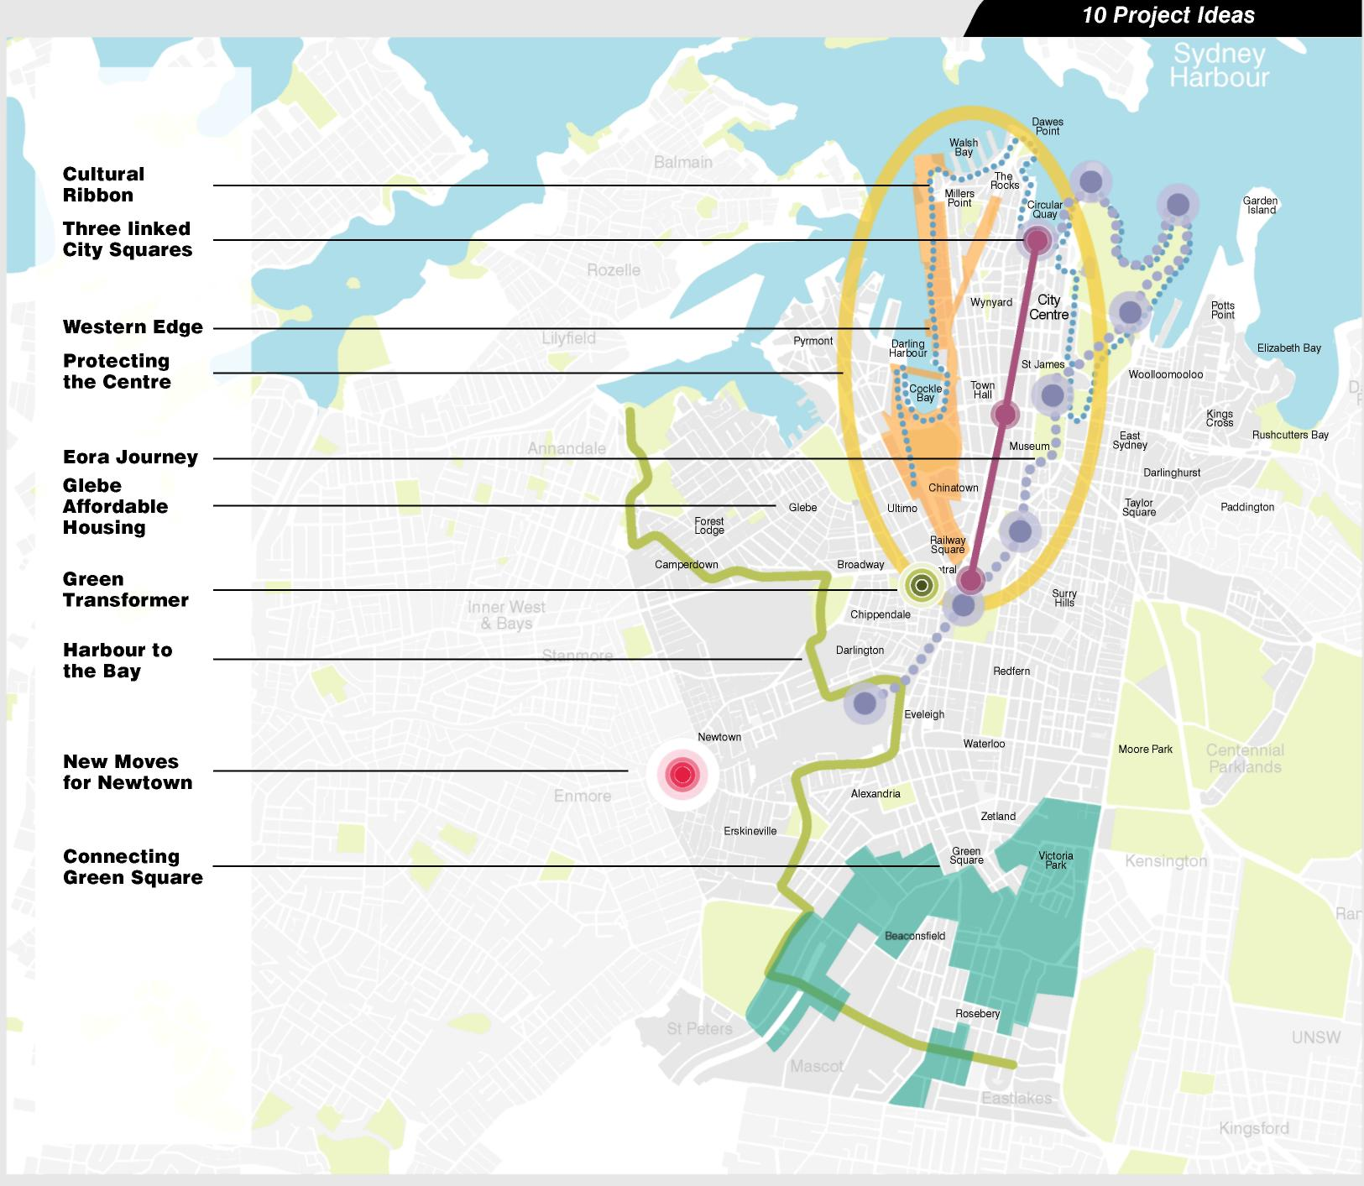

Idea 1: Western Edge
A revitalised Western Edge of the City.
The 2030 Vision places a new emphasis on the Western Edge as a place of great future opportunity.

1. Western Edge

Connecting the Western Edge of the City to the water
A series of related project ideas would integrate the State Government’s proposed development of the former wharves at Barangaroo into surrounding City areas.
Lowering the Western Distributor to ground level, or just below, and covering it would enable reinstatement of the traditional east-west connections through the City Centre.
Replacing the massive freeway with a traditional street pattern would enable the residential communities of Barangaroo and Millers Point to form a new distinctive Activity Hub with easy connections to the City Centre and the waterfront.

"It is the ordinary day to day lived urban experience of people’s basic needs that counts. Can I walk from where I live or work to a public space where I can just be rather than having to buy something? Desirable places fulfil the need for just being, enabling us to experience the moment, a chance for an encounter, a space for coincidence."
Charles Landry The Art of City Making

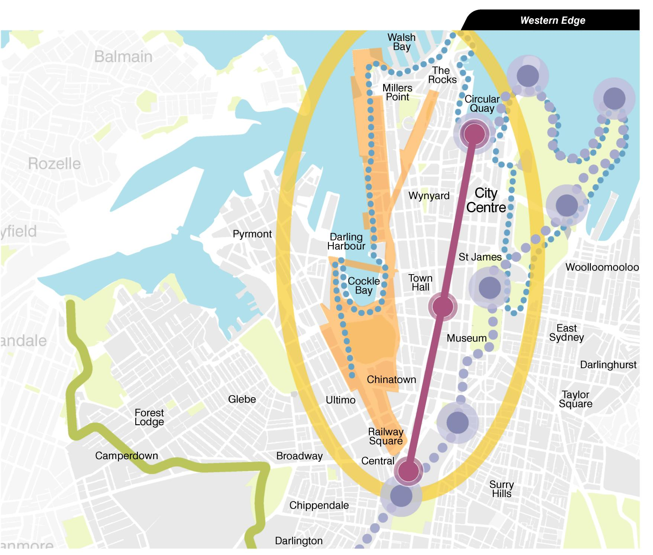

Other outcomes include:
- A variety of workspaces from large floor plate commercial development at Barangaroo offering premium office space to a new creative business precinct for retail, residential and business activities around York, Clarence, Kent and Sussex Streets. Characteristic human scale buildings, sunny streets and walking connections to the harbour.
- Integration of Darling Harbour into city life by broadening its visitor focus to a mixed community with commercial, residential and public buildings surrounding a park with a traditional street edge.
- Development controls to preserve the western precinct around Sussex Street.
- Creation of a large park at Darling Harbour with easy connections from Barangaroo, Pyrmont, Ultimo and the City Centre and a role as a new neighbourhood park. This would integrate with open space at the northern end of Barangaroo and create an enjoyable boardwalk experience from the park to Barangaroo with many connections to the City Centre.

Initial Step
- Establish a precinct management team to work with government, landowners, business and stakeholders to strengthen precincts and connections and3 expansion to the west and preserve capacity for jobs growth.
- Improved pedestrian links west from the City Centre and along the Darling Harbour foreshore.
- A new urban park 80 per cent the size of Hyde Park at Darling Harbour.
- City Centre growth with premium commercial floor-space west of the City Centre.
- A distinctive retail, residential and small business precinct west of George Street.

THE BIG DIG 1980-2007
The project to underground an elevated six lane freeway began construction in late 1991. Preliminary design started in the 1980s and final design began in the late 1980s. Substantial completion of the project took place in early 2006.
The Central Artery/Tunnel Project was owned and managed by the Massachusetts Turnpike Authority (MTA). The project was funded by Federal and State Governments.

The Problem
- World-class traffic problem.
- An elevated six-lane highway called the Central Artery that ran through the centre of downtown.
- The elevated highway displaced 20,000 residents when it was built.
- Cut-off Boston’s North End and Waterfront neighbourhoods from the downtown, limiting these areas’ ability to participate in the City’s economic life.
- A continuous economic and quality-of-life drain on Boston.

The Solution
- The Central Artery project replaced the six-lane elevated highway with an eight-to-ten-lane underground expressway directly beneath the existing road. Source: www.masspike.com/bigdig/background
- A two bridge crossing of the Charles River.
- The crumbling elevated highway was demolished and in its place is open space and eventually modest development.

The Challenges
- The Central Artery Tunnel Project was public works on a scale comparable to some of the great projects of the last century—the Panama Canal, the English Channel Tunnel, the “Chunnel”, and the Trans-Alaska Pipeline.
- The unique challenge was to construct this project in the middle of Boston without crippling the City.
- Designed to maintain traffic capacity and access to residents and businesses— keeping the City open during construction.

The Benefits
- Improving mobility.
- Reconnected neighbourhoods.
- Better quality of life.
- 12 per cent reduction in City-wide carbon monoxide levels.
- Creation of more than 105.22 hectares of open land.

Idea 2: Three City Squares

Three civic squares as outdoor meeting places on the George Street grand thouroughfare. Town Hall Square would become a new civic meeting place in the heart of the City.

Linked City Squares for Public Life
Few cities in the world enjoy a natural setting as spectacular as Sydney’s. The series of peninsulas and coves and inlets provide a unique setting for a major city with views to the water and landscape beyond.
The City Centre positioned on two hills offers constant surprises. A long narrow City Centre means short distances to cross from east to west, while moving south from Circular Quay presents more challenges.

"The traffic on George Street should be simplified and changed into a public transport street with zones for public transport, cyclists and pedestrians only."
Jan Gehl Public Spaces Public Life, 2008

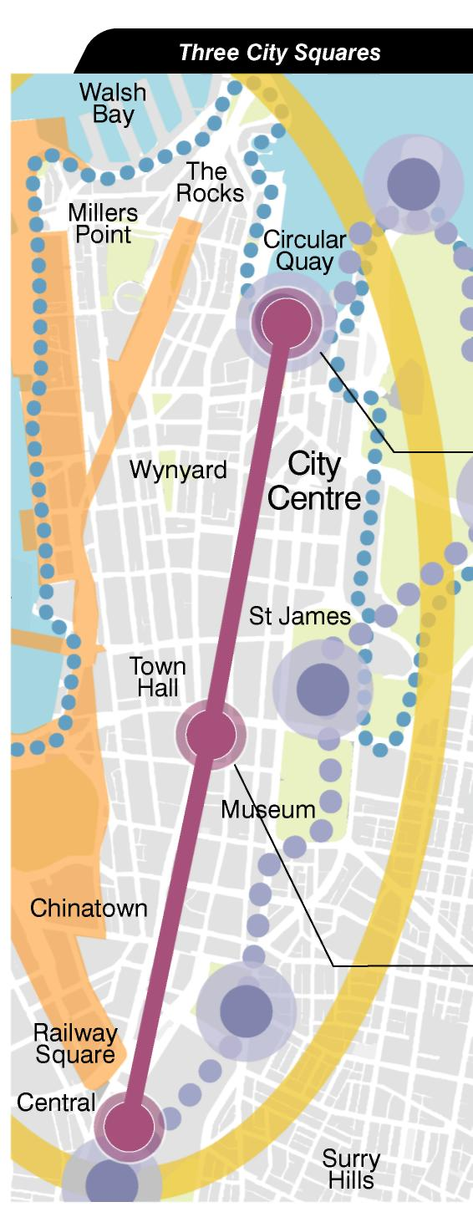

Circular Quay could be renewed as a new harbour gateway to the City with the design of a ^{RC} new public square with better access and views to the water. Customs House Square would be celebrated as a natural gathering place in a harbour City, renewing Sydney’s image nationally and internationally. Concepts for Circular Quay propose removal of the Cahill Expressway celebrating the station as an arrival and interchange to a proposed light rail city loop.

Town Hall Square is proposed as a new civic meeting place creating a civic centre in the European tradition. The plaza would be dominated by the Victorian architecture of the Town Hall, Queen Victoria Building and St Andrew's Cathedral, but new development of sustainable buildings would create a contemporary edge. Redesign of the station and light rail stop would make Town Hall Square a gateway to the southern entertainment precinct and Chinatown Hay market to the south. The square would be a focal point midway along the City’s pedestrian thoroughfare—George Street—in the centre of the City.

The George Street spine would combine sustainable transport such as light rail, walking and cycling; enliven and improve the experience of walking along George Street, while the squares would transform the public life of the City Centre.
Danish architect, Jan Gehl, in his 2008 study, Public Spaces, Public Life Sydney, proposed transforming George Street from a clogged, noisy street to a central north-south spine for pedestrians and public transport linking three major public gathering places. The idea has been developed as part of the 2030 Vision.

- Strong City Centre identity
- Priority for sustainable public transport, walking and cycling
- Reduced noise and improved environment on the City’s main street
- New gathering places in the City
- City squares as a focus for City Centre services and community development

Central Station will be re-cast as an important southern arrival gateway to the City and a place for significant redevelopment over the rail lines and around a series of redesigned public squares. Redesign of the public domain would create easy walking connections above ground to surrounding areas, including Haymarket, Ultimo, Devonshire Street and Surry Hills, Chippendale and to City South.

Through development of the airspace over the rail lines the suburbs surrounding Central Station would be reconnected through new development, with walking links following the traditional street pattern. Access by rail means future redevelopment could include major public facilities, including a Convention Centre.

Idea 3 Protecting the Centre

Rethinking the use of city streets to give priority to people, not traffic, to improve the public life of Sydney. *
To become a more sustainable city it must become easier for pedestrians and cyclists to move around the City.

3. Protecting the centre

Many of Jan Gehl’s key recommendations to protect and enhance the City Centre have been included in the 2030 Vision. They include:

- A waterfront city—increased access and views to the water
- A green connected city
- A better city for pedestrian movement and cycling
- A strong public transport city
- A traffic calmed city including 40km/h speed limits
- A strong city focal point with a central spine and three main linked squares
- An inviting streetscape with a hierarchy of significant public space
- A diverse, inclusive, accessible and lively city

To improve Sydney’s liveability, the 2030 Vision suggests a series of changes, including a reliable, frequent and affordable light rail loop to enable people to get around the city easily.

It is proposed the loop would travel along the George Street spine to link to upgraded rail stations at the three City Squares, and to new metro rail lines and public transport corridors that connect the City Centre to the Villages of Sydney.

Protecting the centre is aimed at gradually changing travel patterns, introducing “green zones” for walking and cycling, more pedestrian-only streets, fewer cars in the City Centre and fewer parked cars.

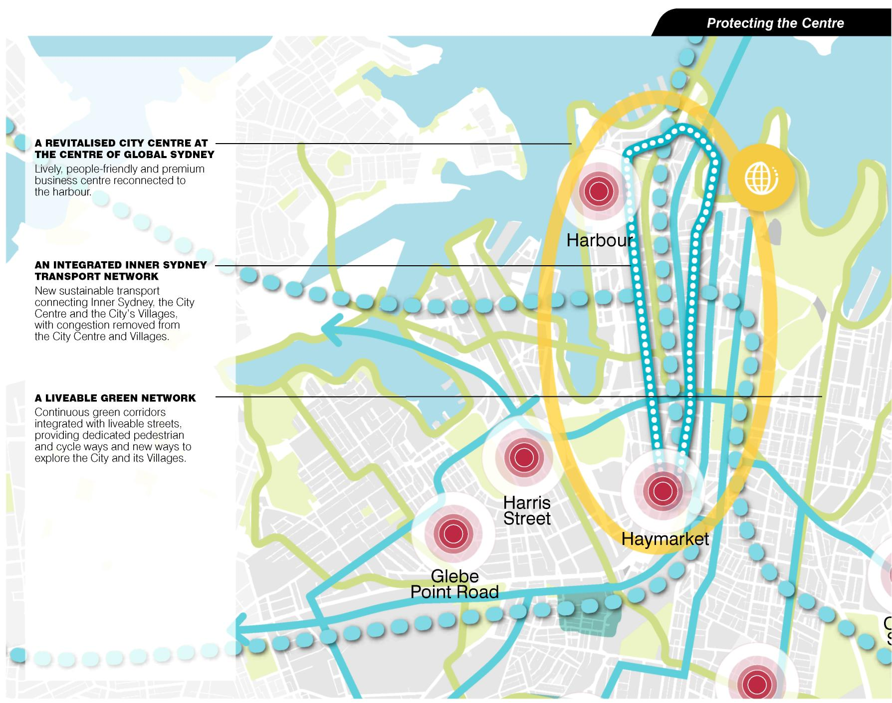

- Improved City access
- More attractive and pleasant streets
- Increased public transport options
- Reduced carbon emissions
- Improved productivity from reduced congestion delays

Case Study: Amsterdamn/Netherlands

METRO/LIGHT RAIL NETWORK THE PROBLEM
- A major exercise was needed to replace its antiquated fleet of 234 trams. Almost a quarter of the fleet was out of service at the time the order was placed and the balance were increasingly unreliable.

The Solution
- Amsterdam now has an extensive network of a combination of tramway and light rail routes.
- Amsterdam is promoting light rail as an attractive form of transport, encouraging people to leave their cars at home, and will be reviewing its performance in 2008-2009.
- A new terminal has been completed at the key interchange at Central Station, where five lines converge, and this was brought into use in June 2000.
- A new tram line opened on 31 May 2005: Line 26 from Central Station to Ijburg. This line links the centre of Amsterdam with the new housing area (40,000 people) on the artificial islands in Ijmeer. The line is 8.5km long and runs on a reserved track bed for most of the route which includes a 1.5km tunnel.
- The system is governed by multiple-aspect colour light signals integrated with the road traffic signals for the street running sections.
- Further route developments are planned including a proposed extension to Amsterdam Airport.

Idea 4: Eora journey

Eora journey will enable us all to share in and celebrate Indigenous culture.
Indigenous, knowledge, culture, history and stories will be ingrained into the public domain of the City.

4. Eora Journey

Pathways from the Harbour to Redfern
The idea of Eora Journey was developed by the City of Sydney in consultation with Sydney’s Indigenous community. Merrima Indigenous design studio within the New South Wales Government Architects Office designed the pathway concept. It was a response to the strong call from the Indigenous community and broader community to celebrate and share the story of the world’s oldest living culture through a cultural walk from Redfern to the harbour. Work has already started to establish a City of Sydney Aboriginal Advisory group to develop this project idea.

"Indigenous people want to make themselves visible to the broader community and encourage cross cultural awareness by hosting an inclusive Indigenous Festival in the centre of Sydney" Dillon Kombumerri Merrima Design

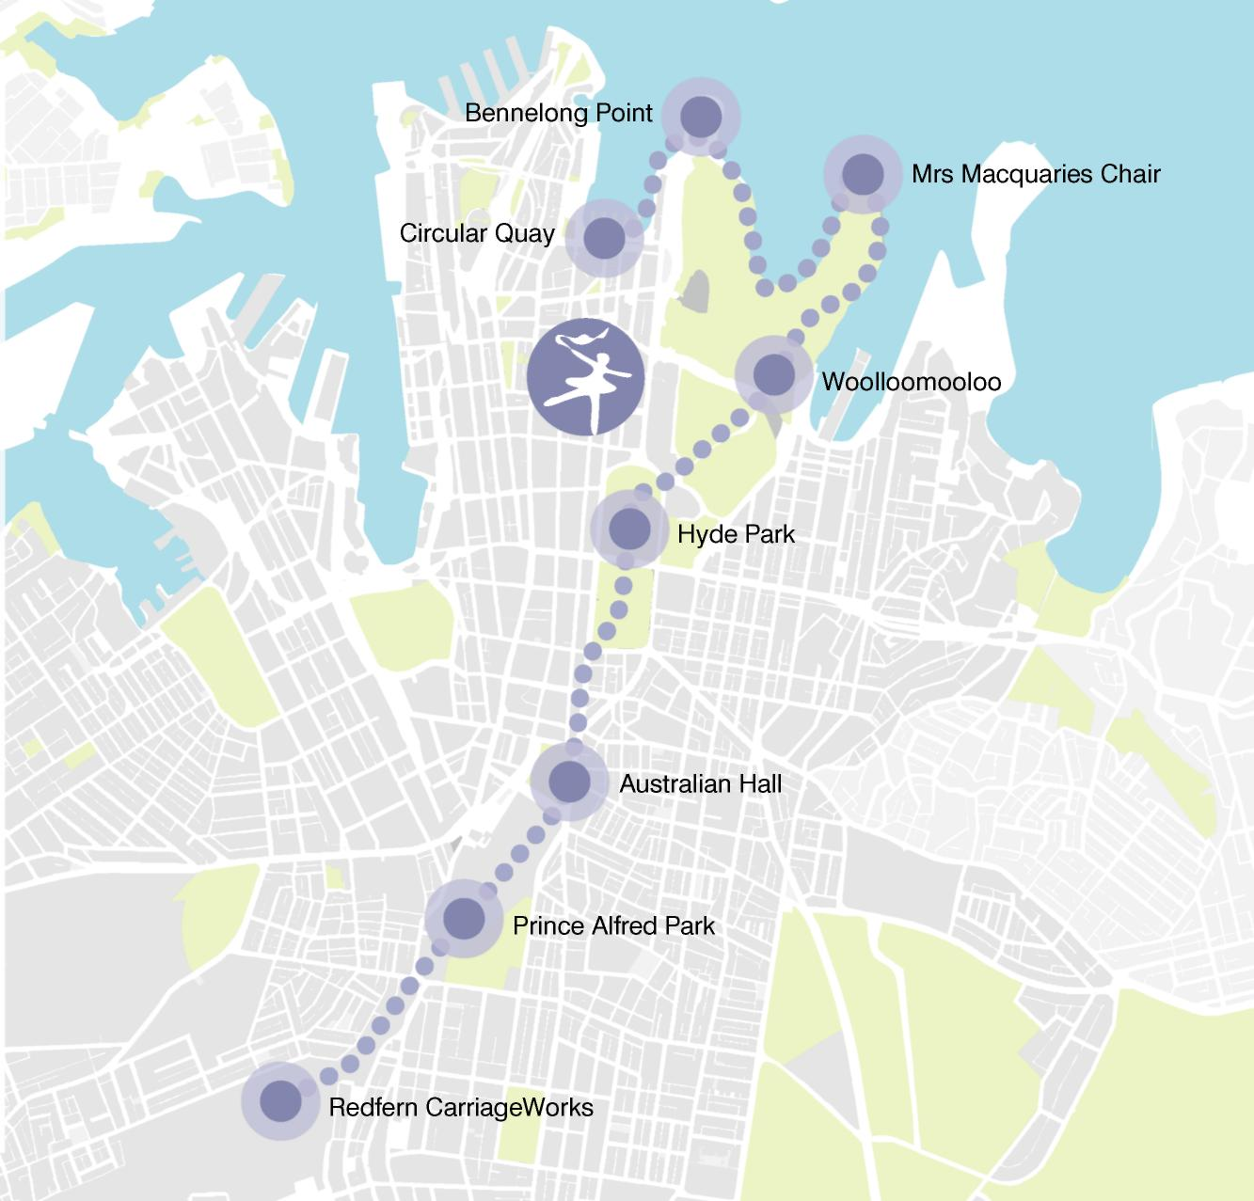

Photo Caption: The Aboriginal Cultural Centre should contain: a Keeping Place, films, art, bush tucker, talks and walks, political workshops, books, historic documents, photography, oral history, dance, boomerang throwing and cultural preservation for the current aboriginal generation especially the young.

Photo Caption: Celebration of identity and culture should be visible at all international entry and exit points.

Photo Caption: Australian Hall,150–152 Elizabeth Street, Sydney. Venue for the first national Aboriginal civil rights gathering—Day of Mourning and Protest conference on 26 January 1938.

Photo Caption: CarriageWorks is a contemporary arts space in historic industrial tram sheds.

The Eora Journey creates a participative Indigenous interpretation experience in the City via a cultural walk from Redfern to Mrs Macquaries Chair. Artworks and messages about traditional and contemporary Indigenous culture at intervals along the walk would teach and share stories.

An Indigenous Knowledge and Cultural Centre was called for by Sydney’s Indigenous community, which is seeking a place of learning, employment, cultural celebration, understanding and innovation. It will be located along the walk and will nurture cultural regeneration and cultural understanding among visitors and the Sydney community.
The detailed development of the Eora Journey and Knowledge and Cultural Centre will involve broad consultation with local Aboriginal peoples and Aboriginal and Torres Strait Islander art organisations and artists and other levels of government, and a range of initiatives—including training and education—to culminate in the Eora Journey.

- Recognising Indigenous culture
- Re-interpreting the City
- Enriches the walking network of the City
- Contributes actively to reconciliation
- Strengthens Redfern’s cultural identity
- Provides a keeping Place, archive, community gathering place and resource centre for the Indigenous community
- Creates commercial opportunities
- A hub for Indigenous people in the City to link with other Indigenous communities

Idea 5 Cultural Ribbon
The Cultural Ribbon will support the City's identity with a Sydney harbour side cultural walking trail.
Sydney will continue to offer internationally recognised, unique cultural experiences.

The cultural ribbon will link Sydney’s leading cultural landmarks along the harbour’s edge, such as The Wharf Theatre, the MCA, The Opera House, Customs House and other cultural attractions.

5. Cultural Ribbon

The cultural ribbon will focus on improved directional signage for Sydney's many cultural attractions in the City Centre and form links to strengthen and support the cultural life of the city.

The Dictionary of Sydney will provide historical stories, facts and information about Sydney as a community resource for the Cultural Ribbon.

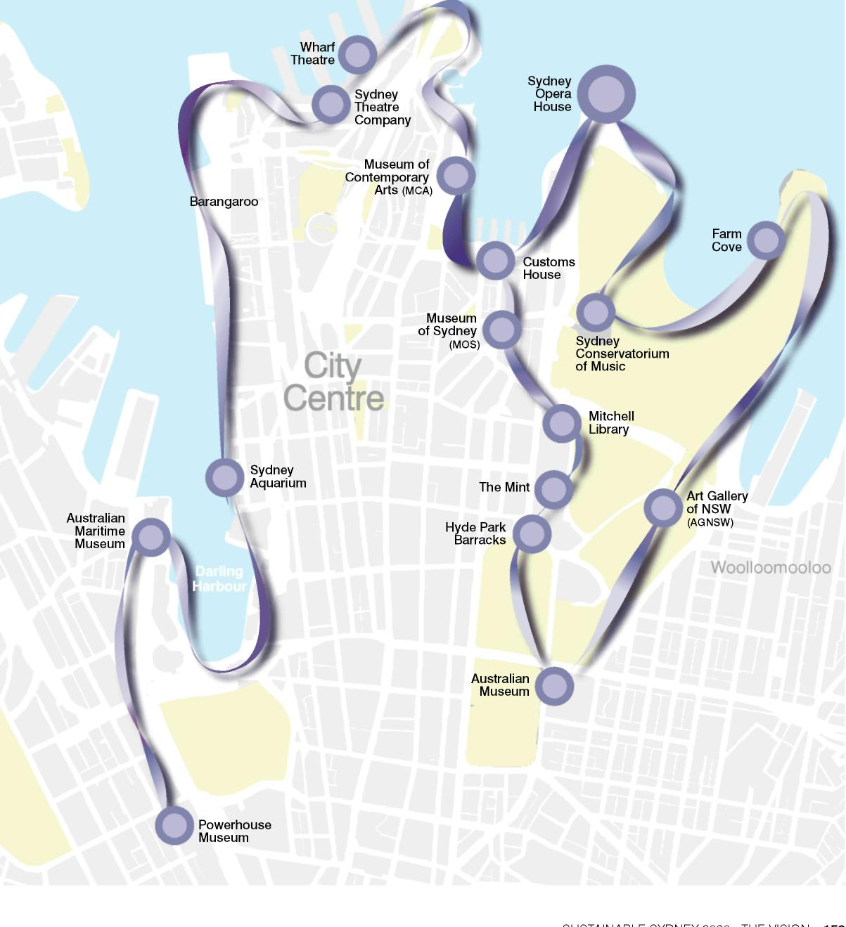

The Cultural Ribbon will identify walking trails with historic landmarks and interpretation and attractions. These include:
- Powerhouse Museum
- Maritime Museum and Aquarium at Darling Harbour
- Theatres on Hickson Road
- Sydney Dance Company
- Sydney Theatre Company
- Bangarra Dance Theatre
- Sydney Observatory
- Argyle Square and the Argyle Cut in the Rocks
- Circular Quay with the Museum of Contemporary Art; Customs House and the Opera House
- Police and Justice Museum
- Museum of Sydney
- Royal Botanic Gardens
- Mitchell Library
- The Mint
- Hyde Park Barracks
- Australian Museum
- Art Gallery of New South Wales
- Sydney Conservatorium of Music

Benefits

- Boosting Sydney’s image as a cultural City
- Building participation in Sydney cultural institutions
- Helping people find their way around the City
- Encouraging sustainable recreational activities
- Better information and interpretation of Sydney’s rich history and culture for visitors and tourists
- Reinforces equity, connectedness and social wellbeing

Idea 6: Harbour to 'the Bay'

The liveable green network will be a comprehensive network of safe, attractive and leafy paths across the City.
The 2030 Vision aims to transform Sydney into a cyclist and pedestrian-friendly City.

6. Harbour to the 'The Bay'

Ten main pathways have been proposed for further investigation to create the green network. They aim to allow people to move easily around their neighbourhood from Village to Village, between major attractions and cultural institutions and the universities, the City Centre and the lively Village main streets.

The design of the Liveable Green Network is intended to encourage walking and cycling as the preferred mode of travel.

When the City is undertaking work on the Liveable Green Network it will take opportunities to incorporate storm water treatment and accommodate the reticulation system for sustainable energy, water, district hot water and cooling.

To support the Liveable Green Network, the City of Sydney Council will ensure cycling and walking amenity is integrated into development.

Harbour to the Bay
A potential 12.6 kilometre corridor connecting the Sydney Harbour to Botany Bay, from Glebe to Rosebery and beyond, linking the waterfront, major parks and major City destinations. The corridor would be designed to ensure safe crossing at major intersections, minimise waiting times and provide easy access to public transport.

Main green corridors
- Sydney Harbour Foreshore
- Circular Quay to Botany Bay
- North Sydney to Central
- Woolloomooloo Bay to Botany Bay
- Balmain to Garden Island
- Pyrmont to Centennial Park
- Glebe to Centennial Park
- Glebe to Rosebery
- Newtown to Randwick
- Cooks River to Centennial Park
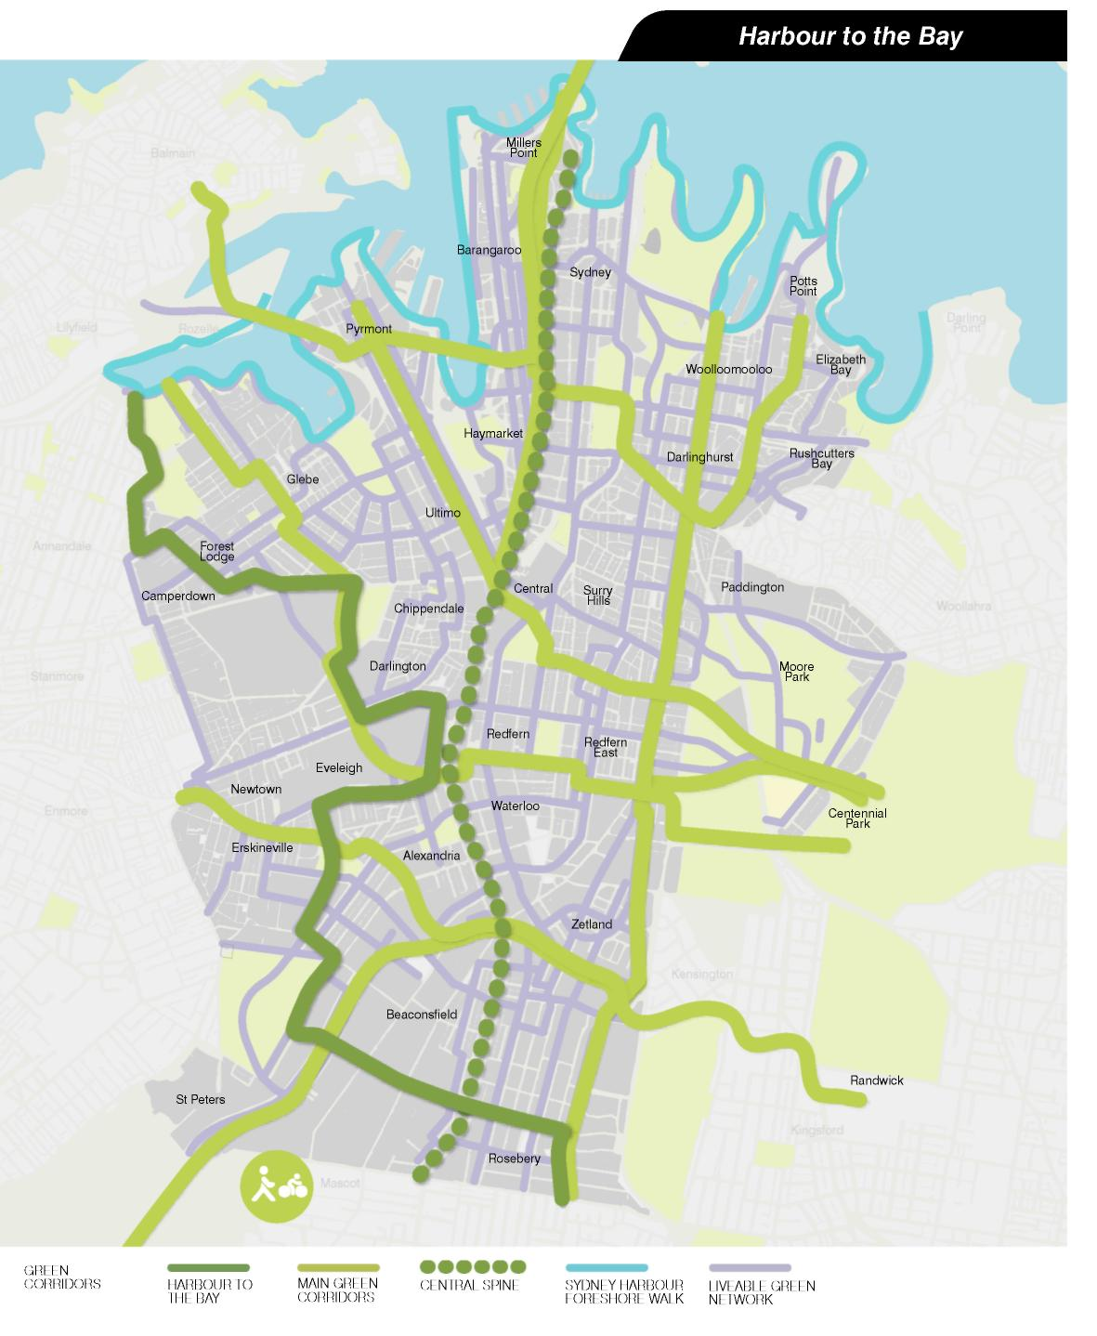

- Reduced carbon emissions through less car use
- Encouraging an active lifestyle to improve community health and wellbeing
- Reduced carbon emission through tree-planting along pathways
- Improved community safety
- Emphasises City of Sydney’s commitment to protection of native fauna, flora and ecologies

Case Study: SAN FRANCISCO BAY WALK

The Problem
- In the 1800s and first half of the 1900s, as the Bay Area grew, industrial and commercial activities proliferated along the shoreline of San Francisco Bay. By the 1950s, 85 per cent of the Bay’s wetlands had been filled in, dried out or converted to salt ponds, and an astounding four square miles of Bay were being filled each year.
- In 1965, responding to citizens’ demands for protection of the Bay’s natural environment, the State Legislature established the San Francisco Bay Conservation and Development Commission with responsibility for planning for the long-term use and protection of the Bay
- In 1987, planning began for the “Ring around the Bay”—a continuous hiking and bicycling trail extending around the perimeter of San Francisco and San Pablo Bays.
- The plan included a specific trail route; the relationship of the route to parks and other recreational facilities; links to existing and proposed public transportation facilities; an implementation and funding program for the trail; and provisions for implementing the trail without adversely affecting the natural environment of the bay.
- By 1999, slightly more than half the Bay Trail’s ultimate alignment, approximately 338 kilometres, had been developed.

The Challenge
- The scale of the project and the need for implementation over the long term and over the term of successive governments and authorities.

The Solution
- When complete, the Bay Trail will be a continuous 644 kilometres recreational corridor that will encircle the entire Bay Area, connecting communities to each other and to the Bay.

The Benefits
- The Bay Trail provides easily accessible opportunities for recreation and exercise that are removed from the hazards of motor vehicles.
- The Bay Trail offers a setting for enjoying and preserving flora and fauna and for broader environmental and cultural education.
- The Bay Trail improves access to the waterfront and many natural, recreational, historic and cultural resources along the Bay shoreline, increasing respect and appreciation for the natural environment.
- The landscaping of the Bay Trail creates a green environment in built up areas and is a friendly, comfortably scaled place that brings people together.
- The Bay Trail offers a transportation alternative by providing bike and pedestrian access to residential neighbourhoods, shopping and business centres, schools and universities, places of interest, parks and entertainment places.
- By reducing traffic the Bay Trail helps reduce air pollution and water pollution.
- By connecting to public-transport, including ferry terminals, bus stops, rail stations—the Bay Trail serves as an alternative transport route.
- The Bay Trail connects nearly one hundred waterfront parks.
- By focusing attention on the waterfront, the Bay Trail spurs planning efforts, which contribute to the revitalization of neglected areas.

Idea 7 Connecting Green Square
A new Town Centre designed for people that connects with local community life.
Green Square can make a major contribution to a sustainably renewed City.

7. Connecting Green Square

The area around the Green Square Town Centre has the potential to have the vibrancy and diversity of Surry Hills but with the added advantage of a linked network of parks, including the major Sydney Park.

The 2030 Vision proposes the Green Square Town Centre be strengthened and supported by the addition of residential, retail and business activities and improved public transport connections. The urban design of development adjoining Green Square will adopt the “fine grain” character of traditional street patterns to evolve naturally into a vibrant and diverse inner urban community.

The Vision sees the southern part of the City as an opportunity for considerable growth, infrastructure improvements and redevelopment over the next 20 years and beyond, to contribute significantly to Sydney’s sustainability. It proposes a long-term approach to preserving opportunities for future development for a range of uses, so that the City can adapt and evolve over time. This will include the renewal and conversion of the Alexandra Canal and its historic cluster of warehouses into a lively residential and mixed-use waterfront precinct, with direct links to Sydney Park, Green Square Town Centre and Moore Park.

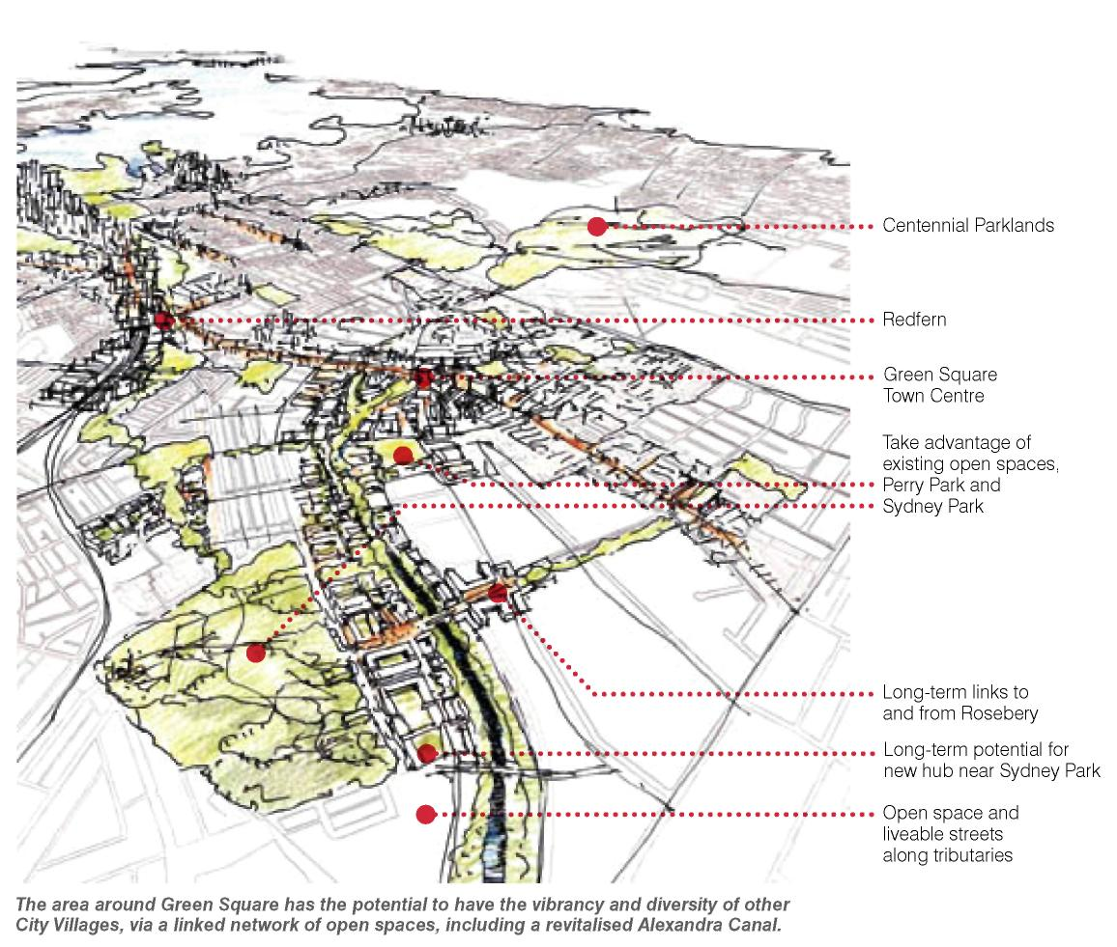

- Improved environmental performance of the City
- Preserving long-term development opportunities for Sydney
- Support for public transport networks
- Increased pedestrian movements and cycling with health benefits
- More jobs closer to home
- Quieter and more attractive walking and cycling streets
- More well designed affordable housing
- Adaptable and resilient buildings
- An authentic place where buildings, streets and public landscapes are varied in design and character
- Green Square can be designed to connect into the traditional fine grain character of surrounding neighbourhoods.

"Green Square can be designed to connect into the traditional fne grain character of surrounding neighbourhoods." Rod Simpson Simpson+Wilson Architecture+Urban projects

CASE STUDY: JAVA ISLAND, AMSTERDAMN, NETHERLANDS

OOSTELIJK HAVENGEBIED THE EASTERN HARBOUR

The Problem
- The site was a disused industrial harbour side and islands with key proximity to the City of Amsterdam.
- The City was experiencing the need for housing expansion across all housing types and saw the opportunity to remediate disused industrial land and to create a car free environment accessible by walking, cycling and public transport.

The Solution
- A close working partnership between public authorities and the private sector enabled 8,000 houses and apartments to be built over the past 10 years, creating a lively neighbourhood and community that has become a world model for urban design.
- The public sector, the landowner, set the design and financial terms for renewal, allowing the private sector to bring finance and development expertise to the table.

The Benefits
- Now a mixed-use neighbourhood of some 1,350 dwellings with 500sqm of commercial space.
- New design approach with apartment blocks up to nine storeys to form a wall around the island.
- Traffic has been kept to the quayside to provide central pedestrian-friendly courtyards.
- The idea of opening up the market to individuals rather than developers.
- Partnership—the role of the local authority as land assembler.
- An ‘open-book’ system allows the City Council to monitor the financial performance of the development as it is designed and developed.
- Concern about privacy is transformed into a positive approach to neighbourliness, health and safety regulations to the community and self-responsibility
- Traffic orientated development to pedestrian-friendly environment.
- Strong guidance on materials, height, massing, landmarks, but flexible enough to create a canvas for imaginative and innovative responses to terraced houses.

Idea 8: Affordable Housing

A partnership project to deliver access to affordable housing for key City
workers.
All levels of government, not-for-profit organisations and the private sector are working together in the 2030 Vision for a Sustainable Sydney.

One of the most urgent issues confronting the City of Sydney is the need for quality affordable housing, to ensure the City can continue as a diverse, inclusive and fair city, open to everyone. Affordable Housing includes long-term rental housing, subsidised community housing and lower cost housing. It is estimated the City needs around 450 dwellings a year to solve the affordable housing shortage facing Sydney.

The City’s housing stock is 74 per cent fats and apartments with 20 per cent semi-detached dwellings or terraces and five per cent separate houses.

The 2030 Vision, in keeping with the goals of the Metropolitan Strategy for Sydney, sets the targets of at least 134,000 dwellings. This includes 48,000 new dwellings in the City catering for an increased diversity of household types, including a greater share of families.

The aspiration is for 7.5 per cent social housing and 7.5 per cent affordable housing delivered by not-for-profit organisations and other providers.

For the City’s economy to grow key workers, such as teachers, nurses and police and specialist tradespeople must be able to afford to live in the City and benefit from the broad range of quality services offered by the City.

Rents in the City have risen over the past three years and the vacancy rate for rental properties has reached a record low at 1.7 per cent. Of 16 apartment developments for sale in the City in the June 2007 quarter, only two units were less than $500,000.

A high proportion of the population spend more than 30 per cent of income on rent or mortgages. Housing stress is defined as those spending more than 30 per cent of their income in this way.

The 2030 Vision aims for a coordinated and strategic approach to facilitating delivery of affordable housing by all levels of government and the not-for-profit sector.

The City wants to establish a subsidised level of long-term rental to give key workers the security of affordable housing in the City and to ensure inclusiveness and diversity of the residential population.

Partnership in progress: Glebe Affordable Housing Project

The 2030 Vision proposal is to build 700 new affordable housing units in Glebe to begin to address the City’s housing shortage.

The City of Sydney has signed a Memorandum of Understanding with the State Government, and Housing NSW to work collaboratively to develop a feasibility study to provide affordable housing on a 3.6 hectare site in Glebe.

Affordable housing close to the City is needed to ensure people employed in essential services like nursing, health and teaching can afford to live close to where they work.

The City of Sydney’s land value is more than $30 million in an area containing some of the most expensive land in Sydney.

The City of Sydney and Housing NSW will share the strategic planning for any proposed developments, using existing under-used land and potentially redevelop existing public housing. The affordable housing project will take full advantage of Federal Government initiatives aimed at increasing affordable housing.

The site includes the City of Sydney’s 20,000sqm Bay Street Depot Site and an adjacent 16,000sqm site (bounded by Bay, Wentworth and Cowper Streets, Glebe) owned by Housing NSW and already containing existing social housing.

A joint master planning process involving community consultation will develop guidelines for the affordable housing model. This initiative will efficiently utilise urban land, demonstrate best practice in environmental sustainability, excellence in urban design and architecture, high quality vibrant public spaces and encourage alternative transport solutions and minimal car use.

The project is intended to be a mix of one third social housing, one third affordable housing and one third market housing.

- Additional affordable, accessible housing
- Maintaining social diversity
- Best practice in design, environmental and social initiatives
- Maintains and improves existing Department of Housing dwellings
- Creates new partnership and models for providing affordable, accessible housing
"Low housing affordability makes it increasingly difficult for people employed in essential services to live in the City they work in. This puts pressure on their work-life balance and results in less time spent with family due to travelling times."
Clover Moore MP Lord Mayor

Delivering housing targets

INCOME SPECTRUM | HOUSING TENURE | OBJECTIVES
High-moderate  Income  Households | Private Housing  •Owners •Purchasers •Renters | Expand supply and choices of private housing for owners and purchasers and the rental market.  OBJECTIVE 8.1 Facilitate the supply of housing by the private market.  OBJECTIVE 8.2 Ensure that housing developments provide a diversity of housing opportunities for different lifestyle choices and household types.  OBJECTIVE 8.3 Ensure that a substantial proportion of housing is aimed at the lower end of the market.
Households in financial difficulty | Not-for-profit Housing | Expand supply of housing at cost and below cost for households in financial stress.  OBJECTIVE 8.4 Facilitate and promote growth in the ‘affordable housing’ sector including by Not for Profit and other housing providers.
Very low  Income  Households | Social Housing  •Public Housing •CSAH Funded | Maintain share and supply of social housing.  OBJECTIVE 8.5 Facilitate and promote growth in the social housing sector to provide housing opportunities for those with very low incomes.  OBJECTIVE 8.6 Promote partnerships and develop advocacy strategies for the delivery of housing for very low through to moderate income households.

MAYOR’S DRAFT HOUSING STRATEGY, 2007

The Problem
- Greater London has a population of 8 million people with high demand for council housing and priority given to those most in need.
- 42 per cent of housing stock in the Greater London Area is “affordable housing,” but this is still not meeting demand.

The Challenge
- The City of London has set a goal that 50 per cent of all new housing should be affordable and this is to be delivered through planning and development controls. 20,000 units per annum being delivered in this way.

The Solution
- The use of planning and development control plans to deliver affordable housing targets.
- 33 London boroughs are responsible for housing issues and own more than 500,000 houses and flats—one in six homes. Each is required to have the equivalent of the NSW Local Environment Plan to enforce provision of affordable housing.

The plan defines:
- The affordable housing level to be provided by a developer (in most cases this is when 15 or more units are built).
- The number of units to be provided by the developer as a percentage of the total, depending on location.
- The type of housing needed, for example, social or intermediate level income housing.

The Benefits
- A long-term strategy to meet housing needs.
- Retaining diversity and key workers in the City.
- Addressing the homelessness problem.

Idea 9 New moves for Newtown
Improved access to the Villages surrounding King Street, Newtown that will support community life, the arts, retail and creative enterprise and the live music scene. Newtown can demonstrate the 2030 Vision's concept of an Activity Hub in the heart of the local community.

Building on the creative hub, the 2030 Vision proposes a series of projects to improve access to the Villages surrounding King Street, Newtown that will support community life, the arts, retail and creative enterprise and the live music scene.

In partnership with Marrickville Council and State authorities, New Moves for Newtown would redesign the station square, create links to Newtown Station from Enmore Road and Australia Street and adapt the railway tram sheds for use by small businesses, fresh food markets and creative activities.

The project allows for adding a major public square around the station and integrating future redevelopment of the Newtown Tram sheds into the Newtown Activity Hub.

It aims to build the local economy, add to the appeal and liveability of Newtown and maintain the area’s distinctive authentic, quirky and historic character. Missing elements of the Activity Hub that could be part of the redevelopment of the tram-sheds are food markets, a library, child care, learning, studio spaces and cafes.

Initial steps
- Partner with Marrickville Council.
- Undertake a feasibility study.
- Advocate to State Government agencies.
- Prepare urban design concept.

A natural extension would involve transforming Erskineville Road as a new park spine to amplify the existing leafy character of the Erskineville Village Centre and improving the connection before Erskineville and Newtown.

Action
Create a network of Activity Hubs as places for meeting, shopping, creating, learning and working.

- Enriching the unique character of Newtown by creating a cohesive hub around the station
- More public meeting places, community facilities and places for recreation
- More attractive walking environment
- Opportunities for affordable, accessible housing at Newtown Square along Erskineville Road
- Upgraded transport interchange for Newtown

"We are imagining Activity Hubs as the old-style town square, the centre of the community." Patrick Fensham Director, SGS Economics and Planning

Case Study: London, UK: THE ROUNDHOUSE CAMDEN TOWN

Problem
- The Roundhouse was built in 1847 as a turntable engine shed at Chalk Farm near Camden Town. Within 20 years, locomotives became too large for the facilities to handle, and the Roundhouse underwent a number of changes of use. For years it was a gin store for the firm of W & A Gilbey Ltd.

The Challenge
- A building of great heritage value needed a long-term use. The Roundhouse had stood unused since before World War II. By 1966, it was grimy and derelict.

The Solution
- The Roundhouse became a well-known arts venue, starting in 1966 when the freehold was taken up by the new Greater London Council. It first opened as a conversion to a theatre in the late 1960s. In the late 1960s and 70s it was a pivotal venue in the UK Underground Music industry.
- By the 1980s the building was closed as a venue and given to the Camden Council.
- Purchased by the Norman Trust, it opened in 2006 to create one of London’s hip local night spots for live music.

The Benefits
- Finding a contemporary long-term use for a purpose designed 19th century industrial building.
- Supporting contemporary music culture.
- Provides a highly flexible and adaptable performance space that gives audiences opportunities and experiences they cannot find elsewhere.
- Programming work that reflects the excitement and diversity of 21st century culture including music, theatre, dance, circus and digital media.

Idea 10: Green Transformers
Re-inventing the supply of energy and water, securing supply for the City with state-of-the-art gas turbine generation. The by-products of this generation could provide greenhouse-free hot water, heating, and cooling.

Converting environmental targets to real change
Global warming is the most important urban management issue for the City, and reducing carbon emissions is central to the 2030 Vision. All of the strategies in the Vision seek to reduce the carbon footprint of the City.

The Vision proposes the introduction of Green Transformers to re-invent the supply of energy and water in the City, securing supply and reducing dependence on coal-fired electricity.

Major renewal sites across the City present an opportunity to develop Green Transformers to lead a shift to energy generated by gas as a low carbon energy, recycled water use and waste to energy conversion.

As owner of the streets, the City has the capacity to extend the environmental outcomes achieved in renewal sites to other areas. By using the streets to develop a reticulation system, renewal sites could provide efficient water reuse and waste-to-energy supply to other sites.

Green Transformers are intended to produce 330 megawatts of natural gas fuelled electricity generation. When combined with other demand reduction measures they will provide 70 per cent of the electricity requirements for the City in 2030 and lower greenhouse intensity by approximately 35 per cent.

The by-products of this generation could provide greenhouse-free hot water, heating, and cooling to approximately 35 per cent of all dwellings in the City and 43 per cent of all non-residential buildings in the City, thereby reducing overall gas and electricity consumption.

The Vision proposes intervention from 2010 with small green transformer installations; increasing to 25 MW by 2015, and then by an additional 20 MW each year for the next 15 years. The Green Transformers offer leadership by implementing fast and effective transition to a low carbon economy by 2030.

The first step by 2009 will be to complete a Green Infrastructure Plan to identify suitable sites for Green Transformers across the City. Implementation is proposed through partnerships with energy and water utilities.

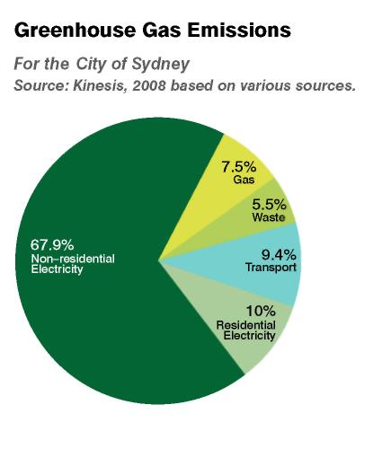
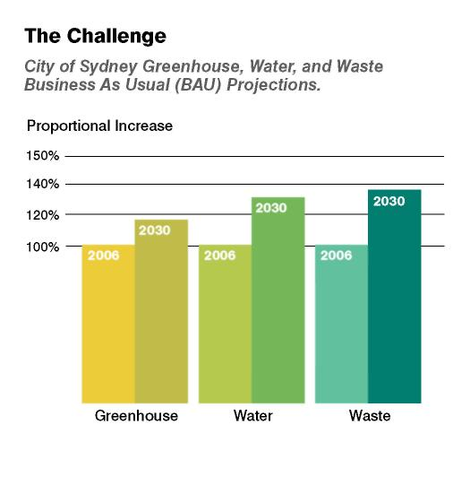
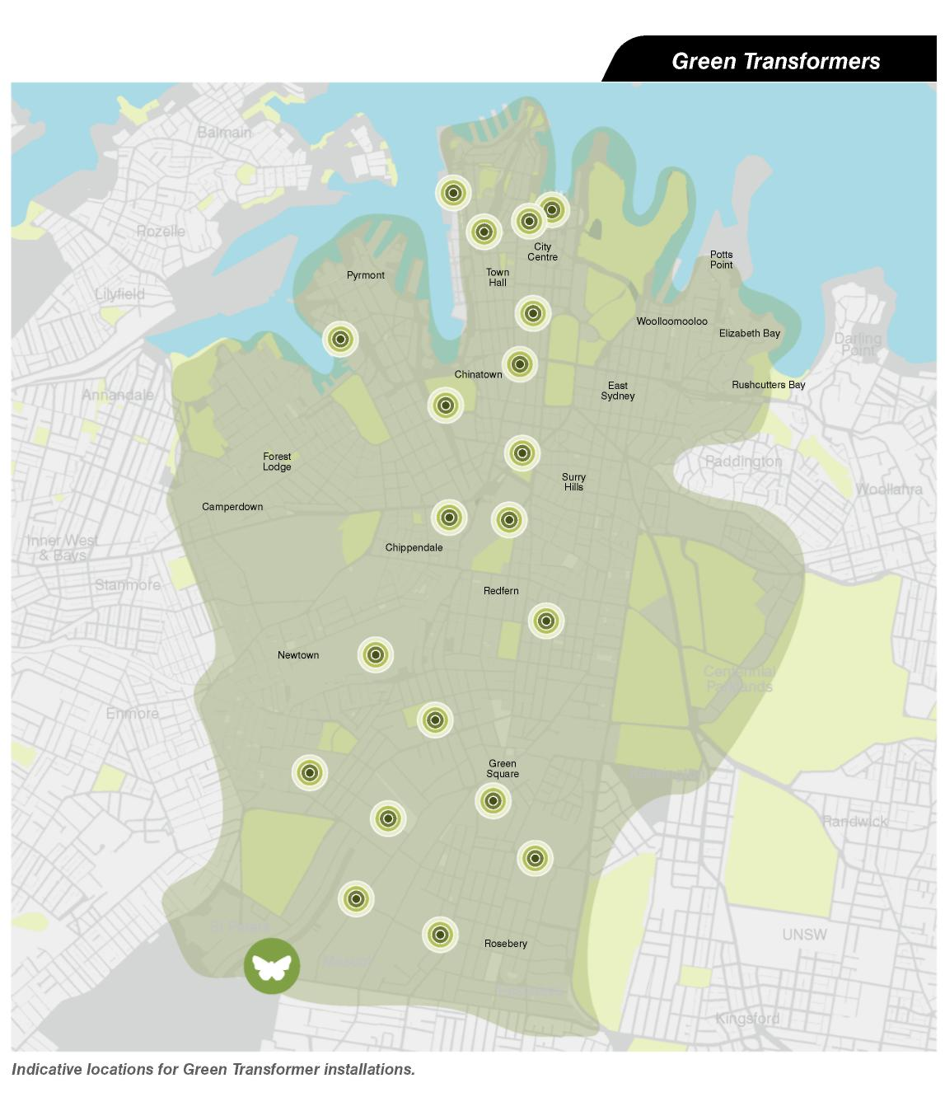

- Long-term energy security
- Stabilising emissions to maintain global climate
- Reducing unsustainable growth in energy, water and waste resource demands
- Generating 330 megawatts of electricity from natural gas combined with demand reduction strategies will provide 70 per cent of City energy needs by 2030
- Lowers the greenhouse intensity of electricity by 35 per cent
- Provides greenhouse free hot water, heating and cooling to 36 per cent of all dwellings and 43 per cent of non-residential buildings
- Reduces carbon emissions by 20 per cent less than 2030 business as usual projections
- 10 per cent of City’s water supply from within its own area
- Bundles existing technologies to consolidate infrastructure

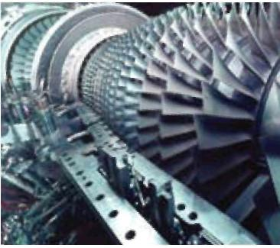

Green Transformer Concept: how it works

Fuelled by natural gas, tri-generation or cogeneration plants, can be around the size of a shipping container. In Europe they are often in a basement or on the side of a building. Cogeneration plants supply hot water for heating and chilled water for cooling and cleaner electricity to the building and the neighbourhood, using the street network.

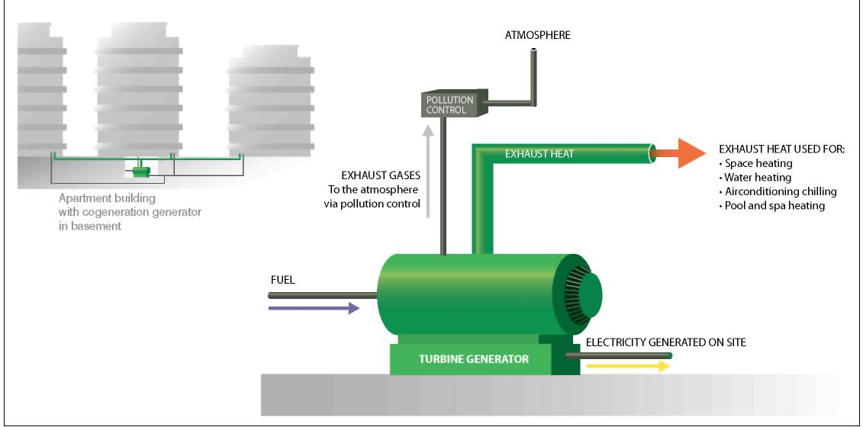

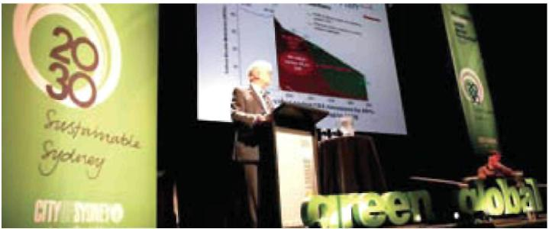

Case Study: Working UK

CLIMATE CHANGE STRATEGY
Woking is believed to be the first UK authority to have adopted a comprehensive Climate Change Strategy on a scale that is likely to meet The Royal Commission on Environmental Pollution targets of 60 per cent reductions of CO2 by 2050 and 80 per cent by 2100.

Allan Jones, former head of the London Climate Change Agency was responsible for the Woking Climate Change Strategy and is now advising the City of Sydney on the reduction of strategies to achieve greenhouse gas emissions in the City.
In the City of London all new development is to include 20 per cent decentralised production of energy otherwise no planning consent.

A Waste to Energy proposal to collect all London’s household and restaurant organic waste and convert it to biogas to produce electricity for two million households is due to begin in 2009.

The Problem
- For the South East of England it is predicted that over the next 80 years there will be an increase in average annual temperatures of between 2.0-2.5 degrees and 4.0-4.5 degrees and decreases in annual average rainfall of 0-10 per cent.
- This masks seasonal variations predicted—wetter winters and drier summers with rain increasing by 20 per cent in winter and a decrease of between 8-23 per cent in summer.
- An expected changing pattern of more extreme weather with floods, and droughts becoming “normal”.
- If action is not taken to reduce greenhouse gases (CO2 equivalent emissions) within 30 years there could be an irreversible effect on the global climate.

The Challenge
- International and national targets have been set to address the issue of climate change.
- Contribution to UK target reduction in greenhouse gases, expressed as CO2 equivalent emissions, should be 60 per cent by 2050 and 80 per cent by 2100.
- City of London aiming to get 25 per cent of residents off the grid by 2025 and 50 per cent by 2050.
- The Climate Change Strategy for Woking aims to build on the Council’s current environmental success and to take a carbon neutral approach to the future of services and activities within the Borough.

The Solution
- The strategy sets out a range of options which aim to reduce CO2 equivalent emissions and take further measures to enable the habitats within Woking to adapt to Climate Change.
- In 1990 it was estimated that Woking produced one million tonnes of CO2 emissions per year-the aim is to reduce this output to 200,000 tonnes per year by 2090
- Developing a guidance on Climate Neutral Development. The guidance encourages developers to design and build new development which does not contribute to the causes of climate change, and is resilient to future changes in climate.

The result
- Woking achieved a 70 per cent reduction in greenhouse gas emissions in 10 years. Woking has a population of 92,000.
- They installed over 80 heat and power stations and made energy 10 per cent cheaper than that supplied by the grid.

Change Strategies
- Use of sustainable combined heat and power sources of energy in the borough, discouraging the production of CO2 type gases.
- Increased use of photovoltaic and renewable energy.
- Incorporating, at the next review of the Local Plan, planning policies which will ensure that new development in the Borough reduces CO2 equivalent emissions of greenhouse gases (80 per cent less than its impact would have been in 1990).
- Introducing a local award scheme to recognise any developments that incorporate features which contribute to the long-term aim of sustainable development, including reducing CO2 equivalent emissions and mitigating against climate change.
- Adopting a target of purchasing 100 per cent of the Council’s electrical and thermal energy requirements from sustainable sources and 20 per cent from renewable sources by 2010/11.
- Pursuing, in the management of Council land, the use of irrigation systems that integrate the re-use of storm water.
- Adopting best practice in the management of the Council’s own land and buildings and working with the Environment Agency, Thames Water and developers to create wetlands in or near existing floodplains, with a view to enhancing capacity of the floodplain.
- Exploring means of creating environmentally-friendly energy from waste and encouraging the avoidance of landfill.
- Maintaining the Home Energy Conservation Act target of 30 per cent improvement in energy efficiency by 31 March 2006.
- Woking is a partner in the South East Climate Change Partnership. The partnership includes public, private and voluntary sector organisations which are working together to investigate, inform and advise on the threats and opportunities arising from the impacts of climate change in South East England and to promote adaptive planning in the region.

2030 Vision to the Corporate Plan

The next City of Sydney Corporate Plan will be developed to support delivery of the Sustainable Sydney 2030 Vision. The four year Corporate Plan will enable first stage implementation of the Vision as the focus of Council’s future activities.

The 10 Strategic Directions:

- A GLOBALLY COMPETITIVE AND INNOVATIVE CITY
- A LEADING ENVIRONMENTAL PERFORMER
- INTEGRATED TRANSPORT FOR A CONNECTED CITY
- A CITY FOR PEDESTRIANS AND CYCLISTS
- A LIVELY, ENGAGING CITY CENTRE
- VIBRANT LOCAL COMMUNITIES AND ECONOMIES
- A CULTURAL AND CREATIVE CITY
- HOUSING FOR A DIVERSE POPULATION
- SUSTAINABLE DEVELOPMENT, RENEWAL AND DESIGN
- IMPLEMENTATION THROUGH EFFECTIVE GOVERNANCE AND PARTNERSHIPS

- The Corporate Plan 2009–2012 is the City of Sydney’s current Management Plan.
- It will be reviewed and the next Corporate Plan 2010–2013 will be written to meet the 2030 Targets for sustainability.
- A system for monitoring and reporting progress against the targets, including contributions by all levels of government, will be established.

APPENDICES

Snapshot of Sydney in 2008

- The City of Sydney provides the image of Australia to the world. It is home to 165,000 residents and provides 380,000 jobs, and on an average day, including visitors and students, it is estimated that there are approximately one million people in the City. The City of Sydney is a focal point for activities and services at the local, national and global level.
- In the last two years employment in the City of Sydney has grown by 15,000 jobs, almost a quarter of the total for metropolitan Sydney, although migration into metropolitan Sydney has recently been in decline.
- During 2007- 08 the estimated value of economic activity in the City Centre was $78 billion, representing 8.1 per cent of Australia’s GDP. In 2008, Sydney has been ranked 9th as a global finance centre, 10th in the MasterCard Index of Commerce Cities and 9th in the Mercer Quality of Living Index.
- Sydney is head office to almost half the top 500 companies of Australia and New Zealand, and 60 out of the top 100 largest corporations in Australia and New Zealand are located here. Tw o thirds of the Asia-Pacific regional headquarters of global corporations are located here.
- The Banking and Finance sector is a key driver of the Sydney economy. Almost 80 per cent of international and domestic banks with an Australian head office are based in Sydney and importantly 65 per cent of all banking and finance industry business and 70 per cent of the nation’s financial services are in Sydney.
- In terms of its global economy, Sydney is 26th in world city terms and the Sydney CBD is in the top 15 in global CBD size.
- More than 15 per cent of Australia’s exporting Advanced Business Services, including banking, investment and I T, are located in Sydney.

A vision based on broad input

The engagement and consultation program for Sustainable Sydney 2030 Vision was the most extensive in the City of Sydney’s history.

The consultation began in June 2007 and continued throughout 2008.

The City talked to a full spectrum of interested groups and individuals, including school children, young people, business leaders, artists, educators, community activists, residents, shop keepers, small businesses, councillors, church and sporting groups.

Some 12,000 people were directly consulted at more than 30 community forums. A further 4,000 people were directly consulted through City Talks and 2,000 gave comments on the 2030 Future Phone at public events, schools and educational institutions.

Comprehensive media coverage of Sustainable Sydney 2030 in 2007 and 2008 has touched hundreds of thousands of people.

The Vision’s public exhibition, held over six weeks at Customs House, attracted well over 50 per cent of the 157,000 visitors to the venue over that period.

During the consultation period 2030 branding was extensive in the City through bus shelter advertising and banners together with magazine and internet advertising.

Information on the 2030 Vision project placed in 19 Council venues across the Local Government Area is estimated to have reached many of the 245,000 visitors to the venues.

During the exhibition period 547 people were briefed on details of the Vision at 11 sessions conducted by the City Engagement team.

A City Talk to launch the Vision held in April 2008 was attended by 1,200 people, while information sheets were distributed to more than 2,000 people attending Sydney’s Primo Italiano festival.

The Lord Mayor, the City’s Chief Executive and members of the City Strategy team provided a series of briefings for Local, State and Federal Government leaders and business executives.

The Vision exhibition attracted substantial interest. As at June 2008, the 2030 website had received a total of 18,854 individual visitors.

Ongoing engagement will be maintained as a foundation principal to delivering the Vision over the next 20 years and beyond.

Submissions

Some 89 individuals and organisations made formal submissions responding to the 10 Strategic Directions of the Vision, in addition to 157 email comments and 93 written comments.

Analysis of the public submissions revealed broad support for integrated transport, greater environmental leadership, more opportunities for walking and cycling and a more lively City Centre.

In calling for a sustainable City, a majority of people called for social sustainability, a City that is fairer, family-friendly, inviting and accessible to everyone.

The values of all sections of the community gathered during the consultation process under pin the final 2030 Vision futures forum JUNE 2007

More than 500 people from all walks of life and across a spectrum of age groups attended the Forums to discuss the seven focus areas for the Vision.
The focus question for the forums was “What kind of City do you want Sydney to be in 2030?”
Business and Community Forums Report Executive Summary—July 2007 Appendix

Signposts to the future Community workshop SEPTEMBER 2007

At a major community workshop in September, participants from the community were asked to workshop ideas and projects that could deliver on the Sustainable Sydney 2030 Vision principles.

They were also asked to make a choice of how they would allocate funds to projects, indicating their priorities. The conversation was led by fve leaders from the Sydney community, who each explored themes of importance to making Sydney a more liveable and sustainable City by 2030.

Signposts to the Future Community Forum Workshop Report Summary October 2007 Appendix

Signposts to the future Business and Cultural Representative workshop OCTOBER 2007

Attendees proposed actions and discussed the ideas emerging from the consultation work so far, and provided feedback on hopes and aspirations for Sydney. Sectors represented included property, business and finance, the cultural industries including film, visual and performing arts, professional services, peak industry groups, Local Government, Municipal Mayors from adjoining councils and State Government representatives.

Speakers at the Forum included, Peter Thompson ABC; Stephen Loosely, Committee for Sydney; Roy Green, MGSM; Maria Atkinson, Bovis Lend Lease; Amrita Cheema, SBS; Greg Smith, Animal Logic; Peter Holmes à Court, Rabbitohs; Nicholas Wolff, Fraser’s Property Group, Brendan Crotty and Ken Morrison, Property Council of NSW.

Signposts to the future Forum Executive Report Sustainable Sydney 2030 Business and Cultural Representatives Forum Report October 2007

Aboriginal and Torres Strait islander forum and Consultation
SEPTEMBER 2007

An intensive community consultation process with the Aboriginal and Torres Strait Islander community was conducted between 15 August and 5 October 2007. Over 200 people were interviewed or surveyed by peer consultants; 12 leaders attended the Lord Mayor’s Roundtable Luncheon and a further 60 attended consultations at Glebe, Woolloomooloo and Redfern with a total attendance of over 60 people.
Aboriginal and Torres Strait Islander Community Workshop report Summary October 2007

Roundtables JULY, AUGUST 2007

The Lord Mayor hosted 10 roundtables with representatives and leaders from the community, business, social, education, built environment and civic and cultural life.
The conversations were wide ranging with participants offering commitment to the process of developing a vision and to its future implementation.
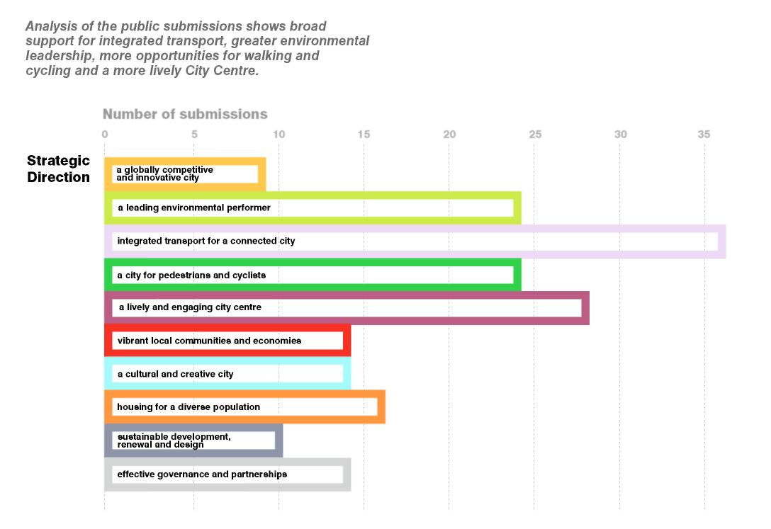

STATISTICS
- The most extensive consultation in the City of Sydney’s history
- More than 12,000 people consulted
- Nine roundtable discussions
- Two major community workshops
- Live Green panel discussions
- Two "Signposts to the Future" forums
- A six-week formal public exhibition period
- 18,854 website hits up to June 2008
- 157,000 visitors to Customs House during the 2030 exhibition period
- 3,552 website downloads
- Six forums with Indigenous community
- Eight primary school workshops

City Talks
Between mid 2007 and 2008 the City’s program of City Talks had a focus on exploring the issue of Sustainable Sydney 2030.

In 2007, playwright Neil Armfeld; Director of the Sydney Festival, Fergus Lineham; and Director of the Museum of Contemporary Art, Liz Ann Macgregor, lead the series with a focus on Sydney’s cultural life.

International architect and urban design guru Professor Jan Gehl—whose Public Space and Public Life study recommendations are central to the thinking of the 2030 Vision—presented his recommendations.

In 2008 the draft 2030 Vision was presented by authors Patrick Fensham from SGS Economics and Planning; Rod Simpson from Simpson+Wilson Architects; and environmentalist Bruce Taper from Kinesis.

Live Green AUGUST 2007

Live Green is a vibrant, new event for the City that demonstrated how the community as a whole can learn to live green. The event included talks about Sustainable Sydney 2030, Visions of Sydney history display and the future phone.

‘Sustainable Sydney 2030: A plan to take us there’ was a workshop hosted by Peter Thompson with community members interested in Sydney’s future growth and change and how it can respond to environmental challenges.

Visions of Sydney Exhibition

The Vision of Sydney exhibition was created for Live Green but was exhibited in City venues throughout 2007 and 2008. The multimedia exhibition was developed by the City Strategy and Engagement team with the City Historian. It used archival materials to place Sustainable Sydney 2030 as a visioning process towards a long-term plan for the future.

The project aimed to encourage residents, workers and visitors to reflect on past visions and imagine the Sydney they want for the future. Sydney’s growth and development patterns were tracked from 1788 to 2000, identifying the significant events that shaped the City as it is today.

Art & About 2007

The City’s Art & About program included a project run by The Red Room Company’s poet’s workshop. Children from City primary schools gave their view of the future in verse and artwork. Called “Child’s Eye 2030,” the poems and paintings were projected on the wall of the AMP Building at Circular Quay, giving a colourful, imaginative view of the future.
Child’s Eye 2030 Art and About 2030 October 2007

A poem from Art & About
BRAVO CHILD & Year 3 & 4 Newtown Public School

Untitled
Warn the people that they have to be rich.
Use organic petrol.
Be ready to be micro-chipped.
We are all running, if time stops we stop.
Tall or small, down we fall.
Buildings will be invisible,
Transport will be in the sky,
Everyone will do Science.
If you die, I die.
…I hope they have cakes that are good for you.

The future phone
A fun way for young people to leave a message about the Sustainable Sydney 2030 Vision, the Future Phone was located across a range of City venues. The future phone included a comfy armchair in a private booth with hand set, allowing people to leave a recorded message describing the kind of City they want Sydney to be in 2030.
Locations included high schools, universities and prominent business district areas. Students, workers, residents and visitors to Sydney took a couple of minutes to say what they wanted for Sydney’s future.

Highlights from the Future Phone April 2008

City of Sydney foyer DECEMBER 2007
“I think what is critically important is the public domain reinvigorating the streets, the squares, making the parks dynamic parts of the City as well as fantastic green spaces as part of the City. Public transport has to be an absolute priority and the City should get the State Government to be creative about lots of public transport… we are decades behind. That is the most important thing.”

Customs house OCTOBER 2007
“I would like Sydney to be a place where people could come into City squares with their families, where they could enjoy family time together in an environment where they can enjoy also the beauty of our City including its harbour. I would like to see walking tracks, I would like to see cycle ways as well. I am obviously aware that business needs to continue and I would hope that the walkways and cycleways could be joined effectively with business. I would like a clean and green City that caters for people in all areas of their life.”

Glebe Street fair NOVEMBER 2007
“We would like to see rent a bicycle where you can pick-up bicycles for a limited amount of time and use them on the constructed bicycle ways in the City and the Inner West.”

Customs house OCTOBER 2007
“What I would like to see is our City to be more people-friendly. Get rid of the cars as much as we can to provide walking spaces, make certain that we do not lose any of our parks and make it a place for people and children particularly so it is friendly and we make the most of our wonderful City.”

Newtown festival DECEMBER 2007
“I think King Street Newtown should be turned into a car-free space with a tram and buses only, with cars diverted around the space itself. I think it would be so much nicer it is such a cultural hub as it is. But it would be so beautiful to have seating out in the street and to have more public space to have a little bit of an area where people can wonder around and more greenery because it is a really beautiful area. More dog parks and more community art and art devoted to local members of the community, remembering the quintessential characters of the community that people wouldn’t necessarily remember.”

Live Green AUGUST 2007
“A City of the future will be a City of green links. One where the City can use design to activate spaces, will have liveable streets and an emerald necklace that runs from Moore Park around to Victoria Park via Green Square. East-West links.”

Customs house OCTOBER 2007
“I think the City should have much more affordable housing so that people can have the opportunity to live in the City. I also think the buses and public transport should be a lot cheaper, much more efficient. I think that the spaces there should be a lot more open spaces, grassy play areas for children particularly in various suburbs in the City, for example Paddington, Glebe Newtown. Much more safe open public places for children and families to play.”

City Talk SEPTEMBER 2007
“I would like to see more open spaces and better preservation of Sydney’s architectural heritage because it is one thing to have a good City to walk through or a good City to visit but if we do not preserve the buildings that made the City through its different time periods then we are losing part of the City and we are missing I think some of what the vision for Sydney 2030 is all about.”

Highlights from the Future Phone April 2008 (continued) Danks Street festival OCTOBER 2007
“I live in the Alexandria area and I think that the Green Square Centre is going to be a great asset for our area and I also think that perhaps we need a few more parks and cafes with the new apartments precinct that are coming up that are actually opened on Sundays as a lot of the cafes aren’t open and it would be great that you could have somewhere to go with families or with friends on a Sunday so parks and cafes are what I am up for.”

City of Sydney foyer DECEMBER 2007
“My idea for the future of Sydney is that we should start exploring the underground city centre. In particular, getting in some bars, working overnight. I think we should improve our train lines, particularly Central and Town Hall. I think we should kind of go towards the direction that Melbourne is heading in the café culture—a lot of the small alleyways and lanes that can be used for different purposes and styles.”

Live Green 25 AUGUST 2007
“I believe in 2030 we should have an integrated transport system. That we need to give pedestrians more of the City and improve the light rail and increase cycling access to the City in a safe and durable way.”

City of Sydney foyer DECEMBER 2007
“I think we need to have community gardens where people can grow their own food. It is going to be a huge problem to get more locally grown food. You have to really encourage that because once the price of oil goes through the roof the price of food will go up with it. That is my idea.”

Erskineville youth Centre OCTOBER 2007
“I think that we should have a couple of more facilities for young people in the area, not just Erskineville, but Redfern, Waterloo, Newtown and all the inner City areas, and I think we need a pool and some more creative ideas, more cultural background, you know Indigenous days, stuff like that.”

Martin Place OCTOBER 2007
“I want less coal and more energy efficient things in the City.”

Customs house OCTOBER 2007
“I would like more parks and more bike ways so I could bike around the City and not rely on public transport. Thank you.”

Surry hills festival 2007
“I would like more cool little bars and pubs and more places to ride your bike, more money for public schools.”

St Vincent's College 2007
“In the future I hope that Sydney is more ecologically sustainable, upholds the values of multiculturalism but keeps our Australian identity.”

Newtown festival December 2007
“Don’t underestimate the importance of live music particularly when it is free, because independent musicians will do anything to get their music out there. Encourage art in any form whether it is street art, fashionable art, anything.”

St Scholasticas NOVEMBER 2007
“I want Sydney in 2030 to be a place where everyone is treated equally and a place where we can all feel safe in our homes and a place where I can feel safe and respect everyone.”

Newtown festival December 2007
“I would like to see Sydney being run by green energy. Renewable energy sources are very important because eventually coal is going to run out and obviously polluting forms of energy and that is not a very sustainable way to run the City.”

St Scholasticas NOVEMBER 2007
“For the year 2030 we think there should be better public transport and more of it so it is more reliable, so less carbon dioxide is released into the atmosphere and less cars and traffic and will help global warming and be safer for pedestrians. We also want to protect parks and stuff that are sometimes being sold-off to developers because they are important public space.”

Sydney university OCTOBER 2007
“The economy has got to be one of Australia’s biggest challenges in the coming decades. With China on the boom with their population and industrialisation. I believe that the key to achieving a better economy for Australia is to expand ties within the Asia-Pacific region.”

2030 Exhibition period information briefings
- Cultural, Design, Economy, Environment, Transport, Education and Social sectors
- Chinese community,
- Community stakeholders
- City Indigenous community
- People with Disabilities
- Gay and Lesbian and Transgender community
- Young professional and young people
- Committee for Sydney
- Sydney Chamber of Commerce
- NSW Local Government Conference
- Property Council of Australia
- Urban Task Force
- Australia Council for the Arts
- Events NSW
- The Royal Australian Institute of Architects
- Planning Institute of Australia
- Australian Institute of Landscape Architects
- Urban Development Institute of Australia

Government briefings
Between March and May 2008, the City of Sydney briefed State and Federal stakeholders on the 2030 Vision.
Minister Anthony Albanese, Federal Minister for Infrastructure
Minister Tanya Plibersek, Federal Minister for
Housing, Minister for Status of Women
Malcolm Turnbull, Shadow Federal Treasurer
Morris Iemma, Premier of NSW
Minister Frank Sartor, Minister for Planning NSW
Minister John Watkins, Minister for Transport NSW
Minister Ian McDonald, Minister for Primary Industries,
Minister for Energy, Minister for Mineral Resources and Minister for State Development NSW
Minister Matt Brown, Minister for Housing and Tourism NSW
Minister Paul Lynch, Minister of Local Government NSW
Minister Verity Firth, Minister for Environment and Housing NSW
Council of Capital City Lord Mayors
Inner City Mayors
Mr Barry O’Farrell, Leader of the Opposition NSW
Ms Gladys Berejiklian, Shadow Minister for Transport and Citizenship
Mr Barry Buffer, Director-General of Tourism NSW
Mr Mike Allen, Director-General of Housing NSW
Mr David Richmond, Coordinator-General NSW
Mr Warwick Neilly NSW Premiers Office
Ms Kathy Roil, Department of Housing NSW
Mr Sam Haddad, Department of Planning NSW
Mr Rob Lang, Sydney Harbour Foreshore Authority
Central Sydney Planning Committee
Councillors—City of Sydney
Former Prime Minister, Paul Keating

Guiding Principles for Sustainable Sydney 2030 Vision were developed through consultation.

GLOBALLY COMPETITIVE
The City will contribute to maintaining Sydney’s position as the premium destination in Australia for global and national investment, high quality connectivity and high quality employment. The City Centre and its Villages will be destinations of choice for international and national visitors, major events and conferences.

LIVEABLE
The City of Sydney will balance increased numbers of residents and employees with improved access to high quality amenities, an attractive and safe public domain, and design excellence in the built environment, an active street life and cultural vitality. These aspects will be foundations for both its urban villages and a strong economy.

CULTURALLY RICH
The City will continue to be a leading cultural centre and an international cultural leader, fostering the development of and participation in cultural activities, events and performances, by and for its diverse resident, worker and visitor communities.

INNOVATIVE, EDUCATED AND SKILLED
The City will be a world leader for knowledge and information sharing, creativity and skills development by fostering a culture of enterprise, lifelong learning and achievement.

ENVIRONMENTAL LEADER
The City will minimise its energy and water use, its waste generation and its air quality impact through the City of Sydney’s own activities and by working with other stakeholders. The City of Sydney will plan for the future impacts of climate change.

SENSE OF PLACE
The City will respect and respond to its beautiful setting and inherited landscape between Sydney Harbour and Botany Bay, and value its rich cultural and urban history and heritage. Outdoor activities and lifestyles will be encouraged to take advantage of Sydney’s mild and attractive climate.

DIVERSE AND INCLUSIVE
The City of Sydney will respect and value its Indigenous and multicultural heritage. The City will encourage a range of different living styles, ages and household types and promote respect between its communities.

EQUITABLE
The City of Sydney will act to improve social and income equalities and access to affordable services and facilities at the local community level. This will build high levels of trust, improved health, greater enterprise, creativity and resourcefulness, building a sense of belonging and connection among the City’s residents, workforce and visitors.

CONNECTED AND ACCESSIBLE
The City will enjoy a comprehensive walking and cycling network that provides access to and between the City Centre, the Villages and surrounding areas. This should be supported by a high capacity, quality integrated public transport system that connects the City Centre to the Villages and to other parts of the Sydney Region.

LEADING CAPITAL CITY GOVERNANCE
The City of Sydney will be a leader in policy development and debates, advocacy, environmental management, public sector administration and as an employer. The City of Sydney will actively seek partnerships with other councils, other levels of government, and community and business stakeholders for Sydney and national policy aims. The City of Sydney will maintain the highest standards of due process, due diligence, efficiency and transparency in its decision making to ensure long-term financial sustainability.

Transcribers Note: Image is too complex to be transcribed. Should you require this information in an alternative format please contact: City of Sydney 9265 9333, TTY: 9265 9276, council@cityofsydney.nsw.gov.au Translation service (TIS) 13 14 50

Acknowledgements

City of Sydney Council members June 2008
The Sustainable Sydney 2030 Vision was adopted unanimously by Council on 30 June 2008.

- Lord Mayor Clover Moore MP
- Deputy Lord Mayor Chris Harris
- Councillor John McInerney
- Councillor Robyn Kemmis
- Councillor Marcelle Hoff
- Councillor Philip Black
- Councillor Michael Lee
- Councillor Verity Firth
- Councillor Tony Pooley Councillor Shayne Mallard

City of Sydney

The Sustainable Sydney 2030 project was led by the City Strategy and design team with support from across the City of Sydney organisation.

- City Engagement Community Engagement Unit Communications and Media Unit Events Unit Marketing Unit
- Corporate Services Finance Unit Information Management
- City Community and Cultural Services Community Living Unit
- City Projects Design Unit
- City Strategy and Design City Plan Development Economic Development Unit Environmental Development Unit Strategic Social Planning Unit
- City Transport and Major Projects Transport Strategy Unit
- Properties
- Property Strategy Unit

SGS Consortium

SGS Economics and planning was engaged by the City of Sydney to lead a team of strategic planning, transport, social, cultural, environmental, governance, and design and economics experts to prepare the Sustainable Sydney 2030 Vision.
The SGS Economics and Planning Consortium Team

- SGS Economics and Planning
- Simpson+Wilson Architecture and Urban Design
- Hill Thalis Architecture and Urban Design
- Kinesis
- Australia Street Company
- Strategic Economics
- Geoff Anson
- Neil Prosser
- Milbur Consulting
- Anagram Studio (and Christie Hunt)
- Griffth University

Architects

The City of Sydney engaged a team of architects and urban design firms to develop projects and transforming urban design ideas.

- Hassell
- Bates Smart
- McGregor Westlake Architecture
- Neeson Murcutt
- Russell Olsson Urban Projects
- Johnson Pilton Walker
- Tony Caro Architecture
- Tonkin Zulaikha Greer
- Lacoste +Stevenson Architects
- Merrima Design
- Anton James Design

Glossary of Terms

Accessibility—refers to the extent to which people have access to employment, goods and services, either through proximity or transport links to connect places.

Accessible Transport—public transport that meets the needs of all residents, visitors and workers. ‘Accessible’ public transport is vital for people with disabilities and those with mobility impairments in particular, so that they have the opportunity to play a full part in society. Accessible transport ensures that every stage in the journey ca be accessed by people with disabilities.

Affordable Housing—conveys the notion of ‘reasonable’ housing costs in relation to income. Reasonable housing costs are defined as totalling approximately 25-30 per cent of gross household income for households on very low to moderate incomes. Moderate income was determined in the 2008 Federal Budget as up to $70,000 for a household. The term affordable housing can relate to a range of housing forms and tenures. Throughout Australia, affordable rental housing is owned by State and Local governments, charitable organisations. Affordable housing may also be private housing, however, in the City this is largely confined to accommodation in boarding houses, though there is some affordable housing available for rent or purchase on the private market.

Amenity—the enjoyment of the environment, whether public or private lands, by individuals or the community. It includes tangible and non-tangible elements such as privacy, safety, sunlight, views, quiet, access to local facilities and similar freedom from nuisance.

Clusters—are concentrations of competitive and complementary firms, usually geographically based, where constant interaction and learning from each other drives competitiveness. Clusters arise because of the benefits of proximity for many types of inter firm transactions such as exchanges of ideas and technology, as well as access to specialised institutions and inputs such as skilled labour and extensive supply chains.

Cogeneration—is a high-efficiency energy system that produces both electricity and the productive use of otherwise ‘waste’ heat from a single fuel source, such as natural gas. It is typically two to three times more fuel efficient compared to conventional technologies, such as coal fired power generation of electricity. Cogeneration can significantly decrease total site energy costs and greenhouse gas emissions.

Commercial Core—is a section of the Central City where residential land uses are limited. The principle function of the commercial core is to provide and protect capacity for a range of commercial floor space areas. The allocation of residential land uses in traditional commercial areas of the City Centre, can effectively ‘crowd out’ future commercial development. Strata titling of residential buildings impedes future redevelopment opportunities.

Cross-Regional—refers to travel that does not focus on trips on the established radial transport network—that has a focus on the City Centre.

Cycle Network—streets with dedicated cycle lanes that ensure separation from vehicular traffic, transit and pedestrians. Cyclists should be able to cycle everywhere, including main streets. However, it may not be always possible to include dedicated cycle lanes between the kerb and parked cars on these streets. Therefore, alternative routes one or two streets back are provided for less confident cyclists (Bourke Street and Crown Street). This network builds on the City of Sydney Cycle Strategy to provide a continuous network connecting all parts of the City.

Development Controls—can be statutory or non-statutory instruments which specify requirements for carrying out development. Development controls typically include provisions such as building height restrictions, parking requirements, setbacks, foor space, density and minimum site areas.

Environmental Footprint—the area of land needed to provide the range of goods and services consumed by its residents. It is a way of estimating the total environmental impact of residents.

Fine Grain—small scale, generally lower cost spaces providing for a diverse range of activities and users. The fine grain spaces include small retail tenancies with street access including basement and first floor levels, as well as offices, studio spaces or other activities with access inside arcades, underground connections, through office foyers or other buildings. Fine grain spaces often front or are accessed from smaller streets or lanes, and are within lower grade office or mixed use buildings, generally in the less expensive precincts. The fine grain spaces with their mixed ownership and leasing patterns enable more organic changes to occur throughout the City and support lower cost and start-up businesses that contribute to a vibrant and active City.

Global City—also known as a world City, is a City which has a direct and tangible impact on world affairs through socio-economic cultural and political means.

Global Economic Corridor—the part of eastern Sydney stretching from Sydney Airport and Port Botany through Sydney City and North Sydney to Macquarie Park. It serves as Sydney’s, NSW’s and Australia’s most valuable link with the global economy.

Global Sydney—the main focus for national and international business, professional services, specialised health and education precincts, specialised shops and tourism, it is also a recreation and entertainment destination for the Sydney Region and has national and international significance. Global Sydney is defined in the Metropolitan Strategy and is made up of the City of Sydney LGA and North Sydney LGA.

Green Reticulation—is the pipe work required to distribute the products from Green Transformers (electricity, heating, cooling, and recycled water). This could be provided directly to surrounding buildings, and could also link to existing energy and water infrastructure.

Green Transformers—located in local strategic sites, Green Transformers could provide electricity, heating, cooling, recycled water, and convert residential and commercial waste to energy.

High Capacity Fixed Rail—also known as rapid transit, or metro rail system. High capacity fixed rail is a rail-based system characterised by a high capacity and high frequency of service. These systems can be elevated, on ground or underground, however are always independent from other traffic. Trains are generally single-decker with multiple doors on each car to allow rapid loading and off-loading of passengers. High capacity fixed rail systems typically serve the City Centre and inner suburbs, with commuter rail serving the outer area.

Housing Affordability—is a term to encapsulate the ease at which households across all income groups can access housing. The City of Sydney takes a wide view of the affordability question.

Human Capital—refers to the supply of productive skills and technological and creative knowledge embodied in labour.

Knowledge-Based Economy—an economy based on the use of knowledge to produce economic benefits. Knowledge and education are treated as business products where innovative intellectual products can be exported for a high value return. The liberalization of trade barriers has meant that many advanced economies rely on knowledge and innovation for competitive advantage.

Liveable Green Network—is made-up of streets and lanes that have pedestrian and cyclist priority and good amenity. They will generally be traffic calmed and densely planted with street trees. Some streets and lanes will have the capacity to incorporate stormwater treatment and accommodate the reticulation system for sustainable energy, water, district hot water and district cooling. The Liveable Green Network links the hubs, main streets, main institutions and the City Centre. The Liveable Green Network is made up of Liveable Main Streets, as well as the quieter streets, some of the quieter streets will also form part of the continuous cycle network.

Liveable Main Streets—active shopping strips that are the focus for activities in villages or activity hubs. These main streets have only moderate vehicular traffic, with traffic volumes maintained or reduced and quality facilities for pedestrians. Cycle lanes on these streets are more likely to be next to moving traffic. Main streets also provide connections to public places for meeting and enjoying City life.

Live sites—performance spaces in Activity Hubs across the City, to provide opportunities for creative expression and contribute to community cultural vitality.

Modal Interchanges—comprises of physical and nonphysical elements that allows seamless transition between different modes of public transport including trains, buses, light-rail, taxis and ferries. Physical elements include infrastructure and facilities such as station platforms, pedestrian right of way, weather protection structures, signage, lighting, and dedicated bays and space for transport. Nonphysical
elements include timetabling and ticketing systems.

Networks—are groupings of firms and organisations including training institutions that constantly exchange knowledge and information, and promote learning.

Not-for-Profit Housing—also referred to as ‘Intermediate Housing’, refers to housing that is provided at cost excluding a private developer’s profit margin. Such housing is provided in the City by Not-for-Profit (NFP) organisations such as City West Housing Pty Limited (CWH). Some NFP housing providers are funded by the Centre for Affordable Housing (part of the NSW Department of Housing). Community housing associations are often involved in the management and development of NFP housing.

Public Domain—refers to areas of the City in which access to and use of is available for any member of the public. Public domain typically includes parks, plazas, footpaths and streets. Public domain elements of the City are typically controlled by the City of Sydney.

Renewable Energy—renewable energies utilise natural resources such as sun, wind, water and biomass to create electricity. Unlike energy derived from fossil fuels, renewable energy supplied can never be exhausted. Importantly, renewable energies do not emit greenhouse gases and thus do not contribute to global warming. Renewable energies have gained significant momentum over the past decade.

Road Hierarchies—refer to the different ‘roles’ of roads within a city. Road hierarchies are usually based on traffic volumes and road capacity. Roads with high traffic volumes are often considered major roads.

Roads and Traffic Authority— responsible for designated main roads. The Council has responsibility for local roads.

Social Capital—refers to features of social organisations, such as trust, norms, and networks that can improve the efficiency of society by facilitating coordinated action (Putnam, R 1993)

Social Housing—includes all public housing, community housing, crisis accommodation (with and without ancillary support services) and Aboriginal housing (managed by the Department of Housing or by the local Aboriginal organisations).

Special Rate Levies—an additional levy on existing rates on all rateable property for the purposes of funding new public infrastructure and development that will deliver benefits to the community as a whole.

Subsidised Housing—is defined as housing that is provided for rent or purchase at below the market price. This includes social housing and to some extent, NFP housing.

Sustainability—in 1987 The Bruntland Report, defined Sustainable Development as ‘development which meets the needs of the present without compromising the ability of future generations to meet their own needs’. In June 1992, the Rio Earth Summit further refined the definition to include 12 core principles including ‘the right to development must be fulfilled so as to equitably meet developmental and environmental needs of present and future generations’. The principles of sustainability are of inter-generational equity, intra-generational equity, precaution and conservation of diversity. Sustainable Development is not just about the physical environment, but about the economy, society and cultures as well, and how a balanced combination of these, through good governance, will result in greater outcomes for present and future society.

Sydney Region—the 43 local government areas of Ashfield, Auburn, Bankstown, Baulkham Hills, Blacktown, Blue Mountains, Botany, Burwood, Canada Bay, Camden, Campbelltown, Canterbury, Fairfield, Gosford, Hawkesbury, Holroyd, Hornsby, Hunters Hill, Hurstville, Kogarah, Ku-ring-gai, Lane Cove, Leichhardt, Liverpool, Manly, Marrickville, Mosman, North Sydney, Parramatta, Penrith, Pittwater, Randwick, Rockdale, Ryde, Strathfield, Sutherland, Sydney, Warringah, Waverley, Willoughby, Wollondilly, Woollahra and Wyong.

Transport Corridor—is a linear tract of land dedicated to at least one main line for transport. Transport corridors can be road, rail or canal and are generally high capacity routes. Transport corridors typically connect two major ‘anchor’ destinations, with many destinations in between.

Urban Consolidation—the increase of dwelling densities within established areas over and above that which is already there through infill or redevelopment of existing buildings.

Urban Footprint—the extent of the urban area predominately allocated to accommodate urban development.

Urban Infrastructure—includes hard and soft infrastructure such as water, sewer, energy, roads, public transport and community services.

Urban Renewal—the revitalisation of established urban areas to provide for a greater range of housing, employment and social activities.

Value-Added Economy—refers to the production processes of firm's that ‘add value’ to materials, components and knowledge entering the economy. Value-adding processes can be distinguished as ‘thinking’ processes (design, brokerage, marketing, strategy formulation) and ‘making’ (manufacturing) and ‘distribution’ (transport, logistics, after sales service).

Value Capture—is a public finance tool that seeks to capture the increases in land value as a result of new public investment. This increase in land value is recouped by the public sector to finance the current investment for other public projects in the future. Increases in land value are typically ‘captured’ via a land or property tax.

Very Low, Low and Moderate Income Household—are those whose gross income falls within the following ranges of percentages of the median household income for the Sydney Statistical Division: Very low income household is less than $30,000, low is $30,000 to $48,000 and moderate is $48,000 to $75,000.

Wi-Fi—is a wireless technology brand that allows any Wi-Fi enabled device (such as a laptop or mobile phone) to connect to the internet when within range of a wireless network connected to the internet. Wi-Fi can make access to the internet publicly available at ‘Wi-Fi hotspots’ provided either free of charge or to subscribers to various providers

What area does the Vision Cover?

Sustainable Sydney 2030 is the Vision for the area defined as the City of Sydney Local Government area. The City of Sydney is the organisation responsible for this area, but given its pre-eminent economic and cultural role numerous other stakeholders have an interest in this area. The State Government has an explicit strategic interest and this is outlined in the Metropolitan Strategy and in the City of Sydney subregional plan. State agencies such as the Sydney Harbour Foreshore Authority and the Redfern-Waterloo Authority, among others, also have key planning and development responsibilities.

The City is at the centre of inner Sydney which includes the inner west, eastern suburbs and North Sydney. This area is a key focus for jobs and leisure and cultural offerings for the wider Sydney Region. Sustainable Sydney 2030 recognises this critical broader development context, and while the City of Sydney is driving Sustainable Sydney 2030, its implementation will depend on coordinated action by a number of players.
To ensure there is clarity regarding the relevant geographies and responsibilities the different terms and areas are defined as follows:

The City of Sydney—refers to the Council as an organisation, responsible for the development and local administration of The City.

The City—refers to the geographical area that is administered by the City of Sydney and its physical elements.

The City Centre—refers to the Sydney Central Business District.

The Council—refers to the elected Councillors of the City of Sydney.

Inner Sydney—refers to the eleven Local Government areas of inner Sydney: the City of Sydney, North Sydney, Waverley, Randwick, Ashfield, Botany Bay, Marrickville, Leichhardt, Woollahra, Rockdale and Canada Bay.

The Sydney Region—refers to the 43 Local Government Areas of the Sydney metropolitan area and Central Coast (this is also the area defined by the Australia Bureau of Statistics as the Sydney Statistical Division).

A Vision to create a better Sydney

